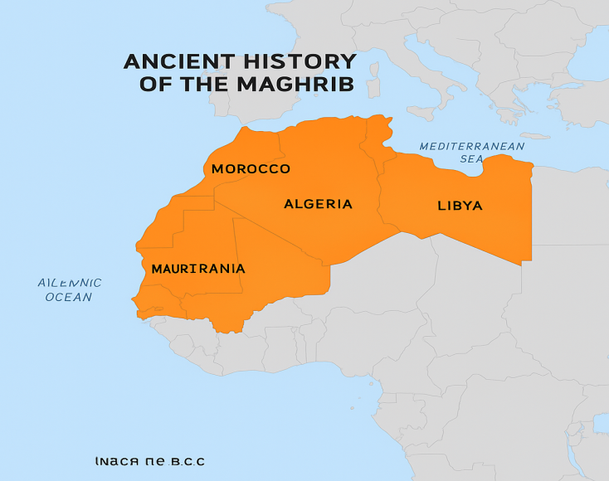
نص يعالج حضارة المغرب القديم

Text n 01 :
Maghreb, region of North Africa bordering the Mediterranean Sea. The Africa Minor of the ancients, it at one time included Moorish Spain and now comprises essentially the Atlas Mountains and the coastal plain of Morocco, Algeria, Tunisia, and Libya.
The native peoples of the Maghreb have resisted successive Punic and Roman invasions. Not until the 7th and 8th centuries was the Maghreb conquered; the Arabs helped the native peoples to convert to the religion of Islam and Arabic, the language of the Qurʾān, thus absorbed the Maghreb into the Muslim civilization. Despite this absorption, most of the North African societies have preserved their cultural identity throughout the centuries.
The people of the Maghreb belong to both Berber and Arab ethnolinguistic groups. The Berbers are descended from the earlier inhabitants of the region and may trace their ancestry to Paleolithic times. Many other groups have invaded the area, including the Phoenicians, the Arabs, and the French. About one-sixth of the population of the Maghreb still speak one of the Berber languages (most of them in Algeria and Morocco), but most also speak some form of Arabic.
The ancient Greeks used the word Libya (derived from the name of a tribe on the Gulf of Sidra) to describe the land north of the Sahara, the territory whose native peoples were subjects of Carthage, and also as a name for the whole continent. The Romans applied the name Africa (of Phoenician origin) to their first province in the northern part of Tunisia, as well as to the entire area north of the Sahara and also to the entire continent. The Arabs used the derived term Ifrīqiyyah in a similar fashion, though it originally referred to a region encompassing modern Tunisia and eastern Algeria.
The Arabs also borrowed the word Barbar (Berber) from the Latin barbari to describe the non-Latin-speaking peoples of the region at the time of the Arab conquest, and it has been used in modern times to describe the non-Arabic-speaking population called Berbères by the French and known generally as the Berbers (although their term for themselves, Amazigh, has grown in usage). As a result, Europeans have often called North Africa the Barbary States or simply Barbary. (A frequent usage refers to the non-Phoenician and non-Roman inhabitants of classical times, and their language, as Berber.
It should be stressed that the word Libyan is used here to describe these people in ancient times.)
Adapted from https://www.britannica.com

Task 1 (Paragraph 1): Instructions: Read Paragraph 1 and identify which parts belong to the Maghreb.
Write Yes or No next to each item.
- _____ The Atlas Mountains
- _____ Moorish Spain
- _____ Coastal plain of Morocco
- _____ Algeria
- _____ Tunisia
- _____ Libya
- _____ The Arabian Peninsula
- _____ Mediterranean Sea (as a border)

Task 2 (Paragraph 2): Instructions: Decide whether the statements are True (T) or False (F) according to Paragraph 2.
- _____ The native peoples of the Maghreb accepted Punic and Roman invasions easily.
- _____ The Maghreb was conquered in the 7th and 8th centuries by the Arabs.
- _____ Islam and Arabic entered the Maghreb during the Arab conquest.
- _____ All North African societies lost their cultural identity after Arab absorption.

Task 3 (Paragraphs 3 & 4): Instructions: Match each numbered word with the correct lettered definition. Write the correct letter in the “Answer” column.
Word (Numbered) | Definition (Lettered) | المصطلح بالعربية
1. ethnolinguistic groups | a. A large land that includes many countries
2. descended | b. Came from earlier generations
3. ancestry | c. People who live in a particular place
4. inhabitants | d. Originating from another word or source
5. derived | e. A political division or administrative region
6. province | f. A group defined by shared language and cultural traits
7. continent | g. Family lineage or historical origin

Task 4 (Paragraphs 4 & 5): Instructions: Choose the correct answer according to Paragraphs 4 and 5.
1. The word Berber comes from:
a. The Phoenician word B’rbr
b. The Latin word barbari meaning “non-Latin-speaking peoples”
c. The Greek word Libya
d. The Arab term Amazigh
2. Who used the term Berbères to describe the non-Arabic-speaking population?
a. Arabs
b. Phoenicians
c. French
d. Greeks
3. Europeans have often called North Africa:
a. Libya
b. The Barbary States
c. Africa Minor
d. Ifrīqiyyah
4. The term Libyan in the text refers to:
a. People living in modern Libya
b. The Greeks’ name for the Sahara Desert
c. People in North Africa in ancient times
d. A Phoenician colony
Text n 02 :
The earliest societies in the Maghrib were Amazigh communities, whose presence can be traced back thousands of years. Archaeological findings in Algeria, Libya, and Morocco show evidence of early agriculture, rock art, and organized settlements.
Beginning in the 12th century BCE, the Phoenicians established a series of trading posts along the Maghrib’s Mediterranean and Atlantic coasts. These settlements including sites near modern Tunisia and Morocco were not meant for military conquest but served as maritime commercial stations. Through trade, Phoenicians introduced writing systems, craftsmanship techniques, and economic exchanges that linked the Maghrib to the wider Mediterranean world (Aubet, 2001).
By the 6th century BCE, Carthage, originally a Phoenician colony in modern Tunisia, became the dominant power in the central and western Mediterranean. Carthage expanded its influence across the coastal Maghrib, forming alliances with Amazigh communities and developing major commercial centers. Classical writers describe the cooperation and occasional conflicts between Carthaginians and Amazigh rulers, particularly during the rise of the powerful Numidian king Masinissa (Fantar, 1993).
The defeat of Carthage by Rome in the Punic Wars marked a major shift in the region’s history. From the 2nd century BCE, the Romans gradually incorporated large parts of the Maghrib into their empire. Territories in modern Algeria and Tunisia became key Roman provinces, while northern Morocco was integrated into Mauretania Tingitana. Roman rule brought urban growth, agricultural expansion and extensive road networks. Cities such as Carthage, Volubilis, Timgad, and Leptis Magna became important administrative and cultural centers (Raven, 1993).
Roman influence remained significant until the 5th century CE, when the Western Roman Empire weakened and the Maghrib experienced new waves of political change. Despite these shifts, the ancient period left a lasting imprint on the region’s cultural and historical identity.

