Your first draft will help you work out:
- the structure and framework of your essay
- how you will answer the question
- which evidence and examples you will use
- how your argument will be logically structured.
Answering Assignment Questions
In order to decide how to answer an essay question, you need to identify what the question requires in terms of content and genre. This guide outlines some methods to help you analyse essay questions.
Analyse the question using key words
Assignment questions can be broken down into parts so that you can better understand what you are being asked to do. It is important to identify key words and phrases in the topic.
What are key words?
Key words are the words in an assignment question that tell you the approaches to take when you answer.
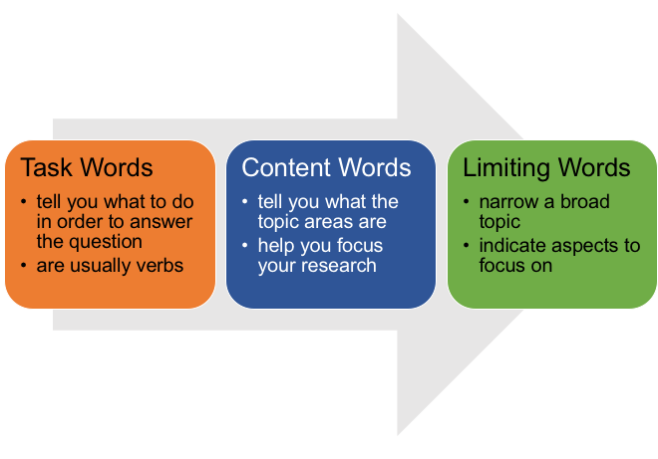
Make sure you understand the meaning of key words in an essay question, especially task words. As Task words are verbs that direct you and tell you how to go about answering a question, understanding the meaning helps you know exactly what you to do.
Content words tell you what the topic area(s) of your assignment are and take you halfway towards narrowing down your material and selecting your answer. Content words help you to focus your research and reading on the correct area.
Limiting words make a broad topic workable. They focus the topic area further by indicating aspects you should narrowly concentrate on.
If you're not sure about any aspect of the question, ask your tutor/lecturer for clarification. Never start any assignment until you know and understand exactly what you are being asked to do.
How to use key words
• Look for the keywords in your essay question.
• Underline them.
• Spend a little time working out what they mean.
Example Question:
Computers have had a significant impact on education in the 20th century. Discuss the changes they have made.

Task Words
DISCUSS : Examine key points and possible interpretations, sift and debate, giving reasons for and against. Draw a conclusion.

Content Words
EDUCATION, COMPUTERS. Content words help you to direct your research and reading towards the correct area(s), in this case on computers and on education.

Limiting Words
CHANGES, SIGNIFICANT IMPACT, 20TH CENTURY. Limiting words further define the topic area and indicate aspects you should narrowly concentrate on. For example, in this question, do not just write about computers in education, Discuss the SIGNIFICANT IMPACT they have had and the CHANGES computers have made to education during a certain time: the 20TH CENTURY.
Your first draft will not be your final essay; think of it as raw material you will refine through editing and redrafting. Once you have a draft, you can work on writing well.
Structure
Structure your essay in the most effective way to communicate your ideas and answer the question.
All essays should include the following structure.

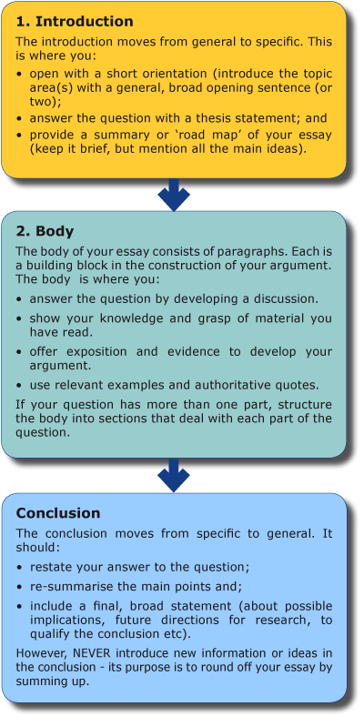

Essay paragraphs
A paragraph is a related group of sentences that develops one main idea. Each paragraph in the body of the essay should contain:
- a topic sentence that states the main or controlling idea
- supporting sentences to explain and develop the point you’re making
- evidence from your reading or an example from the subject area that supports your point
- a concluding sentence that restates your point, analyses the evidence, or acts as a transition to the next paragraph.

