Activity (Source, Janet Holmes, 2013)

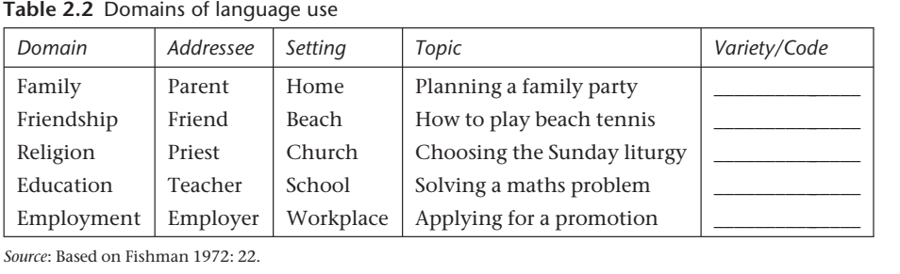

*What is Domain?*

*………………………………………………………………………………………………………………………………………………………………………………………………………………………………………………………………………………………………………………………………………………………………………………………………………………………………………………………………*