Université Larbi Ben M’hidi-Oum El Bouaghi
Faculté des Sciences et des Sciences Appliquées
Département d’Hydraulique
Module: Anglais technique

Master I (HU) Contrôle de rattrapage 27/6/2021: 1^{30min}

Read carefully then answer the questions:
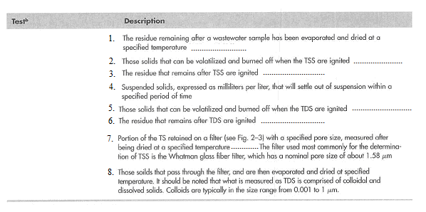
- Give the test name for each description. (7Marks)

- Fill in the blanks with the right temperature from the list below: (3Marks)

- 550 ± 50 °C
- 103 to 105 °C
- 105 °C

- Translate into french : wastewater sample; dried; burned off; pore; remains; residue; retained. (7Marks)

- From the text, give the complete name of the test abbreviation: (3Marks)
  - TDS
  - TS
  - TSS

Good luck
TL.

