Larbi Ben M’hidi University, Oum El Bouaghi Module : ESP
Faculty of Letters and Languages Level : M1 Did
Department of English Teacher : Dr. Azeroual

Lecture 03: Syllabi Types

Introduction
Syllabus design is one of the most essential elements on the part of the ESP course developer, in particular selecting the appropriate methodology. Syllabus design was influenced by the important changes in language curriculum development. The different types of syllabi presented in the literature were an outcome to the development in approaches and theories in language teaching to suit the variety of contexts and situations. Generating a language program from the available types of syllabi is a major decision in language teaching.

1. Defining Curriculum /Syllabus
Throughout the history of EFL/ESL, the terms ‘curriculum’ and ‘syllabus’ have been used interchangeably or differentiated depending on the context as there are conflicting views on what distinguishes syllabus design and curriculum development.
Here are some of the definitions offered:
- . . . the syllabus is simply a framework within which activities can be carried out: a teaching device to facilitate learning. It only becomes a threat to pedagogy when it is regarded as absolute rules for determining what is to be learned rather than points of reference from which bearings can be taken (Widdowson, 1984,p. 26).
- Hutchinson and Waters (1987) define the term syllabus as “a document that says what will (or at least what should) be learnt. Generally speaking, this document includes he topics covered in a particular subject, which function as a guide for both teachers and students. The main role that ESP syllabus plays is to break down the mass of knowledge to be learnt into manageable units (p.80).
- Richards (2001) defines syllabus as a specification of the content of a course of instruction and lists what will be taught and tested. Thus the syllabus for speaking course might specify the kinds of oral skills that be taught and practiced during the course, the functions, topics, or other aspects of conversation that will be taught, and the order in which they will appear in the course. (p.2).
- Allen (1984) defines curriculum as a very general concept which involves consideration of the whole complex of philosophical, social and administrative factors which contribute to the planning of an educational program. Syllabus, on the other hand, refers to that subpart of curriculum which is concerned with a specification of what units will be taught (as distinct from how they will be taught, which is a matter for methodology) (Quoted in Nunan, 1988, p.6).
In simpler words, curriculum is a theoretical document that deals with the abstract general goals of education which reflect the overall educational and cultural philosophy of a country. Syllabus is a detailed document that refers to the content of a particular subject. that translate abstract goals of the curriculum into concrete learning objectives.

2. Types of Syllabi
Robinson (1991), proposed three types of syllabi: Content-based Syllabus, Method-based Syllabus, and Skill-based Syllabus (Figure 6).
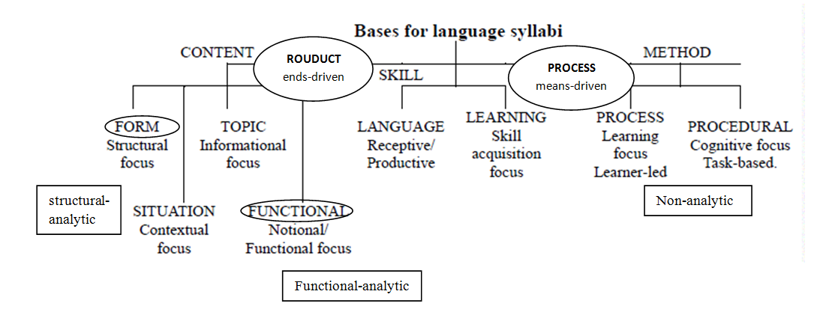
Figure 6. Bases for language syllabus design (Robinson, 1991,p. 35)
- Content-based Syllabus is also referred to as product syllabus. It is generally organized around forms and notions and function and it can be further divided into: Topic, Situation focus. In ESP, the conventional course content is language form which consists of an ordered set of language items, typically graded by supposed difficulty of learning. Notional-functional syllabus appears as a norm ESP course that based on two concepts; notions (time and space) and functions (greeting and asking).In addition, one of the basic objectives of the ESP course is to teach specific content and it can be easily achieved through the topic-based syllabus that deploys the content of the students’ work or specialist study. The most common type in EAP is situational model that involve units indicating specific situations, such as 'At the Post Office'.
- Method-based Syllabus is further divided into two sub-categories: learning process and task or procedure. Learning-process syllabus focuses on the process of learning performing certain tasks and activities during the course not the products. Task-based language teaching is concerned with communicative and cognitive processes consisting of a set of tasks or activities ordered according to cognitive difficulty. It aims at attaining the teaching objectives through tasks which are implemented in different ways depending on the ESP classroom.
- Skill-based Syllabus is based on the development of the language skills (listening, reading, writing and speaking) and sub-skills using the target language. It is one in which the content of language teaching is a collection of specific abilities that may play a part in using language. Its main aim is to enable students learn specific language skills, such as listening to spoken language for the main idea, writing different types of paragraphs, giving effective oral presentations, reading texts for gist or supporting details.

3. Choosing and Integrating Syllabi Types
The most frequent question generally asked is which syllabus to choose? In discussing syllabus choice and design, it should be kept in mind that the issue is not which type to choose but which types which syllabus to put first, and how to relate them to each other.Actually, no single type of content is appropriate for all teaching settings, thus syllabi or content types are usually combined in more or less integrated ways. The real issue is how to integrate the different types syllabus in one teaching programme taking inconsideration the students' needs and the objectives of the course, together with the institutional bias of the teaching institution (Robinson, 1991).
However, due to the variety of syllabuses offered in literature, an important question is raised which type of syllabus we choose in language teaching? To solve such problem, one needs to know about all the types of syllabi to choose the most appropriate. In this line of thought, suggests to integrate these types into a sensible teaching programme would be the best solution.
In this respect, Tarey (1988) suggested some practical guidelines to syllabus choice and design, listed below:
1. Determine, to the extent possible, what outcomes are desired for the students in the instructional program. That is, as exactly and realistically as possible, define what the students should be able to do as a result of the instruction.
2. Rank the syllabus types presented here as to their likelihood of leading to theoutcomes desired. Several rankings may be necessary if outcomes are complex.
3. Evaluate available resources in expertise (for teaching, needs analysis, materials choice and production, etc.), in materials, and in training for teachers.
4. Rank the syllabi relative to available resources. That is, determine what syllabus types would be the easiest to implement given available resources.
5. Compare the lists made under Nos. 2 and 4. Making as few adjustments to the earlier list as possible, produce a new ranking based on the resources' constraints.
6. Repeat the process, taking into account the constraints contributed by teacher and student factors described earlier.
7. Determine a final ranking, taking into account all the information produced by the earlier steps.
8. Designate one or two syllabus types as dominant and one or two as secondary.
9. Review the question of combination or integration of syllabus types and determine how combinations will be achieved and in what proportion.
10. Translate decisions into actual teaching units.

Conclusion
Designing syllabus and developing curriculum is one of the crucial issues in ESP teaching in different contexts. Undoubtedly, it requires knowledge of what learners want and need to learn and the learning environment. Different types of syllabi are used in the domain of ELT, and our conclusion is that, similarly to teaching methods, a syllabus should not be employed independently of other syllabus types. In other words, presented in the literature, yet the best syllabus is a result of integrated approach in designing to meet the learners’ needs.

