The Making of England

The English people are made of different races that came from different areas of Europe at different periods of time.
The Iberians
The first people to come to England were probably prehistoric people who came from Iberia or from North Africa. They were black haired people. At first these people reached England because they were hunters then theykeptanimals and grew corn crops, and knew how to make pottery.
These were the first of several waves of invaders before the first arrival of the Celts.

The Celts
Around 700 BC, another group of people began to arrive. Many of them were tall, and had fair or red hair and blue eyes. These were the Celts, who probably came from central Europe
The Celts are important in British history because they are the ancestors of many of the peoplein HighlandScotland, Wales, Ireland and Cornwall today.
Celtic languages, which have been continuously used in some areas since that time, are still spoken.
It is these people who the Romans invaded.

The Romans
The first official contacts between Rome and Britain in were made in 55-54 BC when Julius Caesar the Roman Emperor decided to invade Britain to teach the Celts a lesson because they helped the other Celts of Gaul in their wars against the Romans.
But the full Roman Conquest came nearly a century later when the new Emperor Claudius decided to invade Britain in AD43to make it a Roman province. The Roman occupation of ‘Britannia’ (most of modern-day England and Wales) was to last from AD 43 to 410.
Resistance to the Roman invasion came from Boudicca a widow of a Celtic king. In AD 60 Boudicca rose up against the Romans but she was defeated in a battle during which 80,000 Briton and just 400 Romans were killed. After the battle Boudicca was determined not to be captured. She gave her daughters deadly poison before taking her own life. To this day, Boudicca remains the symbol of revolt against Roman occupation.
When the Romans first arrived there were many different groups of people. Each group had its own king. They didn’t think themselves as British but the Romans called all these people Britons.
In many places round the country, Britons started to live like Romans. They wore Roman clothes, built fine houses and went to theatres and baths. Most people could speak Latin, the Roman language. In the later years of Roman occupation they became Christians.

The Anglo-Saxons
But in 409 the Roman army left Britain to fight in other parts of the Empire. Soon after this, invaders from present-day Germany and Denmark came to Britain.These new invaders are made of three tribes: the Angles, Saxons and the Jutes.
The Angle and Saxon armies destroyed everything in their path, and the Roman way of life disappeared from Britain. Many Britons moved west to escape the invaders. By the 7th century, groups of Britons were in control of present-day Scotland, Wales and Cornwall, but Angles and Saxons ruled the rest of Britain. During the Anglo-Saxon rule England was divided into 7 kingdoms known as The Heptarchy.(Northumbria, Mercia, Essex Wessex, Sussex, , East Anglia and Kent).
From c.1000 the country began to be called Angle-land “land of the Angles.” Later its name became England. The reasons why the name of the Angles was ultimately given the language, country and the nation remain obscure.
The strength of Anglo-Saxon culture is obvious even today. Days of the week, for example, were named after Germanic gods: Tig (Tuesday), Wodin, (Wednesday), Thor( Thursday) Frie or Fraia, a goddess( Friday).
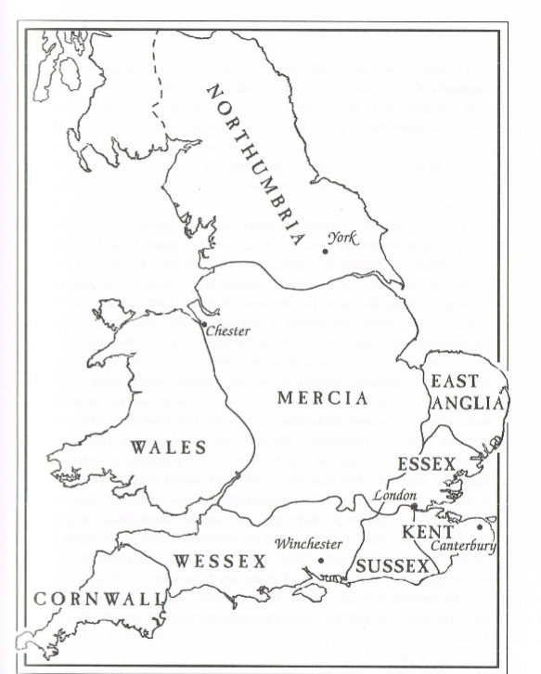

The Vikings
Then at the end of the 8th century, new invaders started attacking the coasts of Britain – Vikings from Scandinavia. At first they came to steal gold and silver from monasteries. Then some made their homes in Britain, and from the 860s they controlled a large area of northern and eastern England. The Saxon kings fought against them. Alfred the Great defeated the Vikings and sent them away from Britain. But they returned, and in the early 11th century there was a Viking king of England, King Canute.

The Normans
The Normans came next. Their conquest was probably the most important in British history because it was the last.
In 1066William Duke of Normandy conquered England when he defeated the Saxon King of England at the Battle of Hastings and on Christmas Day he was crowned King of England.
William the Conqueror had to fight other Saxon armies in England. But then he was able to build a new Norman England. William organised his English kingdom according to the feudal system which had already begun to develop in England before his arrival. The basis of feudal society was the holding of land, and its main purpose was economic.
Thecentral idea was thatall land wasownedby theking but itwasheld byotherscalled"vassals",inreturn for servicesandgoods.
The king gave large estates to his main Norman nobles in return for a promise to serve him in war for up to forty days. The Saxons had nothing.
For more than 200 years the language of the English Aristocracy was the Normans’language, French. Saxons continued to speak their own language. The Saxons’ language finally grew into modern English but as a result of the Norman invasion, half of the words in today English language come from French.

