The Difference between the British Isles, UK and Great Britain
One of the most common mistakes people make when talking about geography in this country is to confuse the UK with Great Britain or the British Isles – a cardinal sin in the eyes of any true geographer!
So let’s clear this up once and for all
The British Isles
This is purely a geographical term – it refers to the group of islands situated off the north western corner of mainland Europe. Great Britain and Ireland are the two largest islands of the 5000 or so smaller islands scattered around the coasts. Remember this only refers to geography, not nationality, and while the Republic of Ireland is part of the British Isles, its people are not British – a very important distinction.
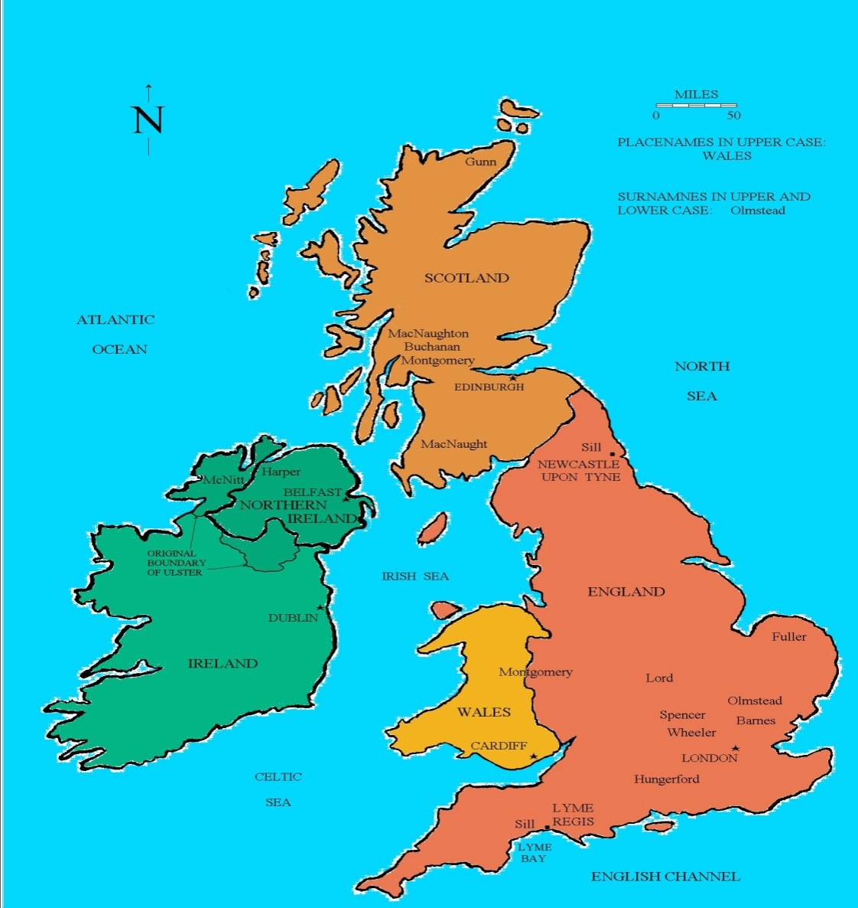

The United Kingdom (UK):

The United Kingdom of Great Britain and Northern Ireland (to give its full name) refers to the political union between England (capital London), Wales (capital Cardiff), Scotland (capital Edinburgh) and Northern Ireland (capital Belfast). The UK is a sovereign state, but the nations that make it up are also countries in their own right.
The UK is short for The United Kingdom of Great Britain and Northern Ireland. It is a sovereign state (in the same way as Algeria or the USA) but is made up of four countries; England, Scotland, Wales and Northern Ireland.
There is a long and complicated history that follows the formation of the United Kingdom, but here are the highlights:
c. 925 – The Kingdom of England. Established by the unification of Anglo-Saxon tribes across modern day England.
1536 – Kingdom of England and Wales. A bill enacted by King Henry VIII which effectively made England and Wales the same country, governed by the same laws.
1707 – Kingdom of Great Britain. The Kingdom of England (which includes Wales) joined with the Kingdom of Scotland to form The Kingdom of Great Britain.
1801 – United Kingdom of Great Britain and Ireland. Ireland joins the union, and once again the name changes.
1922 – United Kingdom of Great Britain and Northern Ireland. The Republic of Ireland (Eire, or ‘Southern Ireland’) became an independent state(capital Dublin) and withdrew from the union, leaving just the northern counties of Ireland. This is the UK that remains to this day.
The Channel Islands and Isle of Man are not part of the UK, but are Crown Dependencies.

Great Britain:

Great Britain, the largest island which consists of England, Scotland and Wales and their associated islands. It does not include Northern Ireland and therefore should never be used interchangeably with ‘UK’ – something you see all too often.
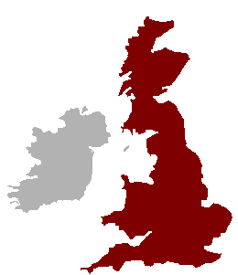
Great Britain, therefore, is a geographic term referring to the island also known simply as Britain. It’s also a political term for the part of the United Kingdom made up of England, Scotland, and Wales (including the outlying islands that they administer, such as the Isle of Wight). United Kingdom, on the other hand, is purely a political term: it’s the independent country that encompasses all of Great Britain and the region now called Northern Ireland.

England
Just like Wales and Scotland, England is commonly referred to as a country but it is not a sovereign state. It is the largest country within the UK both by land and population. Its capital London also happens to be the capital of the UK.

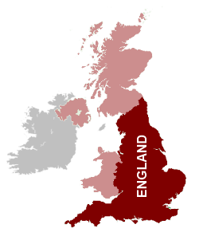
So there you have it! If you are still a bit confused over the differenced, here’s a quick summary:
The British Isles:a collection of over 5,000 islands, of which Great Britain is the largest.

The UK: a sovereign state that include England, Scotland, Wales and Northern Ireland.
Great Britain: the largest island situated off the northwestern coast of Europe.

Ireland: the other large island situated west of Great Britain

