First year Badi rima

Oral Expression

**Eating Out**

**Listen to the conversation in a restaurant and do the exercises**

**Excercise one**: Do this exercise before you listen. Draw a line to match the pictures with the words below

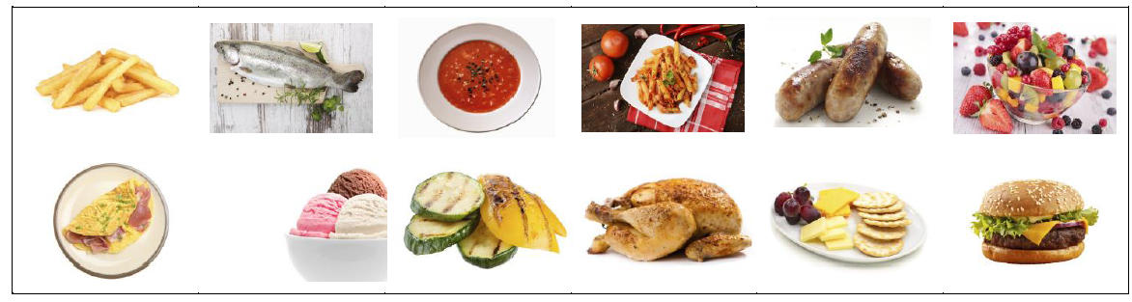

|  |  |  |  |  |  |
| --- | --- | --- | --- | --- | --- |
| fruit salad | cheeseburger | vegetables | cheese and biscuits | ice cream | pasta |
| chips | roast chicken | sausages | tomato soup | omelette | grilled fish |

**Excercise Two :** Are the following sentences true or false ? Correct the false (wrong) ones

1. The customers want two tables…..

2. There are two customers eating together….

3. The two customers order the same starter…..

4. Both customers order the Thai chicken for their main course……

5. The customers order cold drinks……

6. Both customers order a dessert…….

**Excercise Three :** Complete the gaps with a word from the box

|  |  |  |  |  |  |  |
| --- | --- | --- | --- | --- | --- | --- |
| |  |  |  | | --- | --- | --- | | would | ready | for | | have | like | like | |

1. A table…………….. two, please.

2. Are you……………..to order?

3. What would you…….for your starter?

4. I’d…………… French onion soup, please.

5. What………..you like to drink?

6. I’ll………….a fresh orange juice.

**Excercise Four** : What food and drink from this menu would you order?

