Lesson 1: Parts of Speech
Objectives:
By the end of the first lesson,
*The students will be able to identify the different word categories used in building correct English sentences and extended pieces of writing such as paragraphs and essays.
*The students will be able to illustrate the learned about parts of speech
*The students will be able to categorize the sentence parts

1. **What is language?**
- *Student A:* Language is a way people communicate using words, sounds, and gestures.
- *Student B:* It's a system of communication used by humans to express thoughts, feelings, and ideas.

2. **What is language composed of?**
- *Student C:* Language is composed of words, phrases, sentences, and grammar rules.
- *Student D:* It consists of sounds, letters, and vocabulary that help convey meaning.
3. **What are parts of speech?**
- *Student E:* Parts of speech are categories of words like nouns, verbs, adjectives, and adverbs, each with a specific role in a sentence.
- *Student F:* They are different types of words that have specific functions in sentences, like naming, describing, or showing action.
**Teacher's Answer and Introduction:**
Language is indeed a powerful tool humans use to connect and express themselves. It's composed of various elements, including sounds, words, and grammar rules. Now, let's dive deeper into the structure of language by exploring its building blocks, the parts of speech.
Language, as you mentioned, encompasses words and grammar rules. Within this framework, we have parts of speech, which are like the different roles words play in our sentences. They give words specific jobs, allowing us to convey complex meanings clearly. For example, nouns name people, places, or things, while verbs express actions or states of being. By understanding these parts of speech, we can construct sentences effectively and communicate our thoughts precisely.
Today, our focus will be on understanding these parts of speech better. We will explore how nouns, verbs, adjectives, adverbs, and other parts work together to create meaningful sentences. As we progress, remember that grasping the essence of these parts of speech will empower you to express your ideas fluently and write with confidence.

PARTS OF SPEECH

A part of speech is a term used in traditional grammar for one of the nine main categories into which words are classified according to their functions in sentences, such as nouns or verbs. Also known as word classes, these are the building blocks of grammar.
1. **Noun:** A word used to identify a person, place, thing, or idea. For example: *dog, London, love.*
2. **Pronoun:** A word that replaces a noun to avoid repetition. For example: *he, she, they.*
3. **Verb:** A word that expresses an action, occurrence, or state of being. For example: *run, eat, is.*
4. **Adjective:** A word that describes or modifies a noun or pronoun by providing more information about its attributes. For example: *happy, tall, blue.*
5. **Adverb:** A word that modifies a verb, adjective, or another adverb by providing information about how, when, where, or to what degree an action is performed. For example: *quickly, very, often.*
6. **Preposition:** A word that shows the relationship of a noun or pronoun to another word in the sentence. For example: *in, on, at, under.*
7. **Conjunction:** A word used to connect words, phrases, clauses, or sentences. For example: *and, but, or, although.*
8. **Interjection:** A word or phrase used to express strong feelings or sudden emotions. For example: *wow, oh, ouch!*
DIAGNOSTIC TEST
Note the way each of the words is used and after it write what part of speech it is.
Higher education in (1) this country is (2) rapidly becoming higher. (3) More people than ever before (4) graduate from high school (5) and go (6) to college. (7) Many spend five, instead of four, years in (8) college. (9) Today a bachelor's degree is (10) more common than a (11) high school diploma was (12) sixty years ago. (13) Graduate study (14) is as common as undergraduate study was (15) then. (16) Because man's knowledge has increased, there is more for (17) us to learn. (18) Our fields (19) of specialization (20) grow narrower. (21) Although the successful, self-educated man (22) who did not graduate from (23) high school (24) still exists in America, (25) he is a rare exception. (26) His kind will (27) soon be extinct. (28) Anyone who wishes to achieve high position in (29) today's world had better get a (30) college degree. (31) Alas, twenty years of schooling may be (32) necessary for success in the (33) future.

PARTS OF SPEECH

A part of speech is a term used in traditional grammar for one of the nine main categories into which words are classified according to their functions in sentences, such as nouns or verbs. Also known as word classes, these are the building blocks of grammar.

- THE NOUN
Example: In his report on the importance of religion in ancient Egypt, Joaquin wrote about the Great Sphinx and the Great Pyramid at Giza.
A noun is a word used to name a person, place, thing, or idea.
Nouns may be classified in three ways: proper or common; abstract or concrete; and collective.
- A proper noun is the name of a particular person, place, idea: Walker, Memphis, Toyota, Marxism.
- A common noun names any one of a group of persons, places, things, or ideas: woman, city, car, belief.
- A common noun is not capitalized (except when it begins a sentence or is part of a title); a proper noun, however, is.
- A concrete noun names a person, a place, or a thing that can be perceived by one or more of the senses: tree, child, bicycle, mountain, computer.
- An abstract noun names an idea, a feeling, a quality, or a characteristic: confusion, thought, bravery, charm, triumph.
- Collective Nouns The singular form of a collective noun names a group: jury, band, crowd, class, team.
- A compound noun consists of two or more words that together name a person, a place, a thing, or an idea. The parts of a compound noun may be written as one word, as separate words, or as a hyphenated word.
One Word: stairway, bookcase, toenail, Newfoundland.
Separate Words: lieutenant governor, ceiling fan, blue jay, Golden Gate Bridge.
Hyphenated Word: sister-in-law, jack-of-all-trades, great-uncle, stick-in-the-mud.

- THE PRONOUN
Examples: Jay enjoys hiking and camping; in fact, they are his two favorite pastimes. [The nouns hiking and camping are the antecedents of the pronoun they.]
One of the film projectors is broken. It is being repaired. [The pronoun One is the antecedent of the pronoun It.]
The students complained to the principal about the dress code. They wished he had consulted them about it. [The noun students is the antecedent of the pronouns They and them; the noun principal is the antecedent of the pronoun he; and the compound noun dress code is the antecedent of the pronoun it.]
A pronoun takes the place of one or more nouns or pronouns.
- The word or word group that a pronoun stands for is called the antecedent of the pronoun.
Bill loaned James his book. Whose book?
- Personal Pronouns: A personal pronoun refers to the one(s) speaking (first person), the one(s) spoken to (second person), or the one(s) spoken about (third person).
Subject pronouns – I, you, he, she, it, we, they
Object pronouns – me, him, her, us, them, it, you
Possessive pronouns –our, ours, mine, my, his, her, hers, their, theirs, your, yours, its
EXAMPLES: If I give you my address, will you write to me?
We told them that they could go with u
- Reflexive and Intensive Pronouns:
Reflexive pronoun refers to the subject of a verb and functions as a complement or as the object of a preposition.
EXAMPLES: Mary excused herself from the table. [Herself is the direct object of excused.]
He said the mastermind was, in fact, himself. [Himself is a predicate nominative referring to the subject, He.]
They took extra biscuits for themselves. [Themselves is the object of the preposition for.]
An intensive pronoun emphasizes its antecedent—a noun or another pronoun.
EXAMPLES Joseph Vásquez himself wrote the script. [Himself emphasizes the subject, Joseph Vásquez, but has no grammatical function in the sentence.]
The final speech was given by Maya Angelou herself. [Herself emphasizes the object, Maya Angelou, but has no grammatical function in the sentence.]
- Demonstrative Pronouns: A demonstrative pronoun points out a noun or another pronoun.
EXAMPLES Is this the one you want? -- That may be the only reasonable solution. --These or those are the pictures from our vacations.
- Interrogative Pronouns : An interrogative pronoun introduces a question.
EXAMPLES What is the capital of the Hawaiian Islands? Whose is this red sweater? To whom should I direct your call?
- Relative Pronouns: A relative pronoun introduces an adjective clause.
EXAMPLES: The college that I chose is in Texas. -- The woman who chairs the committee is my aunt. -- The birds, which usually have flown south by this time of the year, were still in our backyard.
- Indefinite Pronouns: An indefinite pronoun refers to a person, a place, a thing, or an idea that may or may not be specifically named. In other words, the pronoun may not have a specific antecedent.
EXAMPLES All of the members have voted. [All refers to members.]
Does everyone favor a weekly meeting? [Everyone has no specific antecedent.]
The fallen tree provided homes for several of the creatures of the woods. [Several refers to creatures.]
Common Indefinite Pronouns: all- both- few- nobody- several-another- each- many- none- some-any- either- more- no- one- somebody-anybody- everybody- most- nothing- someone- anyone- everyone- much- one- something- anything- everything- neither- other- such.
Pronoun or Adjective? Many of the words that can be used as pronouns can also be used as adjectives.
EXAMPLES:
This is the best baklava I have ever tasted. [This is a pronoun referring to baklava, the predicate nominative.]
This baklava is delicious. [This is an adjective modifying baklava.]
Which of the rooms is yours? [Which is a pronoun referring to rooms, the object of the preposition of.]
Which room is yours? [Which is an adjective modifying room.]

- THE VERB
A verb expresses action or a state of being.
- Main Verbs and Helping Verbs: A main verb and one or more helping verbs (also called auxiliary verbs) make up a verb up a verb phrase.
EXAMPLES: Daniel has played. [Has is the helping verb; played is the main verb.]
Simon will be going. [Will and be are the helping verbs; going is the main verb.]
Lynn should have been working. [Should, have, and been are the helping verbs; working is the main verb.]
A modal (or modal auxilliary) is a helping verb that is joined with a main verb to express an attitude such as necessity or possibility.
EXAMPLES: We must win this game to reach the playoffs. [necessity]
Mr. Garza said that if we work hard enough on the play we are writing, we may get to perform it for the whole school. [possibility]
A helping verb may be separated from the main verb.
EXAMPLES Have you seen Tom Stoppard’s play Rosencrantz and Guildenstern Are Dead?
You should not miss it.
- Action Verbs: An action verb expresses either physical or mental activity.
EXAMPLES The horse galloped across the field.
The Colorado River runs through the Grand Canyon.
If the ball touched the line, the umpire made the right call.
Do you ever wonder what dogs dream?
- Linking Verbs: A linking verb connects the subject to a word or word group that identifies or describes the subject. Such a word or word group is called a subject complement.
EXAMPLES Wovoka was an influential Paiute prophet. [The subject complement prophet identifies the subject Wovoka.]
Marcy looks serious. [The subject complement serious describes the subject Marcy.]
Computers were once so large that they could fill a room but are now small enough, in some cases, to fit in a pocket. [The subject complements large and small describe the subject Computers.]
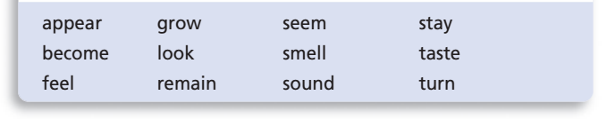
LINKING: The fabric felt soft. [The fabric was soft makes sense.]
ACTION: I felt the fabric. [I was the fabric doesn’t make sense.]

- THE ADJECTIVE
An adjective modifies a noun or a pronoun. To modify means “to describe” or “to make more definite.” An adjective modifies a noun or a pronoun by telling what kind, which one, how many, or how much.
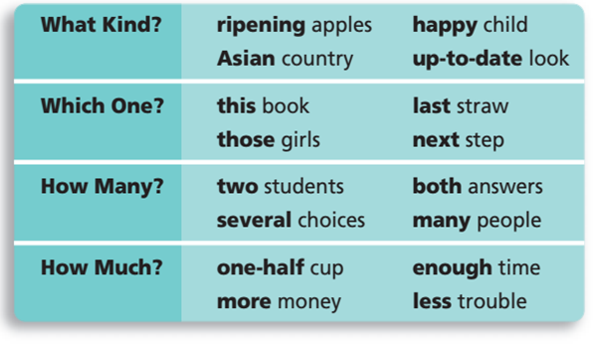
An adjective usually precedes the word it modifies.
EXAMPLE: The tired and hungry hikers straggled into camp.
Sometimes, for emphasis, an adjective follows the word it modifies.
EXAMPLE The hikers, tired and hungry, straggled into camp.
An adjective that modifies the subject may appear in the predicate.
Such an adjective is called a predicate adjective.
EXAMPLES The hikers felt tired and hungry.
Tired and hungry were the hikers.
ARTICLES
The most frequently used adjectives are a, an, and the. These words are called articles.
A and an are called indefinite articles because they refer to any member of a general group. A is used before words beginning with a consonant sound; an is used before words beginning with a vowel sound.
EXAMPLES: Felipe added a tomato and an avocado to the salad.
A European said, “It is an honor to be here with you.”
The is called the definite article because it refers to a specific person, place, thing, or idea.
EXAMPLE We spent the hour discussing the revolution that began in 1791 in Haiti.
Adjective or Pronoun? In different contexts, a word may be used as different parts of speech. For example, the following words may be used as adjectives and as pronouns.
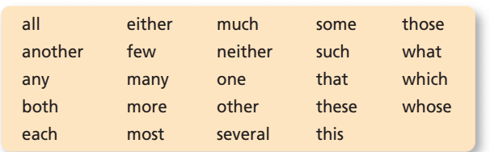
Remember that an adjective modifies a noun or a pronoun and that a pronoun takes the place of a noun or another pronoun.
ADJECTIVE: He wrote both poems. [Both modifies the noun poems.]
PRONOUN: He wrote both. [Both takes the place of the noun poems.]
ADJECTIVE: These books are overdue. [These modifies the noun books.]
PRONOUN: These are overdue. [These takes the place of the noun books.]
ADJECTIVE: Several ducks had dark green heads. [Several modifies the noun ducks.]
PRONOUN: Several had dark green heads. [Several takes the place of the noun ducks.]
The words this, that, these, and those are called demonstrative pronouns when they take the place of nouns or other pronouns and are called demonstrative adjectives when they modify nouns or pronoun.
Adjective or Noun? Most words that are used as nouns can also be used as adjectives.
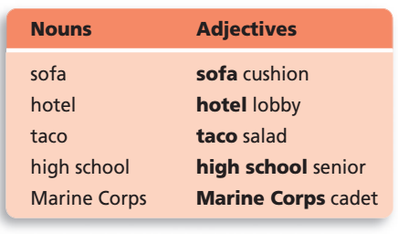
An adjective that is formed from a proper noun, such as Marine Corps in the last example above, is called a proper adjective. Proper adjectives, like proper nouns, are capitalized.
Do not mistake part of a compound noun for an adjective. The entire word group is considered a noun.
COMPOUND NOUNS paper clips, cable TV, time capsule, United States.
- THE ADVERB
An adverb modifies a verb, an adjective, or another adverb.
An adverb tells where, when, how, or to what extent (how much, how often, or how long). Adverbs are most commonly used to modify verbs and verb phrases.
- Adverbs may modify verbs.
EXAMPLES: Teresa spoke eloquently. [The adverb eloquently modifies the verb spoke, telling how.]
Have you heard this melody before? [The adverb before modifies the verb phrase Have heard, telling when.]
They searched everywhere. [The adverb everywhere modifies the verb searched, telling where.]
He had not read the contract thoroughly. [The adverbs not and thoroughly modify the verb phrase had read, telling to what extent.]
- Adverbs may modify adjectives.
EXAMPLES: Phuong Vu is quite creative. [The adverb quite modifies the adjective creative, telling to what extent.]
This species is found on an extremely remote island. [The adverb extremely modifies the adjective remote, telling to what extent.]
- Adverbs may modify other adverbs.
EXAMPLES: Phyllis runs remarkably swiftly. [The adverb remarkably modifies the adverb swiftly, telling to what extent.]
It’s too soon to know the results. [The adverb too modifies the adverb soon, telling to what extent.]
- Noun or Adverb?
Some words that are often used as nouns may also be used as adverbs.
EXAMPLES My parents left yesterday. [The noun yesterday is used as an adverb telling when.]
They will return home Saturday. [The noun home is used as an adverb telling when].
- THE PREPOSITION
A preposition shows the relationship of a noun or pronoun, called the object of the preposition, to another word. Notice how changing the preposition in the following examples changes the relationship between the verb swam and the noun raft.
EXAMPLES: I swam to the raft. -- I swam from the raft. -- I swam around the raft. -- I swam past the raft. -- I swam under the raft.
Object of a Preposition
The object of a preposition is a noun, a pronoun, or a word group that functions as a noun; in most cases it follows a preposition. Together, the preposition, its object, and any modifiers of the object make a
prepositional phrase.
EXAMPLES: Did you see Juanita at the last game? -- The line starts behind him. -- They played a new song by Katie’s favorite group.
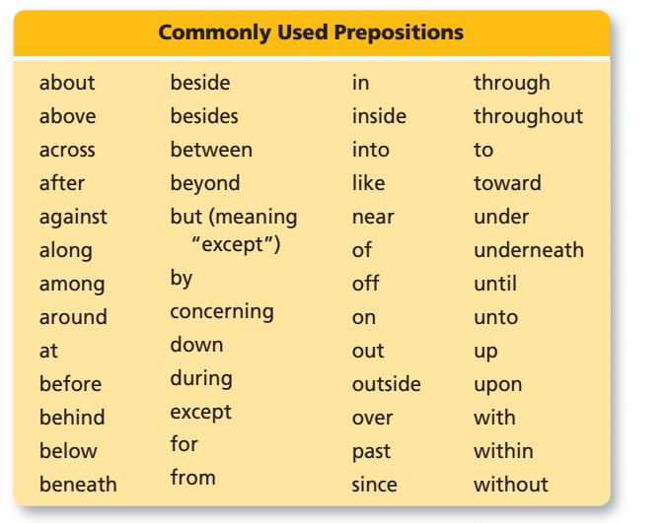
A preposition that consists of two or more words is called a compound preposition.
EXAMPLES Alexandra has been accepted by several private colleges in addition to both state universities.
As of today, she hasn’t made her final choice.
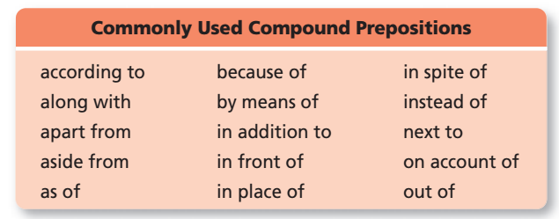
- Adverb or Preposition?
Some of the words that are commonly used as prepositions may also be used as adverbs. Keep in mind that an adverb is a modifier and that it does not have an object. Prepositions always have objects.
ADVERB: Jerry will meet you outside at noon. [Outside modifies will meet.]
PREPOSITION: I will meet you outside the library. [Outside introduces a prepositional phrase and has an object, library.]

- THE CONJUNCTION
A conjunction joins words or word groups.
- Coordinating Conjunctions
A coordinating conjunction joins words or word groups that are used in the same way.
EXAMPLES: In A.D. 711, the Berbers invaded and conquered Spain. [And joins two verbs.]
We missed the opening scene, but we enjoyed the rest of the play. [But joins two clause.]
- Correlative Conjunctions
Correlative conjunctions are pairs of conjunctions that join words or word groups that are used in the same way.
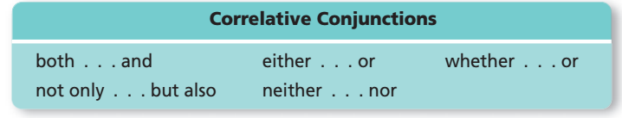
EXAMPLES: Either Fred or Manuela will bring music for the party. [Either . . . or joins two nouns.]
Not only did Garrett Morgan patent the first gas mask, but he also invented the automatic traffic signal. [Not only . . . but also joins two clauses.]
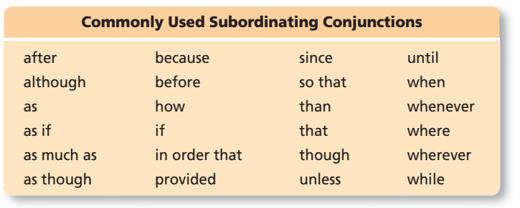
EXAMPLES Many American Indians are reluctant to reveal their traditional names for some places because the names have spiritual meanings.
I gasped when I saw the headline.
A subordinating conjunction may come at the beginning of a sentence instead of between the clauses it joins.
EXAMPLE When I saw the headline, I gasped.
Some words can be used either as prepositions or as subordinating conjunctions.
PREPOSITION: After the election, we celebrated.
SUBORDINATING CONJUNCTION: After we won the election, we celebrated.

- THE INTERJECTION
An interjection expresses emotion and has no grammatical relation to the rest of the sentences.
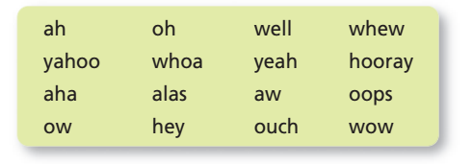
An interjection is often set off from the rest of the sentence by an exclamation point or one or more commas. Exclamation points indicate strong emotion. Commas indicate mild emotion.
EXAMPLES: Hey! I think I know the answer!
Well, I thought I knew the answer.
I think that, aw, you two are the greatest.

