Series of exercises 1
Exercise 1
Calculate the strength of the resultant acting on the charge${ q}_{3}$ From Figure 1
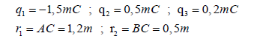
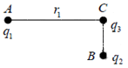
Exercise 2
How much is the electric force superior to the gravitational force? Compare the electric force and the gravitational force between an electron and a proton in a hydrogen atom, knowing that they have the same charge e and the distance between them is about $0.5×{10}^{−10}$m and using the following data:
$e=1.6×{10}^{−19}C, m_{p}=1.67×{10}^{−27}Kg, m_{e}=9.11×{10}^{−31}Kg$
Exercise 3
Let the distribution of charges of the order of the microcollum shown below $AB=d=0.2m$ The charges in A and B are static, unlike the charge in C, which is moving on the line $(AB)$
What is the equilibrium position of the charge placed in C if any?
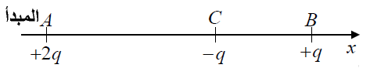
Exercise 4
Calculate the electric field and determine its direction at point a as in the following figure, then calculate the field if:
$$q=5.{10}^{−6}C , r=0,3m$$

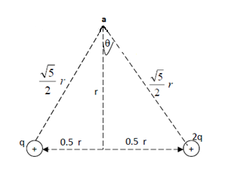

Exercise 5
We consider two chargess q and -2q to be placed respectively in points $A(a,0,0)$ and $A^{'}(4a,0,0)$ at the Kartzian coordinates.
- Calculate the electric potential at a point$M(x,y,z)$
- Set the surface equal to $V=0$.
- That at every point of this surface, the electric field passes at a fixed point, which you have to set.

Exercise solutions
Exercise 1
Since $q_{1}.q_{3}<0$ and ${\vec{F}}_{13}<0$ is a force of attraction
And since $q_{2}.q_{3}>0$ , ${\vec{F}}_{23}>0$ is the force of disharmony.
$${\vec{F}}_{13}=−K\frac{q_{1}.q_{3}}{r_{1}^{2}}{\vec{u}}_{1}\overset{⇒}{}F_{13}=9.{10}^{9}\frac{1,5.{10}^{−3}.0,2.{10}^{−3}}{{\left(1,2\right)}^{2}}\overset{⇒}{}F_{13}=1,875.{10}^{3}N$$
$${\vec{F}}_{23}=K\frac{q_{2}.q_{3}}{r_{2}^{2}}{\vec{u}}_{2}\overset{⇒}{}F_{23}=9.{10}^{9}\frac{0,5.{10}^{−3}.0,2.{10}^{−3}}{{\left(0,5\right)}^{2}}\overset{⇒}{}F_{23}=3,6.{10}^{3}N$$
$$R=\sqrt{F_{13}^{2}+F_{23}^{2}}\overset{⇒}{}R=4,06.{10}^{3}N$$
The angle that R makes with AC is calculated as follows:
$$\tan{α=\frac{F_{23}}{F_{13}}} , \tan{α=1.92 \overset{⇒}{}α=62.49°}$$
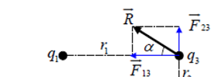

Exercise 2
To calculate the electric force and gravitational force, we find respectively:
$$F_{C}=\frac{Kq_{1}q_{2}}{r^{2}}=\frac{9×{10}^{9}×{\left(1,6×{10}^{−19}\right)}^{2}}{{\left(0.5×{10}^{−10}\right)}^{2}}=92.2×{10}^{−9}N$$
$$F_{G}=\frac{Gm_{1}m_{2}}{r^{2}}=\frac{\left(6.67×{10}^{−11}\right)\left(9,1×{10}^{−31}\right)\left(1,67×{10}^{−27}\right)}{{\left(0.5×{10}^{−10}\right)}^{2}}=40.5×{10}^{−49}N$$
So it's:
$$\frac{F_{G}}{F_{C}}=\frac{40.5×{10}^{−49}}{92.2×{10}^{−9}}=0.4×{10}^{−40}$$
The force of gravity between Proton and the electron is nearly ${10}^{40}$ times smaller than the electric force between them!
Exercise 3
The chargess in A and C are opposite sign, so they attract. If we put $AC=x$, the strength of the attractive force is equal to:
$$F_{AC}=9.{10}^{9}\frac{\left|2q\right|\left|−q\right|}{x^{2}}\overset{⇒}{}F_{AC}=9.{10}^{9}\frac{2q^{2}}{x^{2}}$$
The charges in B and C are opposite sign, so they attract. And since $BC=d−x$, the strength of the gravitational force is equal to
$$F_{BC}=9.{10}^{9}\frac{\left|q\right|\left|−q\right|}{{\left(d−x\right)}^{2}}\overset{⇒}{}F_{BC}=9.{10}^{9}\frac{q^{2}}{{\left(d−x\right)}^{2}}$$
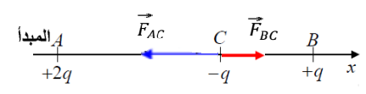

The charge in C, subject to the two electric forces, can only be balanced if the two forces are directly opposite. This is only true if C lies between A and B and on it:
$$F_{AC}=F_{BC}\overset{⇒}{}9.{10}^{9}\frac{2q^{2}}{x^{2}}=9.{10}^{9}\frac{q^{2}}{{\left(d−x\right)}^{2}}\overset{⇒}{}\frac{2}{x^{2}}=\frac{1}{{\left(d−x\right)}^{2}}$$
$$\left.\begin{matrix}\frac{2}{x^{2}}=\frac{1}{{\left(d−x\right)}^{2}} \\ d=0.2\end{matrix}\right|\overset{⇒}{}x^{2}−0.8x+0.08=0\overset{⇒}{}x=AC=0.117m$$
Exercise 4
$$E_{1}=K\frac{q}{{\left(\frac{\sqrt{5}}{2}r\right)}^{2}}=K\frac{4q}{5r^{2}}$$
$$E_{2}=K\frac{2q}{{\left(\frac{\sqrt{5}}{2}r\right)}^{2}}=K\frac{8q}{5r^{2}}$$

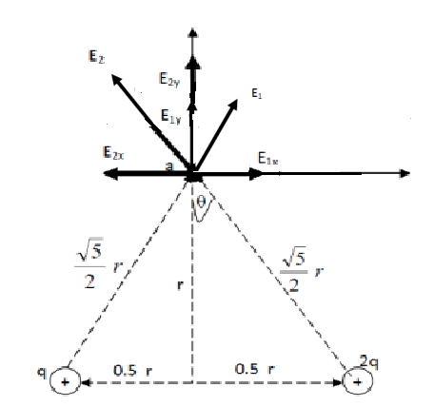
And by analyzing these two fields on the x and y axis, as shown in the previous figure,
$$E_{1x}=E_{1 }sin θ{E_{1y}=E_{1}\cos{θ}}$$
$$E_{2x}=E_{2}\sin{θE_{2y}=E_{2}\cos{θ}}$$
From the previous figure, the x-axis carries two opposite fields, one $E_{1x}$ and the other $E_{2x}$ , but $E_{2x}$ is greater than $E_{1x}$, because $E_{2x}$ is a product of a larger charge than the cause of the $E_{1x}$. And that's where it's going with the $E_{2x}$ direction.
$$E_{x}=E_{2x}−E_{1x}=\left(E_{2}−E_{1}\right)\sin{θ}$$
$$=\left(K\frac{8q}{5r^{2}}−K\frac{4q}{5r^{2}}\right)\frac{0.5r}{\frac{\sqrt{5}}{2}r}=\left(K\frac{4q}{5r^{2}}\right)\frac{1}{\sqrt{5}}=K\frac{4q}{{\left(5\right)}^{\frac{3}{2. }}r^{2}}$$
And it also shows from the previous figure that the y-axis has two areas, $E_{1y}$and $E_{2y}$, and they have the same direction and so on.
$$E_{y}=E_{2y}+E_{1y}=\left(E_{2}+E_{1}\right)\cos{θ}$$
$$=\left(K\frac{8q}{5r^{2}}+K\frac{4q}{5r^{2}}\right)\frac{r}{\frac{\sqrt{5}}{2}r}$$
$$=\left(K\frac{12q}{5r^{2}}\right)\frac{2}{\sqrt{5}}=\left(K\frac{24q}{5^{\frac{3}{2}}.r^{2}}\right)$$
$$E^{2}=E_{x}^{2}+E_{y}^{2}=592. K^{2}\frac{q^{2}}{5^{3}.r^{4}}=10.88×{10}^{5}N/C$$
The trend is given from the following equation:
$$\tan{∅=\frac{E_{y}}{E_{x}}=\frac{24}{4}=6}$$
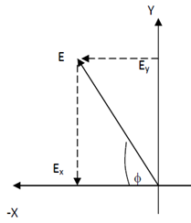
$$\overset{⇒}{}∅=80.54°$$
And it's between the y-axis and the x-axis.
Exercise 5
To calculate the electric potential , we use the peaceful expression:
$$V=K\frac{q}{d}$$
After placing the two points on the landmark as shown in the diagram, we calculate the dimensions d and d' for the point M about the two charges:
$$d=\sqrt{{\left(x−a\right)}^{2}+y^{2}+z^{2}}; d^{'}=\sqrt{{\left(x−4a\right)}^{2}+y^{2}+z^{2}}$$
- So the electric potential at the point $M\left(x,y,z\right)$ is:
$$V_{M}=Kq\left(\frac{1}{d}−\frac{2}{d'}\right)$$
$$V_{M}=Kq\left(\frac{1}{\sqrt{{\left(x−a\right)}^{2}+y^{2}+z^{2}}}−\frac{2}{\sqrt{{\left(x−4a\right)}^{2}+y^{2}+z^{2}}}\right)$$
- the surface equal to $V=0$.
$$V\left(x,y,z\right)=0\overset{⇒}{}Kq\left(\frac{1}{d}−\frac{2}{d'}\right)=0$$
$$\frac{1}{\sqrt{{\left(x−a\right)}^{2}+y^{2}+z^{2}}}−\frac{2}{\sqrt{{\left(x−4a\right)}^{2}+y^{2}+z^{2}}}=0\overset{⇒}{}x^{2}+y^{2}+z^{2}=4a^{2}$$

It turns out the surface is equal to $V=0$. It's a radius of $r=2a$.
- The electric field is vertically on the surface equal to Akmon. Whatever point the field goes through, it's vertical on the surface of the ball, so it's bound to go through position O of this ball.
