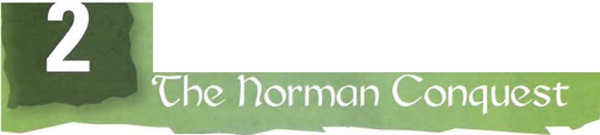
1066 and all that:

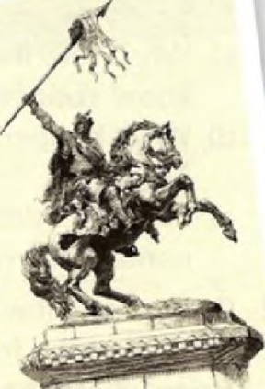
Section 1: Reading
- Before you read - think and discuss
The last time that England was successfully invaded was in 1066. Other countries have been invaded and occupied much more recently and much more often.
  - Why has England not been invaded for such a long time?
  - Has your country been invaded in the last 1,000 years?
  - How does the experience of invasion and occupation affect the people living through it?
  - What reasons are there for invasions?

- Read the text

1066 and all that: 'Che norman Conquest

'Then began the death-bearing clouds of arrows. There followed the thunder of blows ... '
Henry of Huntingdon, Historia Ang/arum, c. 1130

Fact file
  - 5th January 1066: King Harold II succeeds Edward the Confessor, who had no sons, as King of England
  - Sunday 14th October 1066 - Battle of Hastings
  - Harold killed during the battle - thought to be by an arrow in his eye
  - 25th December 1066 - William crowned King of England
  - December 1085- Domesday Book commissioned by William as a land
survey of the whole of England
  - 9th September 1087 -William dies
The last invasion of England
The Battle of Hastings was the decisive victory in the Norman conquest of England. On Saturday 14th October 1066, the Normans of Duke William of Normandy (later known as William the Conqueror) defeated the Saxon
army led by King Harold II, only eight months after Harold had succeeded to the English throne. Many people think that famous date marks the beginning of English history, as it was the last time the country was conquered by a foreign power. Comparing the
significance of the event to that of the Bolshevik 10
revolution, a Russian diplomat once said to an English diplomat: 'You had your 1917 in 1066.'
William - heir to the English throne?
William believed that he was the heir to the English throne and claimed that Harold had sworn an oath accepting this. William travelled with the blessing of the Pope, who did not recognize Harold as king and had given William a ring and a banner to show that God was on his side. He crossed the Channel from

France in boats that his soldiers had made with
their own hands. When they arrived on the Sussex coast there was no one to resist the invading force. But as William walked up the beach, he tripped and fell on his face in front of his troops. Turning this embarrassment to a show of confidence, he rose with his hands full of sand and shouted, 'I now take hold of the land of England!' Everyone cheered.
The battle
William arrived unopposed because Harold's army was distracted by the Viking invasion of the north of England. After defeating the Vikings in Yorkshire, they
30 had to march 250 miles south in only twelve days. Not surprisingly, they were exhausted by the time they reached the south coast. To make matters worse, the Battle of Hastings lasted all day, which was unusual at this time when most battles were over within an hour.
The two armies had between 7,000 and 8,000 men each, but William's army included cavalry. A lack of archers made the English hesitant. Late in the battle, a mixture of genuine and mock retreats by William's army drew the English forces down from
40 their defensive position on the ridge -where the town of Battle now stands. Then, according to the Bayeux Tapestry, King Harold was hit in the eye by an arrow before falling to the ground. It is believed that he was finished off by a Norman horseman, some say by William himself. The Normans then poured through the English ranks and routed them.
The Norman victory at Hastings was decisive, despite approximately 2,000 Normans being killed and wounded in the battle. Saxon casualties, including
50 Harold's two brothers, were greater still. But more importantly, Edgarthe Atheling, the only surviving male member of Edward the Confessor's family, failed in his attempts to organize further resistance .
The Bayeux Tapestry
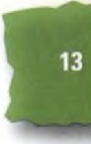
While some facts are known, most of what actually happened in the battle is unclear. There are, however, some records that we can use. The most famous is the Bayeux Tapestry, which is both an artistic masterpiece and a crucial historical source. The belief that Harold was hit in the eye with an arrow stems from a famous
scene in the tapestry which shows a Saxon noble 60
being wounded in this way. This huge visual narrative was the work of Norman women, possibly for the Conqueror's half-brother Odo, who can be seen in the tapestry playing an important role in the battle.
William crowned
Two months later, on Christmas Day 1066, William was crowned King of England in Westminster Abbey. Three years after that, he had imposed his rule over most of England and Wales. He built
huge, impregnable stone castles like the Tower of London and then terrorized the inhabitants of the 10
surrounding countryside into obedience.
Domesday Book
William wanted to raise taxes from the inhabitants of his new kingdom and did not want anyone to avoid paying them. He knew that knowledge is power, so he sent his men to conduct the first doorstep survey in history. They went to every village in England and wrote down exactly who owned what and how much. The findings were written up in a huge book known as the Domesday
Book (1086). According to the Treasurer of England, so it was given this name because 'it is not permissible
to contradict its decisions, any more than it will be those of the Last Judgement' ( dome or doom was the old English word for judgement). Remarkably, the Domesday Book was used to settle a dispute as
recently as 1982.
New English aristocracy
The ruling class of England, and much of the rest of Britain, was recreated by the Norman Conquest. Many current-day British aristocrats can trace their ancestry back to the Conqueror's men; the words noble, gentle go
and aristocrat themselves come from the French.
Death of William
William died after a riding accident in September 1087. Some reports from that time suggest that on his death­ bed he was seized by guilt at the way he had taken the crown from Harold. Three of his sons survived him, but he refused to appoint an heir: 'Having made my way to the throne of that kingdom by so many crimes, I dare not leave itto anyone but God alone.'

