First Year Group : 06
Cross-word about Air Travel
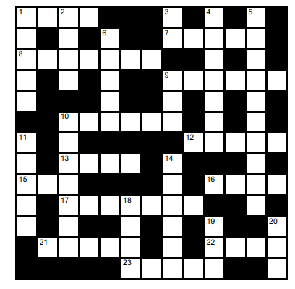
Across | Down
1 Air travel has never been so ____ (4)  7 An aircraft with wings (5)  8 Heathrow or Gatwick, for example (7)  9 The feeling of being very tired after a long  air journey (3,3)  10 A ____ airline offers cheap flights (6)  12 Excess luggage will ____ charges (5)  13 Waiting area for departing passengers (4)  15 A piece of luggage (3)  16 The people who work on an aircraft (4)  17 Qantas is Australia's national ____ (7)  21 Boarding will ____ at 8.30 (5)  22 The travel insurance covers ____ of luggage  (4)  23 A situation in which a plane leaves or arrives  late (5) | 1 A modern jumbo jet has up to 500 ____ (5)  2 The money you pay for a trip or journey (4)  3 ____ in the Air (2009 movie) (2)  4 The person in charge of an aircraft (7)  5 The part of an airport that deals with  passengers who are leaving (10)  6 To get onto an aircraft (5)  9 Owning a private ____ is a symbol of great  wealth (3)  10 Luggage (7)  11 The part of the plane where the passengers  sit (5)  14 To announce that a flight will not take place  (6)  18 To arrive at a place by plane (4)  19 To travel somewhere by plane (3)  20 You're not allowed to ____ your phone  during take-off and landing (3)

