Larbi Ben M’hidi University
English Department
Research Methodology/ 2nd Year
S. AROUF
Direct Quotations2
APA 7th referencing style
When quoting directly, always provide the author, year, and page number of the quotation in the in-text citation in either parenthetical or narrative format. To indicate a single page, use the abbreviation “p.” (e.g., p. 25, p. 41); for multiple consecutive pages, use the abbreviation “pp.” and separate the page range with an en dash (e.g., pp. 34–35). If pages are discontinuous, use a comma between the page numbers (e.g., pp. 67, 72).
The format of a direct quotation depends on its length (fewer than 40 words vs. 40 words or more).
Short Quotations (Fewer Than 40 Words)
If a quotation consists of fewer than 40 words, treat it as a short quotation:
-Incorporate it into the text and enclose it within double quotation marks.
-For a direct quotation, always include a full citation (parenthetical or narrative) in the same sentence as the quotation.
- Place a parenthetical citation either immediately after the quotation or at the end of the sentence.
Effective teams can be difficult to describe because “high performance along one domain does not translate to high performance along another” (Ervin et al., 2018, p. 470).
“Even smart, educated, emotionally stable adults believe superstitions that they recognize are not rational,” as exemplified by the existence of people who knock on wood for good luck (Risen, 2016, p. 202).
-For a narrative citation, include the author and year in the sentence and then place the page number or other location information in parentheses after the quotation.
Biebel et al. (2018) noted that “incorporating the voice of students with psychiatric disabilities into supported education services can increase access,involvement, and retention” (p. 299).

-If the quotation precedes the narrative citation, put the page number or location information after the year and a comma.
“Some people are hilarious, others are painfully unfunny, and most are somewhere in between,” wrote Nusbaum et al. (2017, p. 231) in their exploration of humor.
-If the citation appears at the end of a sentence, put the end punctuation after the closing parenthesis for the citation.
The item read, “What were the best aspects of the program for you?” (Shayden et al., 2018, p. 304).
Block Quotations (40 Words or More)
- If a quotation contains 40 words or more, treat it as a block quotation. Do not use quotation marks to enclose a block quotation.
- Start a block quotation on a new line and indent the whole block 0.5 in. from the left margin.
- Double-space the entire block quotation.
- Do not add extra space before or after the block quote.
- Either (a) cite the source in parentheses after the quotation’s final punctuationor (b) cite the author and year in the narrative before the quotation and place only the page number in parentheses after the quotation’s final punctuation. Do not add a period after the closing parenthesis in either case.
Block quotation with parenthetical citation:
Researchers have studied how people talk to themselves:
Inner speech is a paradoxical phenomenon. It is an experience that is central to many people’s everyday lives, and yet it presents considerable challenges to any effort to study it scientifically. Nevertheless, a wide range of methodologies and approaches have combined to shed light on the subjective experience of inner speech and its cognitive and neural underpinnings. (Alderson-Day & Fernyhough, 2015, p. 957)
Block quotation with narrative citation:
Flores et al. (2018) described how they addressed potential researcher bias when working with an intersectional community of transgender people of color:
Everyone on the research team belonged to a stigmatized group but also held privileged identities. Throughout the research process, we attended to the ways in which our privileged and oppressed identities may have influenced the research process, findings, and presentation of results. (p. 311)

Direct Quotation of Material Without Page Numbers
To directly quote from written material that does not contain page numbers (e.g., webpages and websites, some ebooks), provide readers with another way of locating the quoted passage. Any of the following approaches is acceptable; use
the approach that will best help readers find the quotation:
Provide a paragraph number (count the paragraphs manually if they are not numbered). | People planning for retirement need more than just money—they also “need to stockpile their emotional reserves” to ensure adequate support from family and friends (Chamberlin, 2014, para. 1).
Provide a heading or section name. | For people with osteoarthritis, “painful joints should be moved through a full range of motion every day to maintain flexibility and to slow deterioration of cartilage” (Gecht-Silver & Duncombe, 2015, Osteoarthritis section).
Provide an abbreviated heading or section name in quotation marks to indicate the abbreviation if the full heading or section name is too long | To prevent kidney failure, patients should “get active,” “quit smoking,” and “take medications as directed” (Centers for Disease Control  and Prevention, 2017, “What Can You Do” section).  Note: The original heading was “What Can You Do to Prevent Kidney Failure?”
Provide a heading or section name in combination with a paragraph number. | Music and language are intertwined in the brain such that “people who are better at rhythmic memory skills tend to excel at language skills as well” (DeAngelis, 2018, Musical Forays section, para. 4).

Changes to a Quotation Requiring No Explanation
You may want to make minor changes to a direct quotation; this is possible.
Changes that do not require an explanation include:
- The first letter of the first word can be changed to an uppercase or lowercase letter.
- Some punctuation marks may be changed.
Changes to a Quotation Requiring Explanation
Some changes to direct quotations require explanation, as shown in the example in figure 1. These changes include:
Omitting Material. If you have omitted words within the quotation (to shorten the sentence or tie two sentences together), use an ellipsis. An ellipsis consists of three dots with spaces around each ( . . . ) i.e. with a space before and after.
Inserting Material. Use square brackets [ ], not parentheses, to enclose material such as an addition or explanation you have inserted in a quotation.
Adding Emphasis. If you want to emphasize a word or words in a quotation, use italics. Immediately after the italicized words,
insert “emphasis added” within square brackets as follows: [emphasis added].
Noting error in original(text/source). If you want to draw attention to an error in a quotation, for example, a spelling mistake or wrong date, do not correct it; write [sic] in square brackets.

Figure 1 Example of Changes Made to a Direct Quotation
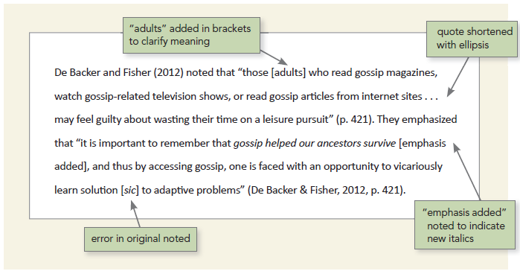

References
American Psychological Association (2020). Publication manual of the American psychological association (7th ed.).

