Greenhouse effect (Effet de serre )

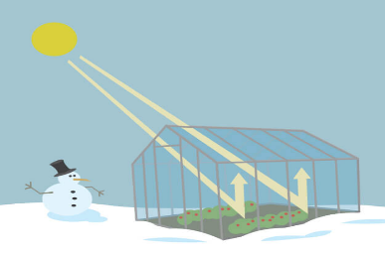
Greenhouse (serriculture )
A greenhouse is a building with glass or plastic walls and roof. Greenhouses are used to grow plants (vegetables and fruits…)
A greenhouse stays warm inside, even during the winter:
- In the daytime, sunlight shines into the greenhouse and warms the plants and air inside.
- At nighttime, it's colder outside, but the greenhouse stays pretty warm inside.
- That's because the glass walls of the greenhouse trap the Sun's heat

The greenhouse effect in the Earth's atmosphere works like
greenhouse
- The greenhouse effect of the atmosphere is a natural and necessary phenomenon for maintaining suitable temperature for life on Earth planet (without this effect the température of Terre could be about -18 °C !
The greenhouse effect occurs when gases in Earth's atmosphere absorb and trap the Sun's heat which is essential to life
These gases which retain heat can be considered as a blanket wrapped around Earth maintaining suitable temperature
A blanket of gases arround the Earth absorbs heat and works like the greenhouse.

Greenhouse gases (GHG)
Are gases capable of keeping solar radiation energy within a
planet's atmosphere.
- About half the light energy reaching Earth's atmosphere passes through the air and clouds to the surface,
- where it is absorbed and radiated in the form of infrared heat.
- About 90% of this heat is then absorbed by greenhouse gases.
- The contribution that a greenhouse gas makes to the greenhouse effect depends on:
how much heat it absorbs,
how much it re-radiates and
how much of it is in the atmosphere.
In descending order, the gases that contribute most to the Earth’s greenhouse effect are:

water vapour (H2O)
carbon dioxide (CO2)
nitrous oxide(N2O)
methane (CH4)
ozone (O3)
The four major greenhouse gases are:
Water vapor (H2O), 36~72% (~75% including clouds);
Carbon dioxide (CO2), 9~26%;
Methane (CH4), 4~9%;
Tropospheric ozone (O3), 3~7%.

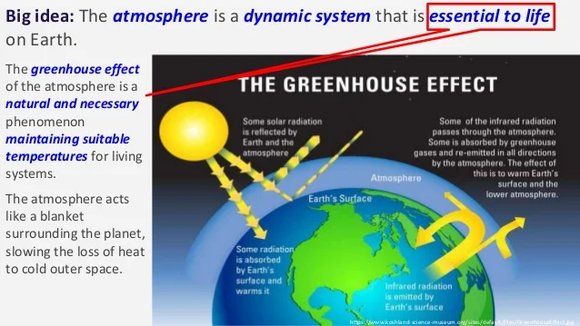
Greenhouse gases include carbon dioxide, methane, nitrous oxides, and water vapor.
Scientists have determined that carbon dioxide's warming effect helps stabilize Earth's atmosphere. Remove carbon dioxide, and the terrestrial greenhouse effect would collapse. Without carbon dioxide, Earth's surface would be some 33°C (59°F) cooler.( Today the average temperature is +15°C without the warming provided by atmospheric carbon dioxide, the average temperature would drop to – 21°C
But in the last century, human activities, mainly through the burning of fossil fuels, add carbon dioxide to the air. The level of carbon dioxide in Earth’s atmosphere has been rising consistently for decades and traps extra heat near Earth's surface, causing temperatures to rise.

