Fossil fuels
Coal, crude oil, and natural gas are considered fossil fuels because they were formed from the fossilized, remains of plants and animals that lived millions of years ago.
Fossil fuels are made from organic substances such as dead plants and animals that got deposited under several tho
usand feet of silt.
As the fossil material begins to get buried deeper and deeper underground it is subjected to increased heat and pressure. As the heat rises, the fossil molecules begin to break apart.
The anaerobic decomposition of buried dead organisms, containing organic molecules, and got converted to natural gas, coal, and crude oil due to the extreme heat and pressure inside the earth’s crust.
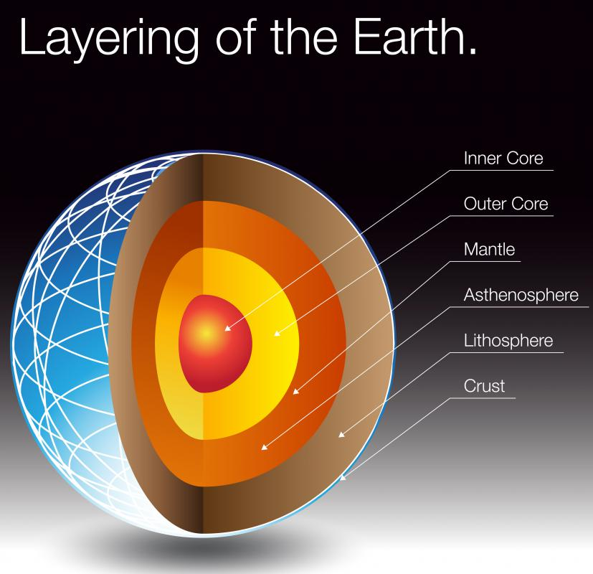
The conversion from these materials to fossil fuels requires a geological process of millions of years.
A fossil fuel is a hydrocarbon-containing material. These fossil fuels contain carbon and hydrogen, which can be burned for energy.
The creation of fossil fuels—either oil, natural gas, or coal—from these fossils is determined by the type of fossil, the amount of heat, and the amount of pressure.
They are also known as non-renewable sources of energy as it takes a very long time for it to replenish.

Advantages of Fossil Fuels

Cheap Source of Energy
Modern technologies can extract fossil products with a great degree of efficiency, substantially decreasing the overall price. In fact, in recent years, the extraction of fossil fuels is cheaper than setting the solar or wind technologies.
Safe to Transport
Massive Economic Benefits
High Calorific Value
Fossil fuels have the greatest calorific value of any fuel. This illustrates why they are still prevailing to renewable types and other alternative energy resources.
Abundant
The reality that fossil fuels can satisfy the requirements of the earth’s population means they are plenteous in supply. Fossil fuels are discovered in almost every region in the world.
Useful byproduct
plastics are secondary byproducts of fossil fuels. They might not be appropriate for the environment, but they are cheap and useful. Plastics are also employed in computers and medical equipment.

Reliable
Other renewable power resources such as wind and solar rely on the current climatic situations to generate electricity. For example, the generation of electricity stops if the sun is not shining. Also, wind speed influences the generation of electricity. Fossil fuels ensure a reliable supply of electricity.

Disadvantages of fossil fuels
- Fossil fuels emit carbon dioxide when burnt which is a major greenhouse gas and the primary source of pollution. This has contributed to global warming.
- They are a non-renewable resource, i.e., once used they cannot be replaced.
- Combustion of fossil fuels makes the environment more acidic. This has led to unpredictable and negative changes in the environment.
- Extraction of fossil fuels causes fatal diseases among the people. For eg., the coal miners often suffer from Black Lung Disease. The natural gas drillers are constantly exposed to chemicals and silica which is dangerous for their health.

/ 1metre= 3,2808399 feet---------- 1ft =0.30m

