Larbi Ben M’hidi University
English Department
TTU/2nd Year
S.AROUF
How to choose a research topic and Variable(s)
Introduction
As a research student you know that choosing a research topic is of primary importance to you, but you must also come up with an appropriate research title and identify the research variables. The research topic, research title and the research variables are fundamentally the most important factors in research. So, you must quickly agree on a research topic and title with your supervisor, and you must know what the research variables are.
Choosing a research topic
1 Pick a (manageable) topic that interests you.
- Try to pick a topic that you find interesting. This will ensure the research process is as engaging and fun as possible.
- Ask yourself: What am I curious about? What questions do I have? What topic would I like to learn more about? [If you’re still not sure, think of 3 things that interest you, even if you don’t think they relate to your class. You might be surprised at the connections you can make!]
- Also consider: How long does my research paper need to be? Choose a topic that seems appropriate for the length of the paper.
For example, “American Literature of the 1950s” is too broad of a topic for a university research paper. You could write a whole book on that topic! “Depictions of Advertising in American Literature of the 1950s” is a more manageable topic to start with.
2 Be flexible
- Understand that choosing a research topic is a cyclical process. No topic should be set in stone.

Learn Choose
a topic

Read Search

- Be prepared to change your topic as you search for information, read about your topic, and learn more.
3 Search for information on your topic
Search for information resources, such as scholarly articles and books, in the library catalogue and relevant databases. What do you find?
Search Results: 1-20 of 21,194
If you find an extensive list of information resources, it may indicate that your topic is too broad. To make your topic more specific and narrow, try to zero in on a single aspect of your topic. Here are some points to consider to help narrow your topic:
- consider narrowing down to a specific region, time period, or group (age, gender, ethnicity).
- Another approach is to explore a specific aspect of your topic, like examining the connection between video games and socialization instead of a general discussion on video games.
- Additionally, you can refine your topic by addressing a specific problem or question; for example, rather than a broad exploration of video games and socialization, you could investigate "how first-person shooter games impact adolescents' ability to learn social behaviour”.
So, narrow your topic and search again.
Search Results: 1-2 of 2
If you cannot find enough information resources, your topic might be too specific. To broaden your topic, consider removing some of your criteria from your research topic. For example, instead of investigating the use of Instagram by university students at funerals, you might broaden your topic to the use of Instagram by university students at funerals. Alternatively, you might need to adjust the keywords you have been using.
Thus, broaden your topic and search again.
4 Read about your topic
While reviewing the selected information resources, you'll gain a deeper understanding of your topic. Based on what you discover, you might find it necessary to make further adjustments to your chosen topic. Don’t be afraid to 5 Begin writing
Start the writing process, and be open to the possibility that your topic might undergo slight changes. Writing serves as a means of thought exploration for your topic. Throughout the writing process, you may choose to enhance and better align your topic with the content of your research paper as your thoughts evolve.
Definition of a variable
A variable is something that can be measured in a study or experiment. The independent and dependent variable are vital to the understanding and development of research.
What are dependent and independent variables in research?
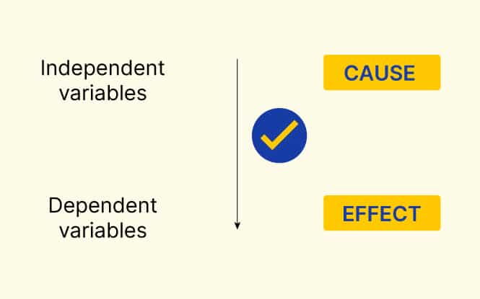

Independent variable definition:
As per the name, an independent variable (IV) stands alone. The value does not change due to the impact of any other variable. The researcher manipulates or changes the independent variable to measure its impact on other variables (dependent variables).
For example, if someone was studying the effect of tooth-brushing on the incidence of caries, the tooth-brushing would be the independent variable.
Dependent variables definition:
Similarly, a dependent variable (DV) as the name suggests, depends on other variables. It is the variable that is being measured in the study or experiment. A researcher measures the outcome of the experiment to see how the independent variable causes change in the value of a dependent variable.
For example, if you are interested in the effect of a diet on health, you can use multiple measures of health: blood sugar, blood pressure, weight, and many more. Each of these is its own a dependent variable with its own research question.

