Food is more than just sustenance; it's a powerful vehicle for expressing culture and identity. It connects us to our heritage, our communities, and ourselves.

**How Food Shapes Identity:**

* **Cultural Heritage:** Traditional dishes and recipes often hold deep historical and cultural significance. They can be passed down through generations, preserving customs and traditions.

[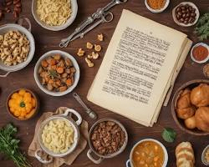S'ouvre dans une nouvelle fenêtre[https://encrypted-tbn0.gstatic.com/favicon-tbn?q=tbn:ANd9GcQl1FhBD5UYuXdXJWASUgQUB6CsAtghEfB2vJ_IakD8QT3rEBDIvIe1kMYK694ZFjOFW7HlUiqzckqbk1GsbI3NqR4dLyDwj1dPEHmi4gZ41zzKukR9QMM](https://www.one-dragon-restaurant.com/the-stories-behind-our-traditional-family-recipes/)www.one-dragon-restaurant.com](https://www.one-dragon-restaurant.com/the-stories-behind-our-traditional-family-recipes/)

Traditional family recipes

* **Regional Identity:** Regional cuisines reflect the unique ingredients, flavors, and cooking techniques of specific areas. They can create a sense of belonging and pride for those who identify with a particular region.

[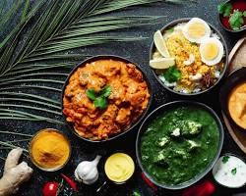S'ouvre dans une nouvelle fenêtre[https://encrypted-tbn0.gstatic.com/favicon-tbn?q=tbn:ANd9GcRAksvQk3-wDvOUmvzaNU5WlzOd1Cfm6qFWGpUqpAaerGYNOwhwnfC9X-_-bQLImb2sZKnQ14mP8agM8nx_GJ7MuvIcZg](https://sukhis.com/an-overview-of-indias-regional-cuisines/)sukhis.com](https://sukhis.com/an-overview-of-indias-regional-cuisines/)

Regional cuisines

* **Ethnic Identity:** Ethnic foods often serve as a bridge to one's cultural roots, connecting people to their ancestors and homeland. They can be a source of comfort and identity, especially for immigrants and diaspora communities.

[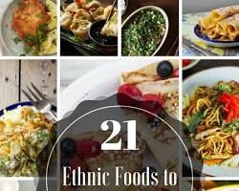S'ouvre dans une nouvelle fenêtre[https://encrypted-tbn3.gstatic.com/favicon-tbn?q=tbn:ANd9GcT3pQ6YgAswJiAkFaC7jOMXJqrQFA4EU27mL-qjc93idQzPN8Y-lfbrcf-ruUyuli0VkZSIplnuBUEM0BVpXOVjGbmXq0GoBeujcpJe](https://therestfulhome.com/21-ethnic-foods-you-should-try-at-home/)therestfulhome.com](https://therestfulhome.com/21-ethnic-foods-you-should-try-at-home/)

Ethnic foods

* **Personal Identity:** Our individual food preferences and dietary choices can also shape our self-perception. Whether we're vegetarian, vegan, or have specific dietary restrictions, our food choices can reflect our values and beliefs.

[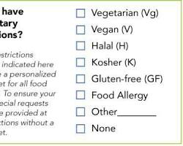S'ouvre dans une nouvelle fenêtre[https://encrypted-tbn2.gstatic.com/favicon-tbn?q=tbn:ANd9GcQDsPs2pPiHN60JT0C5gSmR6KHemKpDPI1y39DsENKpXAWFU3erhAZR-PJSjvsHP1h8wtyE1tPnfR9SJQ_ptDxDc_3GRiAuyfM](https://www.reddit.com/r/sustainability/comments/vrvq0k/to_those_organizing_conferences_please_stop_using/)www.reddit.com](https://www.reddit.com/r/sustainability/comments/vrvq0k/to_those_organizing_conferences_please_stop_using/)

Vegetarian, vegan, or dietary restrictions

**Food as a Social Glue:**

Food brings people together, fostering connection and community. Shared meals, celebrations, and food-related traditions create bonds and strengthen social ties.

**Food and Globalization:**

Globalization has led to the exchange of cuisines and ingredients worldwide. While this has enriched our culinary landscape, it has also raised concerns about the loss of traditional foodways and the homogenization of tastes.

**Food and Identity in the Modern World:**

In today's diverse and interconnected world, food continues to play a vital role in shaping our identities. As we navigate cultural shifts and personal choices, food remains a constant source of connection, expression, and meaning.

**Conclusion:**

Food is a fundamental aspect of human experience, interwoven with our identities on multiple levels. It nourishes our bodies and souls, connecting us to our past, present, and future.

Sources et contenu associé