**Lesson 11: Evaluation of Materials in ESP**

**Introduction**

All too often, ESP teachers become evaluators, designers and developers of materials, simply because “publishers are naturally reluctant to produce materials for very limited markets” (Hutchinson and Waters, 1987) and most ESP areas conform to this reality. These roles are not exclusive to ESP teachers but, if compared with EFL/ESL teachers, they are more often engaged in the task of evaluating, designing and developing materials for their classroom use. It is precisely this additional role of materials providers/developers that has endowed ESP teachers with the denomination of **practitioners** (Robinson, 1991).

**2. Evaluating Published Materials in ESP**

**Materials evaluation can refer to either before the program begins or after or both**. Here, materials evaluation refers to a before- program evaluation of published textbooks. This is motivated by the need to choose materials that will be relevant and appropriate for a particular group of learners and also by the need to identify specific aspects of the materials that require adaptation.

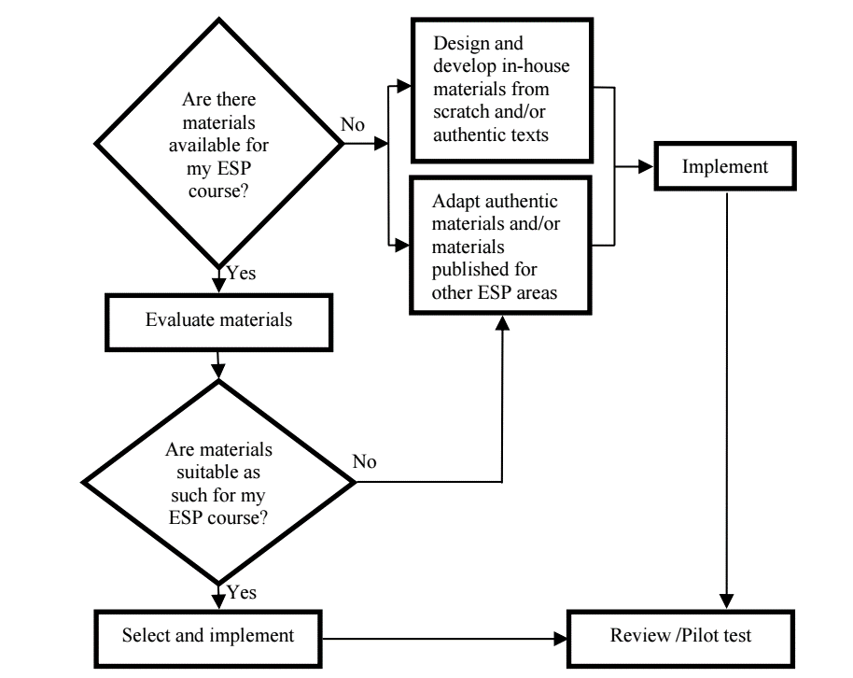

Figure 1. Flowchart on the process of ESP materials development

Materials evaluation is essential in ESP, particularly at the tertiary level, where no single coursebook is used comprehensively. Unlike primary and secondary education, ESP practitioners often select, combine, and supplement materials from various sources to meet course-specific needs. **Evaluation involves assessing materials for their relevance, methodology, and content within a particular context.** While there is no universal framework for evaluation, methods like checklists, interviews, and observations help identify gaps and assess suitability. Notable scholars such as Hutchinson, Littlejohn, and Tomlinson provide comprehensive guidelines and criteria for evaluation, offering valuable insights into aligning materials with course objectives.

* **Specialized Frameworks for ESP Materials Evaluation**

ESP evaluation frameworks have evolved to address the diverse needs of specific disciplines. For example, Pritchard’s (2004) in-depth evaluation of Maritime English materials provides a systematic and credible approach for evaluating ESP resources. Chan (2009) developed a topic-specific checklist for Business English that bridges pedagogical considerations with specialized discourse. Her model categorizes issues like contextualization and learner autonomy while emphasizing the importance of research-based analysis. These specialized frameworks highlight the importance of tailoring evaluation methods to distinct ESP disciplines for greater relevance and effectiveness.

* **The Cyclical Nature of Materials Evaluation**

Materials evaluation is a dynamic and cyclical process that adjusts to course needs and classroom realities. It encompasses different perspectives—prospective, ongoing, and retrospective—while addressing both external (general content) and internal (specific classroom use) dimensions. Pilot testing, or trailing materials, is a crucial step in identifying mismatches between course aims and materials, enabling corrective measures to improve effectiveness. This iterative process ensures that materials remain aligned with learners’ needs and evolving course objectives.

* **Incorporating Feedback in Evaluation**

Feedback from subject-matter experts and learners is invaluable in materials evaluation. Colleagues with domain expertise can provide insights into the relevance of topics and activities, while learners offer practical perspectives on usability and effectiveness. Engaging both groups enhances the alignment between carrier content (subject matter) and real content (specific language), ensuring that materials meet the dual demands of language learning and professional application. Such collaborative input strengthens the overall evaluation process and its outcomes.

**2. Definition and Context of In-House Materials**

In-house materials, also known as tailor-made or locally produced materials, are resources developed by teachers for specific courses, students, and contexts. These materials may be created from scratch or adapted from existing materials and authentic texts. Adaptation involves making changes such as reducing, adding, or modifying content to better suit learners' needs (Tomlinson, 1998). Despite their significance, in-house materials remain under-researched, with limited frameworks available for their development. However, literature from scholars like Dudley-Evans and Tomlinson offers useful guidelines for ESP practitioners.

ESP practitioners often create in-house materials to address gaps in published resources. These materials allow practitioners to adjust difficulty levels, highlight discourse conventions, and cater to diverse learning styles. Additionally, in-house materials help align teaching with institutional or regional demands.

Effective in-house materials balance language, skills, and informative content while aligning with course objectives. They should be adaptable, recyclable, and set in a memorable context. Good materials stimulate interaction, and meet authenticity standards. They also help practitioners refine their teaching style and offer professionally presented content, ensuring a lasting impact on learners.

**3. The Role of the ESP Practitioner in Materials Development**

The responsibilities of ESP practitioners extend beyond teaching to include the development and evaluation of learning materials. Unlike EFL/ESL teachers, who may rely more heavily on published resources, ESP practitioners are expected to tailor materials to meet learners' specific professional needs. This includes staying updated with innovations in the target discipline and incorporating specialized knowledge into their teaching. While effective ESP teaching does not necessarily require expertise in material design, being a good provider of materials is a critical aspect of the role.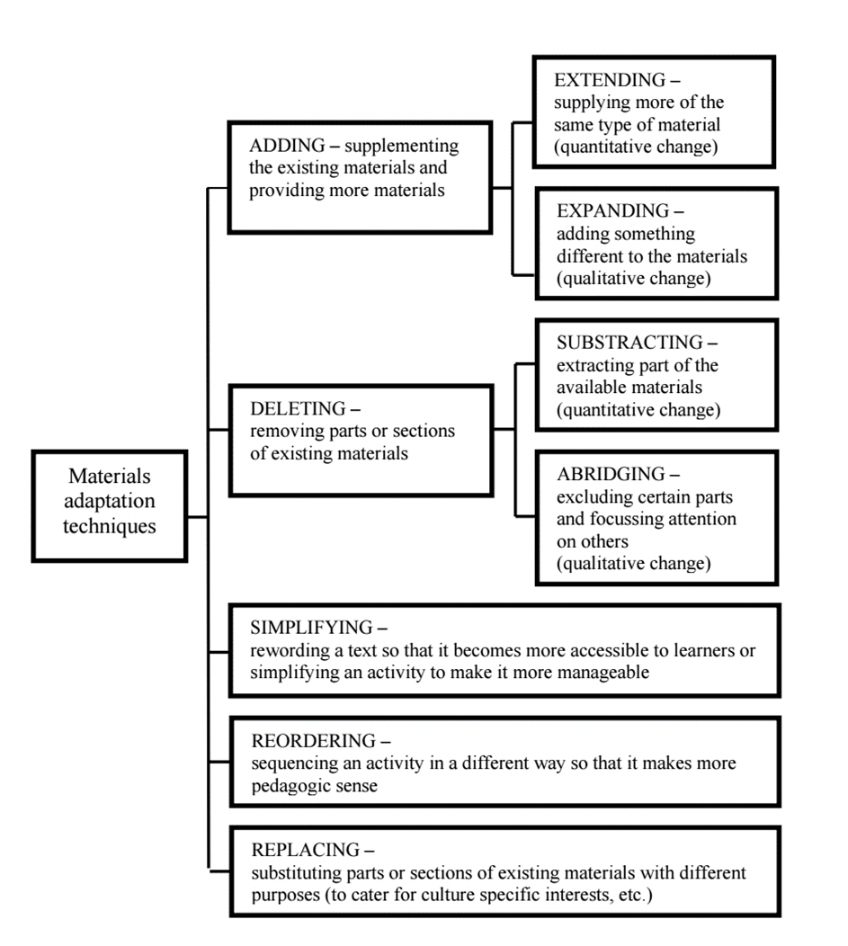

Figure 2. Techniques for adapting materials (based on Islam and Mares, 2003, pp. 91-92)

* **Challenges in Materials Development**

ESP practitioners face significant challenges due to the complexity of modern teaching materials. The increasing availability of resources, such as the internet, demands higher levels of digital literacy and the ability to identify and adapt authentic materials effectively. These expectations create additional pressures on practitioners, who must balance teaching duties with material development.

**4. Steps in Evaluating Materials**  
The evaluation process involves several systematic steps to ensure the chosen materials meet the course’s requirements. According to Hutchinson & Waters (1987), material evaluation consists of four major stages:

1. **Defining Criteria**: Establishing clear criteria for what is needed in the materials.
2. **Subjective Analysis**: Assessing the materials based on personal or intuitive judgments.
3. **Objective Analysis**: Conducting a more systematic analysis, focusing on how well the materials align with the established needs and criteria.
4. **Matching**: Comparing the criteria and subjective analysis to ensure that the selected materials align with the learners' needs and the course goals.

It’s essential for teachers to ensure that subjectivity does not overly influence the initial stages of analysis to avoid overlooking possible alternatives that might better suit the learners’ needs.

**5. Adopt, Adapt, or Write Your Own Materials**  
In ESP, teachers may choose from three approaches to develop materials: adopting existing materials, adapting them, or writing new ones from scratch. Adopting materials may be the easiest option, but often materials need to be adapted to meet specific learner needs. Adapting existing materials allows teachers to modify content to suit the learners' language level, context, and discipline. Writing new materials requires significant time and experience, and although it offers the advantage of being tailored to the learners’ needs, it is often more time-consuming and may not be as effective as using well-established materials.

* **Materials Design Process**

Materials design in ESP often involves creating or adapting content that reflects the specific subject knowledge of the learners. The process includes defining clear objectives for the materials, ensuring they are relevant to the learners’ academic or professional needs. A typical materials design model includes input (e.g., texts, videos), content focus (language as a means to convey information), language focus (studying and practicing language use), and task (using the knowledge in practical applications). This model ensures a coherent and comprehensive learning experience, where each