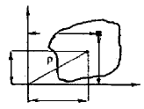

***x***

***x***

***dA***

***y***

***y***

***yG***

***xG***

***G***

1. **Center of Gravity**

The coordinates of the centre of gravity, or centroid, of the area ***A*** located in the plane (*x, y*), if ***dA*** is the area of ​​an element (Fig.1), the total area of ​​the figure is given by the following integral:

Figure 1

 (1)

The coordinates of the centreof gravity of area *A* can be determined from the following relationship:

 (2)

Where : is called the first moment of inertia of section *A* in respect to *y* axis . (Similarly for *Sx*)

***Note*** : knowledge of *Sx* and *Sy* allows us to quickly determine the position of the centre of gravity of the plane section.

1. **Moment of Inertia**

**2.1 Area Moment of** **Inertia or Second moment of area**

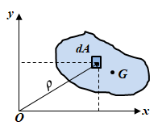The aria moment of inertia, or simply the moment of inertia of a plane surface, is a geometric characteristic defined by:

(3)

**2.2 Product of inertia**

The product of the inertia of area *A* with respect to the *x* and *y* axis is defined as

Figure 2

(4)

Where*x* and *y*are the distances from the elementary area***dA***to the axes.

***Note*** : The product of inertia can be positive, negative or in a special case zero (when it is calculated with respect to an axis of symmetry).

To find the moment of inertia of the differential area about the pole (point of origin) or z-axis, the perpendiculardistance (**ρ**) from the pole to *dA* is used.For the entire area:

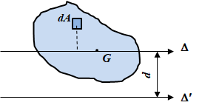 (5)

From Figure 2 : ; one finds

1. **Theorem of parallel axes**

The axis Δpasses through the centre of gravity of the plane surface given in Figure 3. The parallel axes theorem states that the moment of inertia about an axis Δ′paralleltoΔ is given by:

Figure 3

(6)

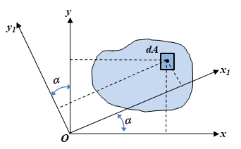This is actually Huygens' theorem. *A* is the area of ​​the given surface, *d* the distance between the two parallel axes.

1. **Expression des moments d’inertie pour une rotation des axes de coordonnées**

Knowing the moments of inertia with respect to the *x-y* axes, we seek to determine the expressions of the moments with respect to the *Ox*1*y*1 axis system.It is shown that:

Figure 4



 (7)



**4.1 Principalaxes and principal moments ofinertia**

Depending on the orientation angle ***α***, there is a position where the moments of inertia ***Ix*** and ***Iy*** take extreme values ​​(max or min). The following procedure allows us to determine the maximum of ***Ix***:

Then :



Whichgives:



By substituting the value of *α*and after trigonometric transformation, we obtain:

(8)

1. **Applications**
2. For the of plane areasshown in figure 5, find the centroid. Also determine its moment of inertia about both centroidal parallel to *x* and *y*.

|  |  |
| --- | --- |
|  |  |
|  |  |

**Figure 5**

|  |  |  |
| --- | --- | --- |
|  |  |  |
|  |  |  |
|  |  | |

1. **Caractéristiques géométriques de quelques sections planes usuelles**

|  |  |  |  |  |  |
| --- | --- | --- | --- | --- | --- |
| **Forme** | **Aire** | **Centre de Gravité** | **Moments d’inertie** | | |
| ***Ix*** | ***Iy*** | ***Ip*** |
|  | ***b.h*** | (*0,0*) |  |  |  |
|  | ***a2*** | (*0,0*) |  |  |  |
|  |  | (*0,0*) |  |  |  |
|  |  | (*0,0*) |  |  |  |
|  |  |  |  |  |  |
|  |  |  |  |  |  |