CODE SWITCHING: Identify the type of code switching for each of the examples below

Example 1:

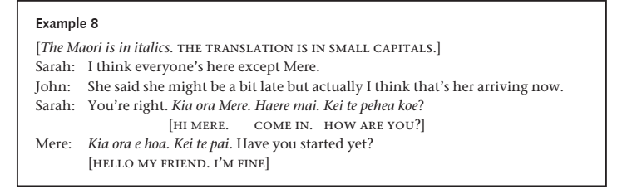

Example 2:



Example 3:

