مثال تطبيقي حول استقرارية بعض المتغيرات الاقتصادية
1-استقرارية السلاسل الأصلية
أولا: التمثيل البياني لدوال الارتباط الذاتي والجزئي
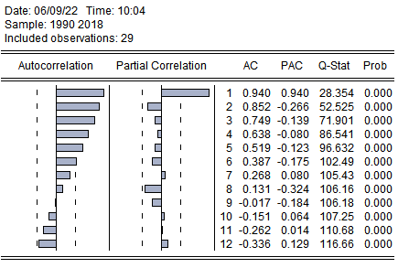
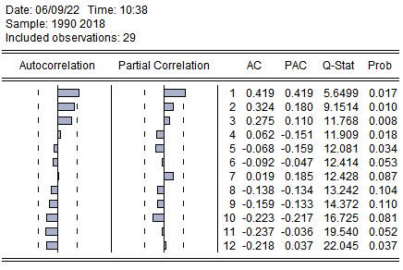
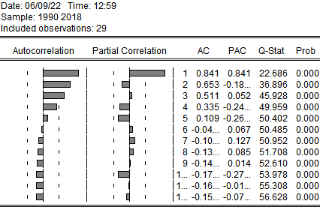
ثانيا: اختبار ديكي فولر المطور
سلسلة متغير البطالة ch
النموذج3
Null Hypothesis: CH has a unit root
Exogenous: Constant, Linear Trend
Lag Length: 0 (Automatic - based on SIC, maxlag=6)
 |  |  | t-Statistic | Prob.*
Augmented Dickey-Fuller test statistic |  |  | -2.385866 | 0.3783
Test critical values: | 1% level |  | -4.323979
 | 5% level |  | -3.580623
 | 10% level |  | -3.225334
*MacKinnon (1996) one-sided p-values.
Augmented Dickey-Fuller Test Equation
Dependent Variable: D(CH)
Method: Least Squares
Date: 06/09/22 Time: 10:27
Sample (adjusted): 1991 2018
Included observations: 28 after adjustments
Variable | Coefficient | Std. Error | t-Statistic | Prob.
CH(-1) | -0.214020 | 0.089703 | -2.385866 | 0.0249
C | 6.971928 | 2.842589 | 2.452669 | 0.0215
@TREND("1990") | -0.224871 | 0.086158 | -2.609987 | 0.0151

سلسلة متغير النمو القتصادي GDP
النموذج 3
Null Hypothesis: GDP has a unit root
Exogenous : Constant, Linear Trend
Lag Length: 0 (Automatic – based on SIC, maxlag=6)
 |  |  | t-Statistic | Prob.*
Augmented Dickey-Fuller test statistic |  |  | -3.164058 | 0.1119
Test critical values : | 1% level |  | -4.323979
 | 5% level |  | -3.580623
 | 10% level |  | -3.225334
*MacKinnon (1996) one-sided p-values.
Augmented Dickey-Fuller Test Equation
Dependent Variable : D(GDP)
Method : Least Squares
Date : 06/09/22 Time : 12 :00
Sample (adjusted) : 1991 2018
Included observations : 28 after adjustments
Variable | Coefficient | Std. Error | t-Statistic | Prob.
GDP(-1) | -0.600783 | 0.189878 | -3.164058 | 0.0041
C | 1.387598 | 0.813461 | 1.705796 | 0.1004
@TREND(« 1990 ») | 0.022388 | 0.048296 | 0.463547 | 0.6470

النموذج 2
Null Hypothesis: GDP has a unit root
Exogenous: Constant
Lag Length: 0 (Automatic - based on SIC, maxlag=6)
 |  |  | t-Statistic | Prob.*
Augmented Dickey-Fuller test statistic |  |  | -3.243200 | 0.0279
Test critical values: | 1% level |  | -3.689194
 | 5% level |  | -2.971853
 | 10% level |  | -2.625121
*MacKinnon (1996) one-sided p-values.
Augmented Dickey-Fuller Test Equation
Dependent Variable: D(GDP)
Method: Least Squares
Date: 06/09/22 Time: 13:36
Sample (adjusted): 1991 2018
Included observations: 28 after adjustments
Variable | Coefficient | Std. Error | t-Statistic | Prob.
GDP(-1) | -0.571227 | 0.176131 | -3.243200 | 0.0032
C | 1.628511 | 0.616269 | 2.642534 | 0.0138
سلسلة متغير االتضخم INF
النموذج 3
Null Hypothesis: INF has a unit root
Exogenous: Constant, Linear Trend
Lag Length: 0 (Automatic - based on SIC, maxlag=6)
 |  |  | t-Statistic | Prob.*
Augmented Dickey-Fuller test statistic |  |  | -1.825803 | 0.6650
Test critical values: | 1% level |  | -4.323979
 | 5% level |  | -3.580623
 | 10% level |  | -3.225334
*MacKinnon (1996) one-sided p-values.
Augmented Dickey-Fuller Test Equation
Dependent Variable: D(INF)
Method: Least Squares
Date: 06/09/22 Time: 12:04
Sample (adjusted): 1991 2018
Included observations: 28 after adjustments
Variable | Coefficient | Std. Error | t-Statistic | Prob.
INF(-1) | -0.244160 | 0.133728 | -1.825803 | 0.0798
C | 4.207949 | 3.353250 | 1.254887 | 0.2211
@TREND("1990") | -0.165523 | 0.156380 | -1.058466 | 0.3000

نموذج 2
Null Hypothesis: INF has a unit root
Exogenous: Constant
Lag Length: 0 (Automatic - based on SIC, maxlag=6)
 |  |  | t-Statistic | Prob.*
Augmented Dickey-Fuller test statistic |  |  | -1.496436 | 0.5207
Test critical values: | 1% level |  | -3.689194
 | 5% level |  | -2.971853
 | 10% level |  | -2.625121
*MacKinnon (1996) one-sided p-values.
Augmented Dickey-Fuller Test Equation
Dependent Variable: D(INF)
Method: Least Squares
Date: 06/09/22 Time: 13:43
Sample (adjusted): 1991 2018
Included observations: 28 after adjustments
Variable | Coefficient | Std. Error | t-Statistic | Prob.
INF(-1) | -0.150959 | 0.100879 | -1.496436 | 0.1466
C | 0.948950 | 1.331281 | 0.712809 | 0.4823
النموذج 1
Null Hypothesis: INF has a unit root
Exogenous: None
Lag Length: 0 (Automatic - based on SIC, maxlag=6)
 |  |  | t-Statistic | Prob.*
Augmented Dickey-Fuller test statistic |  |  | -1.408092 | 0.1447
Test critical values: | 1% level |  | -2.650145
 | 5% level |  | -1.953381
 | 10% level |  | -1.609798

استقرارية السلاسل بعد الفرق الاول
أولا: التمثيل البياني لدوال الارتباط الذاتي والجزئي
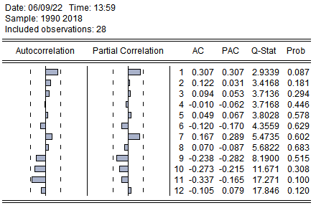
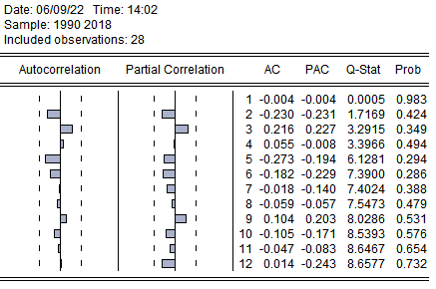

ثانيا: اختبار ديكي فولر المطور
سلسلة متغير البطالة عند الفرق الأول DCH
النموذج 3
Null Hypothesis: DCH has a unit root
Exogenous: Constant, Linear Trend
Lag Length: 0 (Automatic - based on SIC, maxlag=6)
 |  |  | t-Statistic | Prob.*
Augmented Dickey-Fuller test statistic |  |  | -3.647957 | 0.0442
Test critical values: | 1% level |  | -4.339330
 | 5% level |  | -3.587527
 | 10% level |  | -3.229230
*MacKinnon (1996) one-sided p-values.
Augmented Dickey-Fuller Test Equation
Dependent Variable: D(DCH)
Method: Least Squares
Date: 06/09/22 Time: 14:07
Sample (adjusted): 1992 2018
Included observations: 27 after adjustments
Variable | Coefficient | Std. Error | t-Statistic | Prob.
DCH(-1) | -0.718687 | 0.197011 | -3.647957 | 0.0013
C | 0.228886 | 0.955736 | 0.239486 | 0.8128
@TREND("1990") | -0.033826 | 0.057535 | -0.587924 | 0.5621

النموذج 2
Null Hypothesis: DCH has a unit root
Exogenous: Constant
Lag Length: 0 (Automatic - based on SIC, maxlag=6)
 |  |  | t-Statistic | Prob.*
Augmented Dickey-Fuller test statistic |  |  | -3.656347 | 0.0111
Test critical values: | 1% level |  | -3.699871
 | 5% level |  | -2.976263
 | 10% level |  | -2.627420
*MacKinnon (1996) one-sided p-values.
Augmented Dickey-Fuller Test Equation
Dependent Variable: D(DCH)
Method: Least Squares
Date: 06/09/22 Time: 14:09
Sample (adjusted): 1992 2018
Included observations: 27 after adjustments
Variable | Coefficient | Std. Error | t-Statistic | Prob.
DCH(-1) | -0.692632 | 0.189433 | -3.656347 | 0.0012
C | -0.269378 | 0.435971 | -0.617881 | 0.5422
النموذج 1
Null Hypothesis: DCH has a unit root
Exogenous: None
Lag Length: 0 (Automatic - based on SIC, maxlag=6)
 |  |  | t-Statistic | Prob.*
Augmented Dickey-Fuller test statistic |  |  | -3.647928 | 0.0007
Test critical values: | 1% level |  | -2.653401
 | 5% level |  | -1.953858
 | 10% level |  | -1.609571

