Research Question
A research question is a question that a study or research project aims to answer. This question often addresses an issue or a problem, which, through analysis and interpretation of data, is answered in the study’s conclusion. In most studies, the research question is written so that it outlines various aspects of the study, including the population and variables to be studied and the problem the study addresses.
As their name implies, a research question is often grounded on research. As a result, these questions are dynamic; this means researchers can change or refine the research question as they review related literature and develop a framework for the study. While many research projects will focus on a single research question, larger studies often use more than one research question.
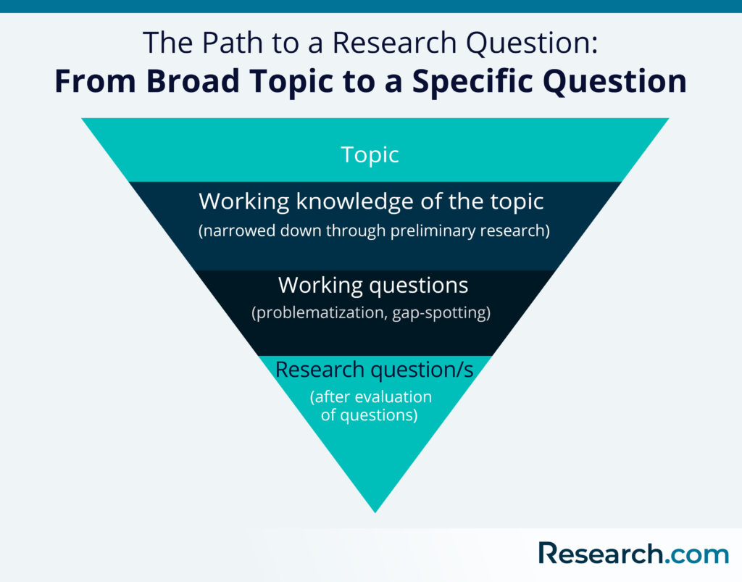

Importance of the research question
The primary importance of framing the research question is that it narrows down a broad topic of interest into a specific area of study (Creswell, 2014). Research questions, along with hypotheses, also serve as a guiding framework for research. These questions also specifically reveal the boundaries of the study, setting its limits, and ensuring cohesion.
Moreover, the research question has a domino effect on the rest of the study. These questions influence factors, such as the research methodology, sample size, data collection, and data analysis (Lipowski, 2008).

Steps to Developing a Good Research Question
Before learning how to write a research paper, you must first learn how to create a research question. Broadly, a good research question should be relevant, decided, and meaningful (Stone, 2002). Creating a research question can be a tricky process, but there is a specific method you can follow to ease the process. The steps to this method are outlined below:

1. Start with a broad topic.
A broad topic provides writers with plenty of avenues to explore in their search for a viable research question. Techniques to help you develop a topic into subtopics and potential research questions include brainstorming and concept mapping. For example, you can raise thought-provoking questions with your friends and flesh out ideas from your discussions. These techniques can organize your thoughts so you can identify connections and relevant themes within a broad topic.
When searching for a topic, it’s wise to choose an area of study that you are genuinely interested in, since your interest in a topic will affect your motivation levels throughout your research. It’s also wise to consider the interests being addressed recently by the research community, as this may affect your paper’s chances of getting published.

2. Do preliminary research to learn about topical issues.
Once you have picked a topic, you can start doing preliminary research. This initial stage of research accomplishes two goals. First, a preliminary review of related literature allows you to discover issues that are currently being discussed by scholars and fellow researchers. This way, you get up-to-date, relevant knowledge on your topic.
Second, a preliminary review of related literature allows you to spot existing gaps or limitations in existing knowledge of your topic. With a certain amount of fine-tuning, you can later use these gaps as the focus of your research question.
Moreover, according to Farrugia et al. (2010), certain institutions that provide grants encourage applicants to conduct a systematic review of available studies and evidence to see if a similar, recent study doesn’t already exist, before applying for a grant.

3. Narrow down your topic and determine potential research questions.
Once you have gathered enough knowledge on the topic you want to pursue, you can start focusing on a more specific area of study. One option is to focus on gaps in existing knowledge or recent literature. Referred to by Sandberg and Alvesson (2011) as “gap-spotting,” this method involves constructing research questions out of identified limitations in literature and overlooked areas of study. Similarly, researchers can choose research questions that extend or complement the findings of existing literature.
Another way of identifying and constructing research questions: problematization (Sandberg & Alvesson, 2011). As a methodology for constructing research questions, problematization aims to challenge and scrutinize assumptions that support others’ and the researcher’s theoretical position. This means constructing research questions that challenge your views or knowledge of the area of study.
Lipowski (2008), on the other hand, emphasizes the importance of taking into consideration the researcher’s personal experiences in the process of developing a research question. Researchers who are also practitioners, for instance, can reflect on problematic areas of their practice. Patterns and trends in practice may also provide new insights and potential ideas for research questions.

4. Evaluate the soundness of your research question.
Your initial research and review of related literature will have produced some interesting questions that seem like they’re worth pursuing. However, not all interesting questions make for sound research questions. Keep in mind that a research question draws its answer or conclusion through an analysis of evidence.
Hulley et al. (2007) suggest using a set of criteria- known as the “FINER” criteria-to find out if you have a good research question. The FINER criteria are outlined below:
F.Feasible
A good research question is feasible, which means that the question is well within the researcher’s ability to investigate. Researchers should be realistic about the scale of their research as well as their ability to collect data and complete the research with their skills and the resources available to them. It’s also wise to have a contingency plan in place in case problems arise.
I.Interesting
The ideal research question is interesting not only to the researcher but also to their peers and community. This interest boosts the researcher’s motivation to see the question answered. For instance, you can do research on student housing trends if it is right up your alley, as they do change often.
N.Novel
Your research question should be developed to bring new insights to the field of study you are investigating. The question may confirm or extend previous findings on the topic you are researching, for instance.
E.Ethical
This is one of the more important considerations of making a research question. Your research question and your subsequent study must be something that review boards and the appropriate authorities will approve.
R.Relevant
Aside from being interesting and novel, the research question should be relevant to the scientific community and people involved in your area of study. If possible, your research question should also be relevant to the public’s interest.

5. Construct your research question properly.
Research questions should be structured properly to ensure clarity. There are a number of frameworks that you can use for properly constructing a research question. The two most commonly used frameworks are explained below.

Examples of Good and Bad Research Questions
The following research question examples can further guide researchers on properly constructing a research question.
Example no. 1
Bad: How does social media affect people’s behavior?
Good: What effect does the daily use of YouTube have on the attention span of children aged under 16?
The first research question is considered bad because of the vagueness of “social media” as a concept and the question’s lack of specificity. A good research question should be specific and focused, and its answer should be discovered through data collection and analysis. You can also hone your ability to construct well-worded and specific research questions by improving reading skills.
Example no. 2
Bad: Has there been an increase in childhood obesity in the US in the past 10 years?
Good: How have school intervention programs and parental education levels affected the rate of childhood obesity among 1st to 6th-grade students?
In the second example, the first research question is not ideal because it’s too simple, and it’s easily answerable by a “yes” or “no.” The second research question is more complicated; to answer it, the researcher must collect data, perform in-depth data analysis, and form an argument that leads to further discussion.

Important Points to Keep in Mind in Creating a Research Question
Developing the right research question is a critical first step in the research process. The key points outlined below should help researchers in the pursuit:
- The development of a research question is an iterative process that involves continuously updating one’s knowledge on the topic and refining ideas at all stages (Maxwell, 2013).
- Remain updated on current trends, state-of-the-art research studies, and technological advances in the field of study you are pursuing.
- Make the research question as specific and concise as possible to ensure clarity. Avoid using words or terms that don’t add to the meaning of the research question.
- Aside from doing a literature review, seek the input of experts in the field, mentors, and colleagues. Such inputs can prove beneficial not only for the research question but also for creating the rest of the study.
Steps to developing a research question:
- Choose an interesting general topic. Most professional researchers focus on topics they are genuinely interested in studying. Writers should choose a broad topic about which they genuinely would like to know more. An example of a general topic might be “Slavery in the American South” or “Films of the 1930s.”
- Do some preliminary research on your general topic. Do a few quick searches in current periodicals and journals on your topic to see what’s already been done and to help you narrow your focus. What issues are scholars and researchers discussing, when it comes to your topic? What questions occur to you as you read these articles?
- Consider your audience. For most college papers, your audience will be academic, but always keep your audience in mind when narrowing your topic and developing your question. Would that particular audience be interested in the question you are developing?
- Start asking questions. Taking into consideration all of the above, start asking yourself open-ended “how” and “why” questions about your general topic. For
- example, “Why were slave narratives effective tools in working toward the abolishment of slavery?” or “How did the films of the 1930s reflect or respond to the conditions of the Great Depression?”
- Evaluate your question. After you’ve put a question or even a couple of questions down on paper, evaluate these questions to determine whether they would be effective research questions or whether they need more revising and refining.
  - Is your research question clear? With so much research available on any given topic, research questions must be as clear as possible in order to be effective in helping the writer direct his or her research.
  - Is your research question focused? Research questions must be specific enough to be well covered in the space available.
  - Is your research question complex? Research questions should not be answerable with a simple “yes” or “no” or by easily-found facts. They should, instead, require both research and analysis on the part of the writer. They often begin with “How” or “Why.”

How to write a research question
You can follow these steps to develop a strong research question:
- Choose your topic
- Do some preliminary reading about the current state of the field
- Narrow your focus to a specific niche
- Identify the research problem that you will address
The way you frame your question depends on what your research aims to achieve. The table below shows some examples of how you might formulate questions for different purposes.
Research objectives | Research question formulations
Describing and exploring | - What are the characteristics of X?  - How has X changed over time?  - What are the causes of X?  - How has X dealt with Y?
Explaining and testing | - What is the relationship between X and Y?  - What is the role of X in Y?  - What is the impact of X on Y?  - How does X influence Y?
Evaluating and acting | - What are the advantages and disadvantages of X?  - How effective is X?  - How can X be improved?

Using your research problem to develop your research question
Example research problem | Example research question(s)
Teachers at the school do not have the skills to recognize or properly guide gifted children in the classroom. | What practical techniques can teachers use to better identify and guide gifted children?
Young people increasingly engage in the “gig economy,” rather than traditional full-time employment. However, it is unclear why they choose to do so. | What are the main factors influencing young people’s decisions to engage in the gig economy?
Note that while most research questions can be answered with various types of research, the way you frame your question should help determine your choices.

What makes a strong research question?
Research questions anchor your whole project, so it’s important to spend some time refining them. The criteria below can help you evaluate the strength of your research question.

Focused and researchable
Criteria | Explanation
Focused on a single topic | Your central research question should work together with your research problem to keep your work focused. If you have multiple questions, they should all clearly tie back to your central aim.
Answerable using credible sources | Your question must be answerable using quantitative and/or qualitative data, or by reading scholarly sources on the topic to develop your argument. If such data is impossible to access, you likely need to rethink your question.
Not based on value judgements | Avoid subjective words like good, bad, better and worse. These do not give clear criteria for answering the question.  - Is X or Y a better policy?  - How effective are X and Y policies at reducing rates of Z?

Feasible and specific
Criteria | Explanation
Answerable within practical constraints | Make sure you have enough time and resources to do all research required to answer your question. If it seems you will not be able to gain access to the data you need, consider narrowing down your question to be more specific.
Uses specific, well-defined concepts | All the terms you use in the research question should have clear meanings. Avoid vague language, jargon, and too-broad ideas.  - What effect does social media have on people’s minds?  - What effect does daily use of Twitter have on the attention span of 16-year-olds at your local high school?
Does not demand a conclusive solution, policy, or course of action | Research is about informing, not instructing. Even if your project is focused on a practical problem, it should aim to improve understanding rather than demand a ready-made solution.  - What should the government do about low voter turnout?  - What are the most effective communication strategies for increasing voter turnout among those aged 18-30?

Complex and arguable
Criteria | Explanation
Cannot be answered with yes or no | Closed-ended, yes/no questions are too simple to work as good research questions—they don’t provide enough scope for robust investigation and discussion.  - Has there been an increase in those experiencing homelessness in the US in the past ten years?  - How have economic and political factors affected patterns of experiencing homelessness in the US over the past ten years?
Cannot be answered with easily-found facts | If you can answer the question through a single Google search, book, or article, it is probably not complex enough. A good research question requires original data, synthesis of multiple sources, and original interpretation and argumentation prior to providing an answer.

Relevant and original
Criteria | Explanation
Addresses a relevant problem | Your research question should be developed based on initial reading around your topic. It should focus on addressing a problem or gap in the existing knowledge in your field or discipline.
Contributes to a timely social or academic debate | The question should aim to contribute to an existing and current debate in your field or in society at large. It should produce knowledge that future researchers or practitioners can later build on.
Has not already been answered | You don’t have to ask something that nobody has ever thought of before, but your question should have some aspect of originality. For example, you can focus on a specific location, or explore a new angle.

