**Teaching Vocabulary**

**1.** **Definition of vocabulary:**

Vocabulary can be defined as “words we must know to communicate effectively; words in speaking (expressive vocabulary) and words in listening (receptive vocabulary)” (Neuman & Dwyer, 2009, p.385).

Richards & Schmidt (2010) defined it as “a set of LEXEMES, including single words, compound words, and idioms” (p.629).

vocabulary refers to “a list or set of words for a particular language or a list or set of words that individual speakers of language might use” (Hatch & Brown, 1995, p. 1)

Diamond & Gutlohn (2006) stated that vocabulary is the knowledge of words and word meanings

**2. Why is Vocabulary Important?**

A strong vocabulary foundation is crucial for TEFL learners for several reasons:

**Comprehension:** Large vocabulary allows students to understand spoken and written English more effectively.

**Communication:** The more words students know, the better they can express themselves and participate in conversations.

**Grammar in Context:** Understanding vocabulary helps students use grammar structures correctly in meaningful contexts.

**Academic Success:** Strong vocabulary is linked to better performance in all academic areas, not just English language learning.

**3. Types of vocabulary**

1. **Receptive Vocabulary or Passive Vocabulary:**

Redman & Gairns (1986) defined it as **“**Receptive vocabulary is the language items which can only be recognized and comprehended in the context of reading and listening material” (p. 64). Accordingly, Nation (2001) defined receptive vocabulary use as that of “perceiving the form of a word while listening or reading and retrieving its meaning” (p. 38)

**2. Productive Vocabulary or Active Vocabulary:** Alqahtani (2015) explained it by saying  
“productive vocabulary is the words that the learners understand and can pronounce correctly and use constructively in speaking and writing” (p. 25)

**4. Aspects of Knowing a Word**

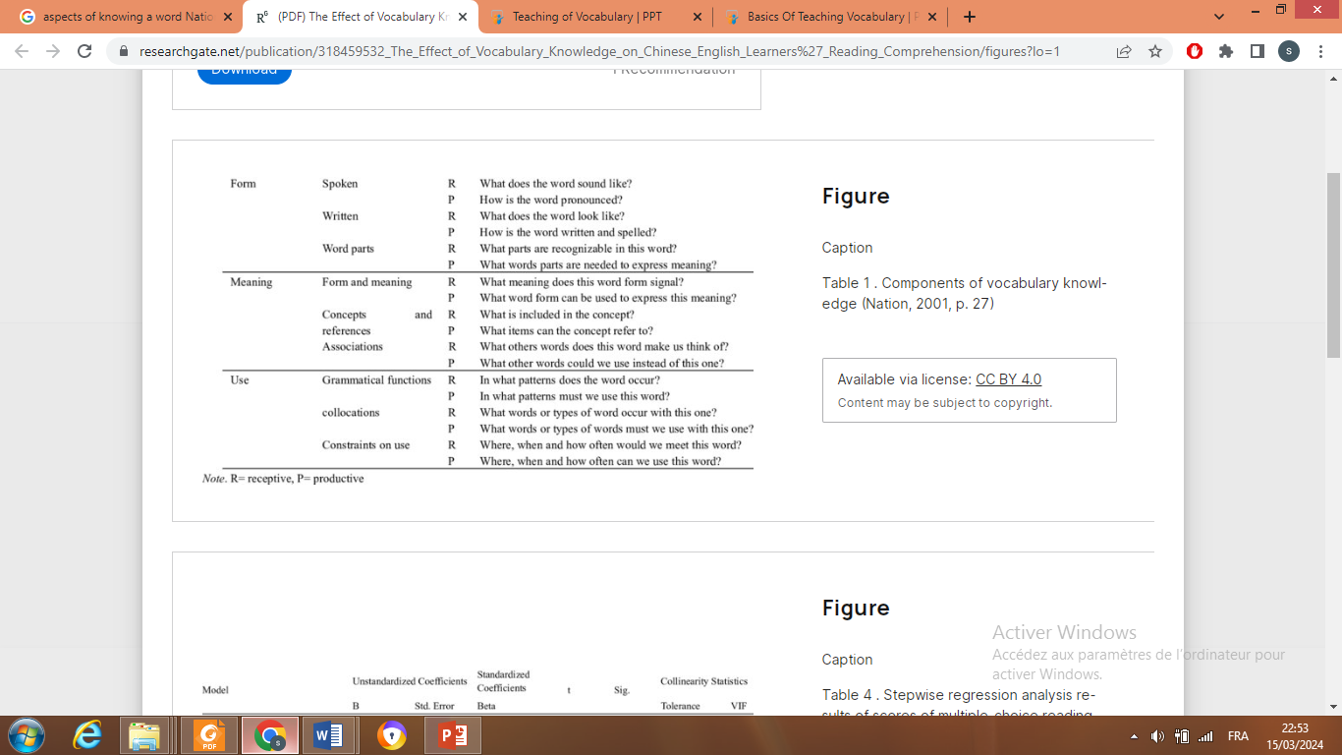

**1 Word Form**

According to Nation (2001), knowing one word form involves knowing **spoken form, written form, and word parts.**

**1. Spoken form**: It means is the ability to know what the word sounds like in a continuous speech on a receptive dimension, as well as the ability to pronounce that words clearly in a connected speech, the productive side.

**2. Written form:** it is the spelling form of the word. When acquiring new items, EFL learners are supposed to know what the word looks like; which is the receptive knowledge, and how the word is written and spelled; which is the productive one. Therefore, EFL learners should be able not only to pronounce words, but also to write them correctly.

3. **Word parts**, such as prefixes, roots, suffixes, and word family, are some parts that may  
constitute a particular vocabulary item. Thus, EFL learners should be aware of these parts that can build words and that are also needed to convey the meaning; i.e. these parts can make different changes in words’ meanings by adding or omitting a specific part.

**2/ Word Meaning**Acquiring the form of vocabulary items is important, but not sufficient; its meaning also plays  
a crucial role in recognizing it and this point should also be recognized. The word meaning aspect underlies three sub-aspects: **form and meaning, concepts and referents, and associations.**

**1 Form and Meaning** : it is generally known that learners relate words forms with their meanings. For example, if learners are aware of the past tense structure and that the past tense  
signals events in the past, they would be able to grasp the meaning.

**2 Concepts and Referent** : In addition, meaning consists of a relationship between a word and its referent. The latter represents the person, thing, action, condition, or case whether in real or in imaginary world. For instance, the word giraffe refers to the spotted animal with a very long neck in Africa (Schmitt, 2000).

**3 Word Associations**Finally, knowing a word involves knowing word associations. Schmitt (2000) claimed that  
words do not exist in isolation, and that they are related to each other in various ways. Word  
associations, therefore, are the mental relationships that relate a word with another. In other words, when a word is provided to a learner, some other related words come to mind.

**3/ Word Use**

Knowing the form and the meaning of a word is not sufficient to acquire new vocabulary items. Nation (2001) noted that word use is one aspect of word knowledge that consists of knowing the grammatical functions, the collocation, and the different constraints of word use.

The grammatical function of a word includes word classes such as verbs, nouns, adjectives and the various classes, as well as the grammatical patterns in which a word typically occur.

**2. Collocations**Word knowledge is to know the words that usually collocate with it.

**5. Should vocabulary be taught?**

Although vocabulary-learning importance has been recognized by many scholars, still, according to Milton (2009), vocabulary learning and vocabulary teaching receive less attention than they deserve (p. 1). One reason is the persistent belief among learners and  
teachers that a learner can learn a new language and manage to use it to a great extent even though their vocabulary is very limited. Another belief, he mentioned, is that vocabulary is learnt implicitly, making it superfluous in teaching.

Takač, (2008) said that the naturalistic approach to language teaching, for example, favored implicit vocabulary learning. The emphasis was on guessing the meaning from context and using monolingual dictionaries; whereas, defining and translating lexical items were to be avoided.But, with time educators such as Sökmen (1997) figured out that implicit incidental learning seems to be a slow and inefficient process which does not necessarily imply long term retention.

It has become apparent that vocabulary acquisition cannot rely on implicit incidental learning, but needs to be controlled. The advocates of this view have begun to insist on more intensive, explicit vocabulary teaching from the very beginning of any language learning syllabus

However, the contribution and effect of explicit vocabulary teaching on vocabulary seems to be under dispute since learners do not learn everything they have been taught. Takač (2008) also highlighted that the contemporary approach to vocabulary teaching recognizes the importance of both implicit and explicit teaching.

**6 Techniques of Teaching Vocabulary**

There are several techniques to present vocabulary. The techniques depend on some factors such as the context, time availability, and its value for the learners (Takač, 2008).

**1. Using Objects**Using this technique includes the use of real objects, visual aids, and demonstration. *real objects technique* is appropriately employed for beginners or young learners and when presenting concrete vocabulary

**Drawing**Brewster, Ellis & Girard (1992) explained this technique by saying that objects can either be  
drawn on the blackboard or on flash cards

**3 Using Illustrations and Pictures**

The list of pictures includes: posters, flashcards, wall charts, magazine pictures, board drawings, stick figures and photographs.

**4. Contrast**Some words are easily explained to learners by contrasting them with their opposite

**5. Enumeration**

One can say “clothes” and explain this by enumerating or listing various items. Teacher may list a number of clothes (e.g. a dress, a skirt, trousers …etc) and then the meaning of the word "clothes" will become clear.

**6. Eliciting**This technique is more motivating and memorable by simply giving pupils a list of words to  
learn

**7. Translation**

**7. Types of Vocabulary Learning**

**a- Incidental Vocabulary Learning:**

It is generally defined as the by-product of any activity not explicitly geared to vocabulary acquisition. It is widely believed that most vocabulary, in both first and second language, is  
acquired incidentally .e. as by-product of such receptive activities as reading and listening

**b- Intentional Vocabulary Learning**

One way to define intentional learning is by the intention of the learner. Learning words from a vocabulary list for a test would be an example of intentional vocabulary learning since the words are learned as a direct consequence of the learner's intention.