The Difference between the British Isles, UK and Great Britain
One of the most common mistakes people make when talking about geography in this country is to confuse the UK with Great Britain or the British Isles – a cardinal sin in the eyes of any true geographer!
So let’s clear this up once and for all
The British Isles
This is purely a geographical term – it refers to the group of islands situated off the north western corner of mainland Europe. Great Britain and Ireland are the two largest islands of the 5000 or so smaller islands scattered around the coasts. Remember this only refers to geography, not nationality, and while the Republic of Ireland is part of the British Isles, its people are not British – a very important distinction.
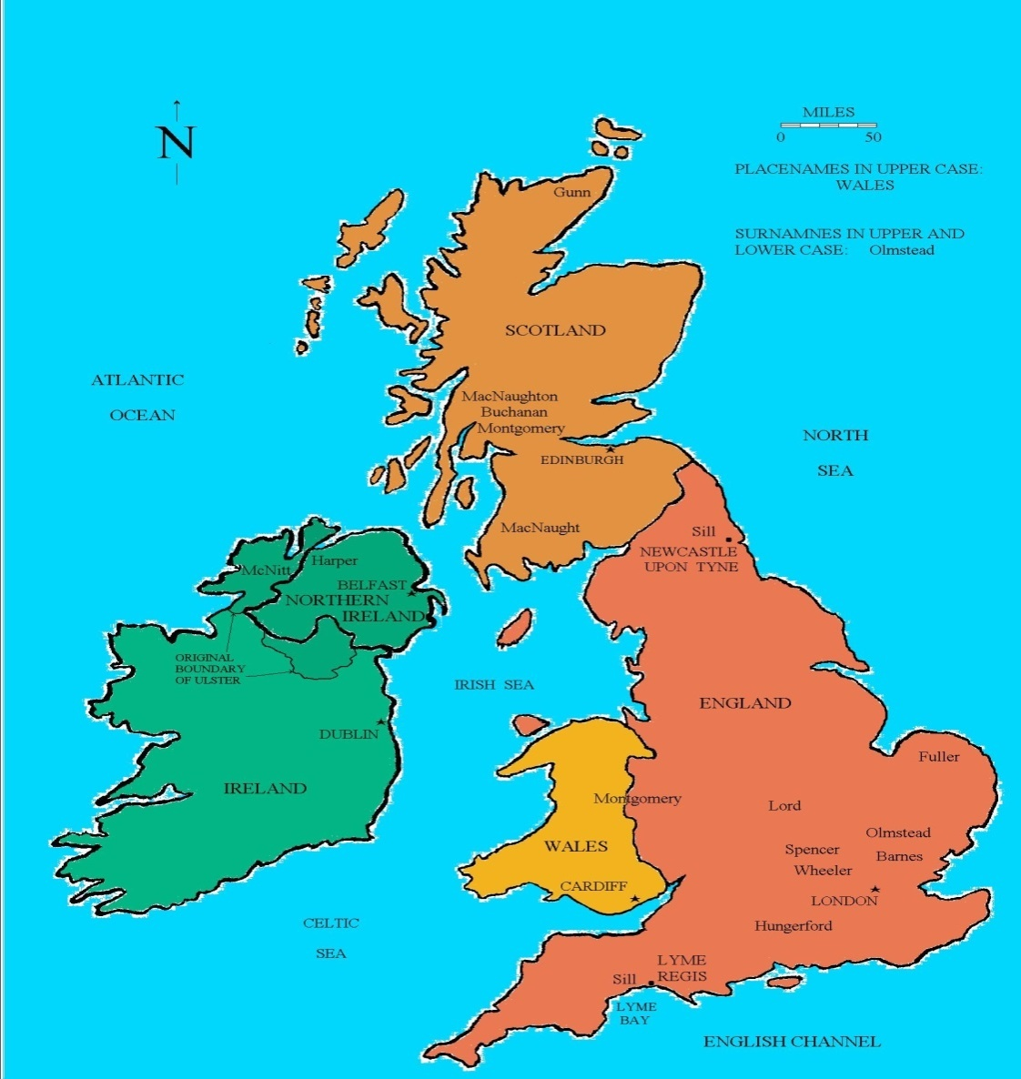

The United Kingdom (UK):

The United Kingdom of Great Britain and Northern Ireland (to give its full name) refers to the political union between England (capitalLondon), Wales (capital Cardiff), Scotland (capital Edinburgh) and Northern Ireland (capital Belfast). The UK is a sovereign state, but the nations that make it up are also countries in their own right.
The UK is short for The United Kingdom of Great Britain and Northern Ireland. It is a sovereign state (in the same way as Algeria or the USA) but is made up of four countries; England, Scotland, Wales and Northern Ireland.
There is a long and complicated history that follows the formation of the United Kingdom, but here are the highlights:
c. 925 – The Kingdom of England. Established by the unification of Anglo-Saxon tribes across modern day England.
1536 – Kingdom of England and Wales. A bill enacted by King Henry VIII which effectively made England and Wales the same country, governed by the same laws.
1707 – Kingdom of Great Britain. The Kingdom of England (which includes Wales) joined with the Kingdom of Scotland to form The Kingdom of Great Britain.
1801– United Kingdom of Great Britain and Ireland. Ireland joins the union, and once again the name changes.
1922 – United Kingdom of Great Britain and Northern Ireland. The Republic of Ireland (Eire, or ‘Southern Ireland’) became an independent state(capital Dublin) and withdrew from the union, leaving just the northern counties of Ireland. This is the UK that remains to this day.

Great Britain:

Great Britain, the largest island which consists of England, Scotland and Wales and their associated islands. It does not include Northern Ireland and therefore should never be used interchangeably with ‘UK’ – something you see all too often.
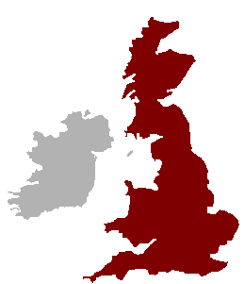
Great Britain, therefore, is a geographic term referring to the island also known simply as Britain. It’s also a political term for the part of the United Kingdom made up of England, Scotland, and Wales (including the outlying islands that they administer, such as the Isle of Wight). United Kingdom, on the other hand, is purely a political term: it’s the independent country that encompasses all of Great Britain and the region now called Northern Ireland.

England
Just like Wales and Scotland, England is commonly referred to as a country but it is not a sovereign state. It is the largest country within the UK both by land and population. Its capital London also happens to be the capital of the UK.

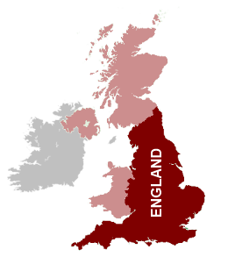
So there you have it! If you are still a bit confused over the differenced, here’s a quick summary:
The British Isles:a collection of over 5,000 islands, of which Great Britain is the largest.

The UK: a sovereign state that include England, Scotland, Wales and Northern Ireland.
Great Britain: the largest island situated off the northwestern coast of Europe.

Ireland: the other large island situated west of Great Britain.

Physical Geography of Britain
Population
Over 80 per cent of Britain’s inhabitants live in England. Around a third squeeze themselves into the south-eastern corner of England, and a snug 20 per cent or so live in or around London. As a whole, England has a population density of 984 sq/mile (380 sq/km) (three times the EU average); Scotland’s is around 168 sq/mile (65 per sq/km) (one of Europe’s lowest); Wales’ comes in at 361 sq/mile (140 persq/km); and Northern Ireland’s is 315/sq mile (122 sq/km). Slowly,Britain’s predominantly urban population (four out of five people live in towns and cities) is seeping out to rural areas, reversing the migratory trends of the 19th and early to mid-20thcenturies. Cultural differences between town and country still occurs: ‘townies’ are rude and self-important; rural folk are unsophisticated bumpkins (these are the stereotypes).
The Climate
Britain’s climate can be a disappointingly tepid affair.It’s often cited as unpredictable, and it is – rain andsun come in quick succession-. As an island lodgedin the Gulf Stream’s mild westerly flow, Britain iswarmer than its northerly latitude would otherwiseallow. It never gets painfully cold (winter temps rarelydrop below minus ten Celsius), nor does it becometruly hot (anything over 30 degrees is a rarity). Ingeneral, the west is wetter than the east, and alsomilder in winter and cooler in summer, although thedifferences aren’t large. The further south you go themore sun you’ll see, although if you get the right Juneday in northern Scotland you can enjoy a whopping18 hours of sunshine. Upland areas, as you wouldexpect, are colder and wetter: the very tops of theScottish Highlands may retain snow throughout theyear, although this is increasingly unusual. Snow canfall anywhere in winter but rarely stays for more thana couple of days at lower levels where it inevitablyevokes media hysteria and transport chaos.
The Land
The land divides into a highland region and a lowland region. The highlands occurnorth and west of a line from the Tees River, in northern England, to the ExeRiver, in the southwest. The lowlands lie to the south and east.All, of the highland region and most of the lowland region were glaciated during thelast Ice Age. In the highlands the massive sheets of ice scoured and eroded theland, leaving rounded summits and barren rocky areas. On the lowlands they leftextensive deposits of clay, sand, gravel, and other glacial material.
Highland Britain
Highlands are the predominant features of Scotland, Northern Ireland, Wales, andwestern and northern England. Blocks of ancient hard rock, which rarely rise asmuch as 2,000 feet (600 m) above sea level, make up most of the land. In manyareas the highlands reach the sea as rocky cliffs and headlands. The highest and roughest sections are the Grampian Mountains and the NorthwestHighlands of northern Scotland. Ben Nevis, reaching 4,406 feet (1,343 m) in theGrampians, is Britain's highest peak.Rough terrain also occurs in the Cumbrian Mountains of England and the CambrianMountains of Wales. Other highland areas include the uplands of southernScotland.
Lowland Britain
Lowland Britain is largely flat to gently rolling, although there is some upland andsome long, rather sharply rising cliffs. Low-lying areas include the Midlands, the London basin, and the Vale (valley) of York. The upland areas, variouslycalled hills, downs, and wolds, include the Cotswold and Chiltern Hills, the Northland South downs, and the wolds of North Yorkshire, Humberside, and Lincoln.Rarely do elevations in these areas reach as much as 1,000 feet (300 m).
Many of the coastal areas of lowland Britain are lined with cliffs, sand and pebblebeaches, and reclaimed tidal land. At Dover, the North Downs end abruptly inmagnificent white chalk cliffs, overlooking the Strait of Dover.The entire lowland region has long been the most productive and populous part ofBritain.

