## *Section Three : Marketing Strategy And Plan*

*Why does having a Marketing Strategy matter? Having a marketing strategy matters because it helps a business define its target audience, identify the most effective channels and tactics for reaching that audience, and align marketing efforts with the overall business goals. Without a clear marketing strategy, a business may struggle to effectively reach its target audience, allocate resources effectively, and achieve its desired results.*

*A marketing plan is a blueprint that outlines your strategies to attract and convert your ideal customers as a part of your customer acquisition strategy. It’s a comprehensive document that details your:*

* ***Target audience:****Who you’re trying to reach*
* ***Marketing goals:****What you want to achieve*
* ***Strategies and tactics:****How you’ll reach your goals*
* ***Budget:****Resources you’ll allocate*
* ***Metrics:****How you’ll measure success*

## *****How to write a marketing plan*****

*As mentioned above, the scope of your marketing plan varies depending on its purpose or the type of organization it’s for.*

*For example, you could look for*[*performance marketing agency*](https://ninjapromo.io/best-performance-marketing-agencies)*to create a marketing plan that provides an overview of a company’s entire marketing strategy:*

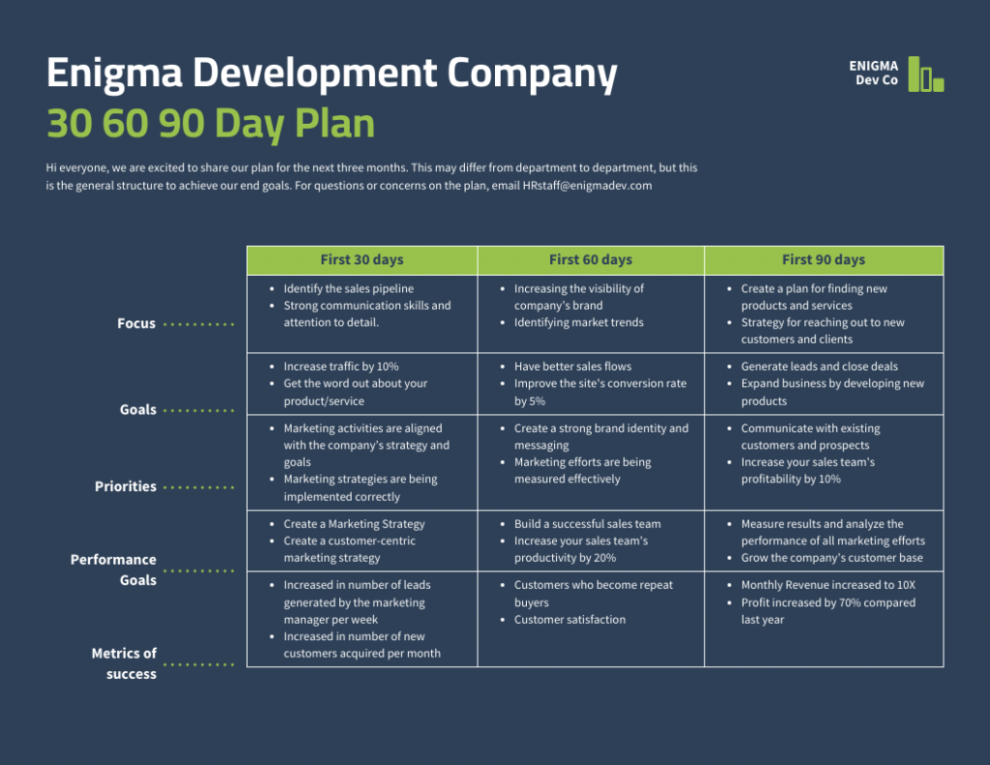

***A typical outline of a marketing plan includes:***

* *Executive summary*
* *Goals and objectives*
* *User personas*
* *Competitor analysis/SWOT analysis*
* *Baseline metrics*
* *Marketing strategy*
* *Tracking guidelines*

*Below you will see in details how to write each section as well as some examples of how you can design each section in a marketing plan.*

### *****Let’s look at how to create a successful marketing plan (click to jump ahead):*****

1. [*Write a simple executive summary*](https://venngage.com/blog/marketing-plan/#1)
2. [*Set metric-driven marketing goals*](https://venngage.com/blog/marketing-plan/#2)
3. [*Outline your user personas*](https://venngage.com/blog/marketing-plan/#3)
4. [*Research all of your competitors*](https://venngage.com/blog/marketing-plan/#4)
5. [*Set accurate key baselines & metrics*](https://venngage.com/blog/marketing-plan/#5)
6. [*Create an actionable marketing strategy*](https://venngage.com/blog/marketing-plan/#6)
7. [*Set tracking or reporting guidelines*](https://venngage.com/blog/marketing-plan/#7)