**England in America**

England and Spain had been heading toward war for years. Trading rivalry and religious differences divided the two countries. King Philip II, who ruled Spain from 1556 to 1598, was a powerful monarch and a strong defender of the Catholic faith. He wanted to put a Catholic ruler on the throne of England and bring the country back to the Catholic Church. King Philip did not consider Queen Elizabeth, a Protestant, the rightful ruler of England.

Attacks on Spanish ships and ports by such English adventurers as **Sir Francis Drake** angered Philip. He thought that Queen Eliza- beth should punish Drake for his raids. Instead, she honored Drake with a knighthood. Philip sent the Spanish Armada to conquer England— but it failed completely.

Although war between England and Spain continued until 1604, the defeat of the armada marked the end of Spanish control of the seas. Now the way was clear for England and other nations to start colonies in North America.

The Lost Colony of Roanoke

The English had made several attempts to establish a base on the other side of the Atlantic before their victory over Spain. In 1583 **Sir Humphrey Gilbert** claimed Newfoundland for Queen Elizabeth. Then he sailed south along the coast looking for a place to establish a colony. Before finding a site, he died at sea.

The following year, Queen Elizabeth gave **Sir Walter Raleigh** the right to claim land in North America. Raleigh sent an expedition to look for a good place to settle. His scouts returned with an enthusiastic report of **Roanoke Island,** off the coast of present-day North Carolina.

In 1585 Raleigh sent about 100 men to settle on Roanoke Island. After a difficult winter on the island, the unhappy colonists decided to return to England. In 1587 Raleigh tried again, sending 91 men, 17 women, and 9 children to Roanoke. **John White,** a mapmaker and artist, led the group. Shortly after arriving on the island, White’s daughter gave birth. This baby, named Virginia Dare, was the first English child born in North America. White explored the area and drew pictures of what he saw. He and other explorers described the towns of the Native Americans who lived in the area:

“Their towns are small and few . . . a village may contain but ten or twelve houses—some perhaps as many as twenty. ”

The new settlers began building a colony. They needed many supplies, however, and White sailed to England for the supplies and to

recruit more settlers. Although he had hoped to be back within a few months, the war with Spain delayed his return for nearly three years.

When White finally returned to Roanoke, he found it deserted. The only clue to the fate of the settlers was the word *Croatoan* carved on a gatepost. White thought the colonists must have gone to Croatoan Island, about 50 miles to the south. Bad weather kept White from investigating. The Roanoke colonists were never seen again.

#### Jamestown Settlement

Roanoke was Sir Walter Raleigh’s last attempt to establish a colony. For a time his failure dis- couraged others from planning English colonies in North America. However, the idea emerged again in 1606. Several groups of merchants sought **charters,** the right to organize settle- ments in an area, from King James I.

**The Virginia Company**

One group of merchants, the Virginia Com- pany of London, received a charter to “make habitation . . . into that part of America, com- monly called Virginia.” The Virginia Company was a **joint-stock company.** Investors bought stock, or part ownership, in the company in return for a share of its future profits.

The company acted quickly. In December 1606, it sent 144 settlers in 3 ships to build a new colony in North America. The settlers were sup- posed to look for gold and attempt to establish trade in fish and furs. Forty of them died during the voyage.

In April 1607, the ships entered **Chesapeake Bay** and then sailed up a river flowing into the bay. The colonists named the river the James and their new settlement **Jamestown** to honor their king. The settlers built Jamestown on a penin- sula so they could defend it from attack. The site had major drawbacks, however. The swampy land swarmed with mosquitoes that carried dis- ease. Jamestown also lacked good farmland.



80W

**The First English Settlements**

Plymouth, 1620

explored the area, and managed to get corn from the local Native Americans led by Chief Powhatan. In August 1609, 400 new settlers arrived. Two months later, John Smith returned to England. Without

MASSACHUSETTS

**Plymouth**

Cape Cod

Adults 70%

strong leadership, the colony could

not feed so many people. The winter

Susquehanna

Leni-Lenape

Wampanoag

Narraganset

Children 30%

of 1609–1610 became known as “the starving time.” Fighting broke out with the Native Americans. When more settlers arrived in the spring

*Atlantic*

Jamestown, 1607

they found only 60 survivors.

VIRGINIA

Nanticoke

*Ocean*

0 100 miles

0 100 kilometers

Powhatan

**Jamestown**

Tuscarora

*Chesapeake Bay*

Roanoke Island

Adults 96%

Children 4%

**$ Economics**

**Farming the Land**

Although the Virginia colonists did not find any gold or silver, they did discover another way to make

*Lambert Equal-Area*

*projection*

Many Native American groups lived near the first English settle- ments in the late 1500s and early 1600s.

1. **Location** Which colony was located farthest north?
2. **Location** Which Native American groups lived nearest to the Jamestown colonists?

The colonists faced more hardships over the next several months. Many of them were not accustomed to hard labor. Because the London investors expected a quick profit from their colony, the settlers searched for gold and silver when they should have been growing food. In addition, disease and hunger took a huge toll on the colonists. By spring 1608, when ships arrived with supplies and more settlers, only 38 of the Jamestown colonists remained alive.

**Captain John Smith**

Governing Jamestown was perhaps the biggest obstacle the colonists faced. The colony survived its first two years because of 27-year- old **Captain John Smith,** an experienced soldier

money for the investors. One colonist, **John Rolfe,** learned to grow a type of tobacco using seeds from the West Indies. The first crop

was sold in England in 1614. Soon planters all along the James River were raising tobacco, and the colony of Virginia began to prosper and grow. Relations with the Native Americans also improved after Rolfe married **Pocahontas,** the daughter of Chief Powhatan.

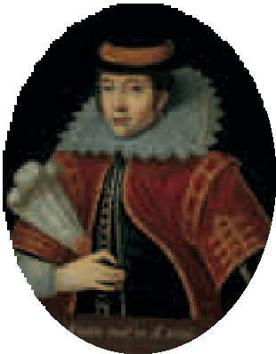In 1614 some of the colonists were allowed to rent plots of land. Most of what they grew on their plots was their own. This move toward private ownership encouraged the colonists to grow food crops to sell—and work harder. One of the colonists explained that the colonists often avoided work when

“our people were fed out of the common store,

and labored jointly together.”

Now that the colonists could farm their own land and operate for profit in a competitive system,

they made greater efforts

and explorer. Smith forced the settlers to work,

to succeed.

***Pocahontas***

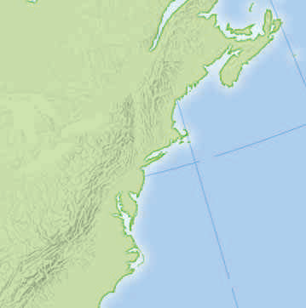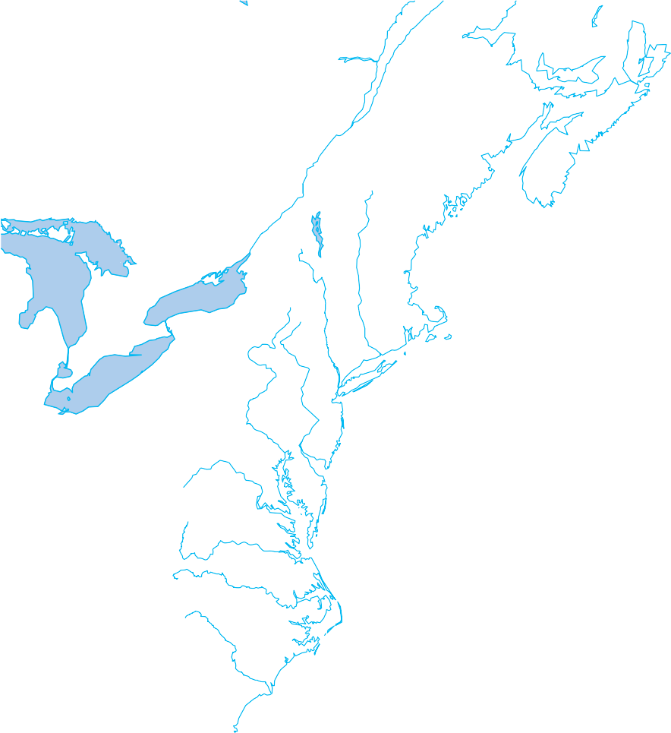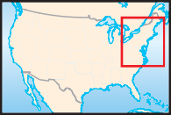

Private land ownership was expanded in 1618. All the colonists who had paid their own way to America were granted 100 acres of land. In order to attract more colonists, the company gave a land grant called a **headright** of 50 acres to those who paid their own way. A settler also received 50 acres for each family member over 15 years of age and for each servant brought to Virginia. This system convinced thousands of people to move to Virginia.

**Citizenship**

**Representative Government**

At first nearly all of Jamestown’s settlers were men. They worked for the Virginia Company and lived under strict rules. As the colony grew, the settlers complained about taking orders from the Virginia Company in London. In 1619 the company agreed to let the colonists have some say in their government. Ten towns in the colony each sent two representatives called **burgesses** to an assembly. The assembly had the right to make local laws for the colony. On July 30, 1619, the **House of Burgesses** met for the first time in a church in Jamestown.

**New Arrivals in Jamestown**

In 1619 the Virginia Company sent 90 women to Jamestown. As a company report noted: “The plantation can never flourish till families be

planted, and the respect of wives and children fix the people on the soil.” Colonists who wanted to marry one of the women had to pay a fee of 120 pounds of tobacco. Men still outnum- bered women in the colony, but marriage and children became a part of life in Virginia.

A Dutch ship brought another group of new- comers to Jamestown in 1619—twenty Africans who were sold to Virginia planters to labor in the tobacco fields. These first Africans may have come as servants—engaged to work for a set period of time—rather than as slaves.

Until about 1640 some African laborers in Jamestown were free and even owned property. William Tucker, the first African American born in the American colonies, was a free man. In the years to follow, however, many more shiploads of Africans would arrive in North America, and those unwilling passengers would be sold as slaves. Slavery was first recognized in Virginia law in the 1660s.

In the early 1620s, the Virginia Company faced financial troubles. The company had poured all its money into Jamestown, but little profit was returned. The colony also suffered an attack by the Native Americans. In 1624 King James canceled the company’s charter and made Jamestown the first royal colony for England in America.