University: Arabi Ben Mhidi University,

Faculty of Economic Sciences,

Department of Economic Sciences

Course: Operations Research 2

**Chapter 02: Inventory Management Models**

Lessons with solved examples

degree students specializing in Quantitative Economicsز

Prepared by: Prof. Dali Saida

Chapter Outline: Inventory Management Models

Firstly, an overview of inventory management issues in general. Secondly, inventory control models:

* The ABC classification system.
* Economic order quantity (EOQ) model.
* EOQ model for batch demand.
* EOQ model for purchase.
* Determining the appropriate time to place a purchase order.
* Exercise chains.

Haut du formulaire

1. Definition of Inventory: Inventory refers to goods and materials owned by an organization for the purpose of resale or for use in the production of goods for sale. In other words, it includes goods used in future production, semi-finished goods, and finished goods stored in warehouses, on work premises, or in transit to customers. These goods are a significant part of the capital assets of industrial establishments and play an important role in changing production rates and national income growth at the overall economic level. Additionally, inventory management involves the sub-activity of supply management responsible for storing raw materials, semi-finished goods, and finished goods between the supply center and the consumption center. Moreover, it is responsible for providing management with information on the status of different types of inventory, their quantities, storage locations, and warehouses used to store inventory during all supply operations.
2. Types of Inventory: A. According to Structural Description:

* Raw Materials Inventory: Raw materials are among the most important factors of production, and without their availability, there can be no production processes. They can be sourced domestically or imported from abroad.
* Purchased Parts: These are ready-made products purchased for integration into final goods or for resale as they are. These parts are needed by both manufacturing and trading establishments.
* Equipment and Spare Parts: This includes machinery, equipment, and spare parts needed by the organization for the maintenance of its production equipment.
* Finished Products: These are fully prepared goods intended for sale and consumption, and they are in high demand by trading establishments.
* Waste and Scrap: These are residues of materials used in the production process, such as wood and iron scraps, etc.
* Packaging Materials: These are inventory items used in the packaging process in all its forms and according to the nature of the products.

B. According to Behavioral Description:

* Minimum Stock Inventory: This is inventory that circulates at a fixed volume, which may be less than the actual needs of the organization. The purpose of this process is to obtain the purchased quantity and reduce the cost of placing purchase orders.
* Anticipated Inventory: This is the inventory of goods prepared for consumption based on probabilistic forecasting. It varies throughout the year and is used to reduce these variations through inventory accumulation or by utilizing existing production equipment, including labor requirements or excess capital needs.
* Fluctuation Inventory: This type of inventory is used either due to fluctuations in the prices of certain products or raw materials or to cope with unexpected fluctuations in consumer demands. Therefore, factories keep quantities of goods in their warehouses to meet consumer demands when necessary. Despite the importance of fluctuation inventory, it is not an absolute necessity, as the organization can do without it if it manages to convince consumers and customers to wait until they request and supply the goods.
* Safety Stock Inventory: Also known as buffer inventory, it is the surplus or increase in materials provided by the organization to avoid inventory depletion problems caused by changes affecting the inventory level, such as increased consumption rate, replenishment period, the capabilities of the organization or its financial center, and errors in estimates. When the waiting period for distribution is long or the estimated consumption rate is high, the organization is exposed to various risks, such as production difficulties and the loss of customers due to inventory depletion. Therefore, it is necessary for the organization to maintain safety stock inventory.

3- Inventory Management Costs: The role of inventory is to provide the organization with the quantity it needs under economic conditions. The costs associated with the procurement process extend beyond the purchase cost of materials and goods. They also include the cost of inventory holding and the cost of stockouts. To achieve effective inventory management, it is essential to minimize and reduce these costs.

a) Ordering Costs: These costs include the procurement procedures starting from the preparation and market analysis until the execution of the purchase. They encompass wages and salaries of employees involved in the purchasing process, transportation costs, inspection costs, and handling expenses from and to the warehouses. These costs increase with the number of orders. Economies of scale can be achieved by procuring in economical quantities, which helps reduce inventory holding and stockout costs.

b) Holding Costs: These costs are incurred from the time the goods enter the inventory until they are consumed or sold. They mainly consist of:

* Financial Burdens: This includes the interest on the capital invested in inventory when self-financed or financed through financial institutions.
* Storage Expenses: These are expenses related to the preservation and maintenance of stored items, such as surveillance costs, rent costs, costs of time and spoilage, and potential loss due to selling expired or deteriorated items at discounted prices or even discarding them.
* Insurance Costs: They should be considered when establishing storage policies, such as goods insurance coverage.

c) Stockout Costs: These costs occur when inventory is depleted due to an interruption in supply, either internally or externally, without sufficient safety stock to meet production and marketing demands. Stockout costs lead to production halts, unfulfilled orders, and additional costs such as lost sales, customers shifting to other suppliers, and expedited order expenses to cover the shortage.

4- Inventory Classification: There are several methods for classifying an organization's inventory to enable effective management:

a) ABC Curve Method: This method ranks materials in descending order based on their annual usage, resulting in three categories:

* Category A: It includes items of high importance, representing 20% of the quantity but accounting for 80% of the total value of stored materials. These are typically slow-moving items.
* Category B: It consists of items that make up 30% of the inventory but represent 15% of the total value. These are moderate-moving items.
* Category C: It includes frequently used materials with high turnover rates. These items constitute 50% of the inventory but represent only 5% of the total value.

b) Based on Inventory Turnover Rate: This classification distinguishes between:

* Fast-Moving Items: These are materials frequently ordered and consumed, and any stockout can result in significant losses.
* Regular Items: They receive less attention but are considered routine and still have an impact on production.
* Slow-Moving Items: These are materials with low turnover rates, and if they are found to be obsolete or damaged during periodic inventory reviews, they should be removed from inventory records.

c) Classification by Material Nature: Materials and components can be grouped based on their nature and purpose, such as spare parts for assembly, indirect production components, and finished products.

d) Classification by Handling Methods: This classification identifies suitable handling and transportation methods, and materials can be categorized as non-stored items, packaged items, or liquid materials transported through pipelines.

e) Classification by Risk Level: This categorization takes into account the hazardous nature, fragility, high value, or short production lifespan of materials.

Secondly: Inventory Control Models: The process of inventory control aims to address the following issues:

1. What do we monitor?

* The ABC classification system.

1. How do we monitor?

* The policy followed in inventory management.
  + Optimal quantities.
  + Optimal lead time.

However, before addressing these questions, we need to understand what we mean by inventory control, its importance, and its objectives.

Concepts of Inventory Control: Inventory control is the activity of planning, scheduling, and monitoring the services, materials, parts, and various requirements used in the production process to ensure their availability in line with the operation schedule in terms of quantity, type, and time.

It is also defined as ensuring the availability of the required quantities of materials while maintaining a balance between the quantities on hand and the required quantities with the least possible investment - without freezing a significant portion of capital in stored items - and reducing the costs of storage, spoilage, deterioration, and price fluctuations.

From this perspective, inventory control operations involve controlling quantities and aim to balance purchasing and production processes. This process aims to ensure the flow of materials and production in the required quantities, ensuring uninterrupted supply and avoiding delays in the arrival of supplies. It also aims to reduce costs, achieve flexibility in the production process, and ensure the smooth operation of customer supply.

Importance of Inventory Control: The importance of inventory control can be highlighted through the advantages and benefits it provides, including the following:

* Avoiding the investment of large quantities of organizational funds in inventory and also avoiding inventory shortages.
* Identifying slow-moving items and obsolete items and taking necessary measures to address these issues.
* Avoiding duplication in stored materials and disposing of scraps, leftovers, and waste.
* Assisting in the proper preparation of sales, production, and storage programs. Production orders cannot be directed until the availability of necessary materials in the warehouses is confirmed. Inventory control also helps in scheduling production to meet sales requirements.
* Inventory control helps identify the materials and quantities used for production purposes or to fulfill customer orders. Additional quantities are supplied to warehouses to maintain regular production and sales operations.

Objectives of Inventory Control: The main objectives of inventory control can be expressed in the following points:

* Achieving maximum efficiency in the operation of production units and sales units.
* Achieving appropriate levels of production and supply in economic quantities.
* Striking a balance between the various cost groups required for storage operations.
* Ensuring proper levels of inventory, neither more nor less than required.
* Maintaining a steady and regular production flow, covering the imbalances caused by temporary production interruptions. Such regularity facilitates the flow of materials by scheduling and implementing production plans and programs within specified deadlines.

In conclusion, effective inventory control enables maximum flexibility and facilitation for both the producer and the consumer by meeting the needs for materials and products in a regular manner. This requires inventory management to prioritize the following three aspects: a) Giving more attention to materials with higher usage. b) Giving more attention to materials that can cause problems with stakeholders. c) Giving more attention to materials that are frequently and repeatedly demanded.

1- ABC Classification System: The ABC classification system is based on dividing inventory into three main categories:

1. Class A: This category includes high-value items that represent approximately 80% of the capital invested in the inventory. These items require strict and high-level control. Although they account for only about 10-20% of the total inventory items, their usage value ranges between 60-80% of the unit quantity, and they contribute significantly to the cost of the final product.
2. Class B: This category includes items of medium value, accounting for around 15-30% of the total inventory value. They are classified as Class B because their annual usage value ranges between 15-30%. Although their quantity is larger, typically around 20% of the inventory, they require less control compared to Class A items.
3. Class C: This category represents items with a low value, accounting for approximately 20% of the invested capital. They have a low impact on production costs and their usage value is less than the turnover rate. While they require minimal control, they make up a significant portion, about 50-75%, of the quantity of items in the inventory. These items are classified as Class C.

The ABC analysis classifies inventory items based on their value and quantity, allowing for a better understanding of their importance and facilitating inventory management decisions.

|  |
| --- |
| التحليل الثلاثي (A ,B,C) للأصناف المخزنة حسب القيمة و العدد |
|  |

2- Economic Order Quantity Model: The Economic Order Quantity (EOQ) model, also known as the optimal order quantity, is a method used to determine the optimal order size for purchasing inventory. This model is credited to one of the prominent pioneers, Harris, and it is one of the most widely used inventory control systems. The EOQ model aims to identify the order quantity that minimizes the cost of acquiring the item.

The economic order quantity can be defined as follows: It is the quantity or value of resources that should be purchased at once in order to produce a specific volume while minimizing the costs of ordering and holding inventory. Simultaneously, it should meet the usage requirements of the users.

Based on this definition, the economic order quantity considers two types of costs:

1. Holding costs: These are the costs associated with holding inventory over time.
2. Ordering costs: These are the costs associated with placing and processing orders.

It is worth noting that these two types of costs are conflicting. As the average inventory volume during a certain period increases, one of these cost categories related to holding inventory will begin to rise due to the increase in the average inventory volume. At the same time, the other cost category related to ordering decreases. Conversely, as the average inventory volume decreases, the holding costs decrease while the ordering costs increase.

The EOQ model aims to find the balance between these costs and determine the order quantity that minimizes the total cost of inventory management.

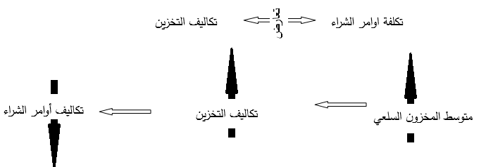

Basic assumptions of the model: • The demand or required quantities are known and constant over time. • The reorder period is the time between placing an order and receiving it. • The unit price remains constant regardless of the order quantity. • The order quantities are equal and cannot be divided. • Orders are placed whenever the inventory reaches the reorder point (no stockout occurs).

Since this model assumes that the demand rate for the inventory remains stable and constant over successive periods, the behavior of such an inventory system can be graphically represented as follows:

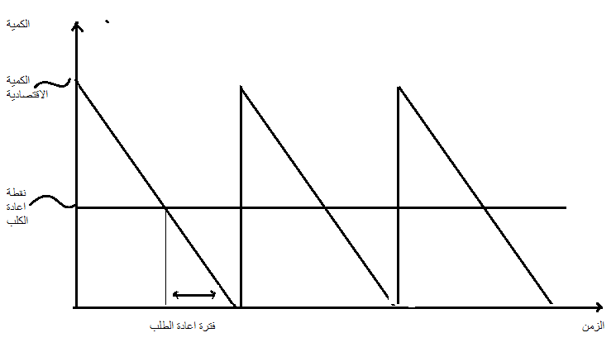

Derivation of the Economic Order Quantity (EOQ): Q: Order quantity purchased by the project. Q/2: Average inventory. CR: Cost of storing one unit. D: Annual requirements (annual consumption). TC: Total storage costs. THC: Costs associated with inventory holding. TOC: Costs associated with inventory ordering. TC*: Optimal total inventory cost. F: Order setup cost. EOQ*: Economic Order Quantity. A: Optimal number of order cycles.

When an order is received, the inventory level reaches 0 (assuming the demand rate is known). The inventory level at maximum inventory level. The inventory level at minimum inventory level 0.

|  |  |
| --- | --- |
| **متوسط المخزون=الحد الأقصى+ الحد الأدنى/2** |  |

It is typically calculated as a percentage of the inventory value or as an absolute value representing the cost of storing one unit for a year. It has an inverse relationship with the volume and value of the inventory.

|  |  |
| --- | --- |
| **THC= CR** |  |

The costs associated with order setup, TOC (Total Order Cost), are calculated by multiplying the number of orders by the cost per order.

|  |  |
| --- | --- |
| **TOC =F** |  |

The Total Cost of Storage (TC)

**TC=THC+TOC**

**TC= (CR) + (F)**

|  |
| --- |
|  |

Example: If the annual requirements for a specific material in a project are 2000 units per year, and the cost of holding one unit is 1 USD/year, with ordering costs of 10 USD. The required tasks are:

1. Drawing a chart illustrating the behavior of cost elements that change with the quantity of demand, Q.
2. Finding the following: • Optimal quantity. • Total optimal cost. • The optimal number of orders.

|  |  |  |  |
| --- | --- | --- | --- |
| **Q** | cost of holding **THC** | ordering costs **TOC** | . • Total optimal cost **TC** |
| 50 | 25 | 400 | 425 |
| 100 | 50 | 200 | 250 |
| 150 | 75 | 133.33 | 208.33 |
| **200** | **100** | **100** | **200** |
| 250 | 125 | 80 | 205 |
| 300 | 150 | 66.66 | 216.66 |

|  |
| --- |
|  |

1. • Optimal quantity **Q*:**

**TOC=THC**

**CR= F**

**Q2/2 CR=DF**

**Q2/2=(DF/CR)**

**Q2=2DF/CR**

**Q*=**

**Q*=**

**Q*=200 وحدة**

. • Total optimal cost

**TC*=TOC+THC**

THC=TOC

**TC*= CR +TOC**

**TC*= CR+ CR**

**TC*=2( CR)**

**TC*=Q* CR**

**TC*=200-1**

**TC*=200**

1. number of orders.

**A=**

**A=**

**A=10**

To derive the economic order quantity (EOQ) in the case of batch ordering, we can use the following variables:

P: Replenishment rate (or production rate). E: Usage rate (equivalent to the demand rate for the item). Y: Gradual replenishment period (during which the item is also being used). G: Usage-only period (utilizing the accumulated inventory when there is no replenishment). (P-E): Accumulation rate.

To calculate the economic order quantity, we can use the following formula:

EOQ = √((2 * P * E * Y) / (P - E + (P - E) * (Y / G)))

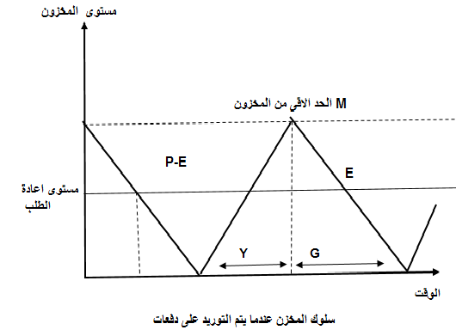

وبالتالي نجد:

متوسط المخزون وليس

التكاليف الكلية **TC=**

ميل خط تراكم المخزون= P-E

ميل خط تراكم المخزون إذ لم يكن هناك استخدام خلال فترة التوريد **P=**

**M=P-E)Y**

**=Y**

**M=P-E)**

**M=(1-)Q**

معادلة كمية الطلب المثلى في حالة التوريد على دفعات تكون

الكمية المثلى لمرت التوريد **Q*=**

Example: One department in an industrial company produces an item that is used in the following department. The daily production rate is 160 units, while the next department uses this item to produce finished goods at a rate of 80 units per day. If the number of working days in a year is 250 days: • Calculate the optimal number of times the first department should operate to produce this item. Assume that the holding cost per unit is 8 dinars per year, and the setup cost for the first department to produce a specific item is 200 dinars per setup. • Calculate the expected maximum inventory level in the department (A).

Solution: Production rate: 160 units per day (P) Usage rate: 80 units per day (E) Working days per year: 250 days Holding cost: 8 dinars per unit per year (CR) Setup cost: 200 dinars per setup (F) Optimal number of operations for the first department

**A=**

مقدار الاحتياجات السنوية في القسم المستخدم للصنف

**D=80*250=2000**

**Q*=**

**Q*=**

**Q*=**

Q*=1414

A=20000/1414 =14.1

The minimum cost of production and storage is calculated by adding the total holding cost (THC) to the total ordering cost (TOC).

The maximum inventory level.

**M=**

**M=**

M=707

1. Economic Order Quantity Model in the Case of Purchasing: In this case, the assumption of a constant item price disappears, meaning that the price decreases if the quantity exceeds certain limits, indicating a discount. Thus, the total cost function becomes as follows: T_c = T_HC + T_OC + T_IC T_IC: Represents the purchasing costs for the units. T_IC = I * D I: Unit purchase price

To determine the economic order quantity for purchasing, we follow these steps:

1. Calculate Q* using the economic order quantity equation with the given holding cost (CR).
2. Determine the price range for that quantity (possible ranges).
3. Calculate the total costs for the possible quantity and the quantities at the price reduction point.
4. Choose the quantity that minimizes the costs, which represents the economic order quantity Q*.

Example: If the demand is D = 2000 and the holding cost is CR = 1, with F = 10 (as given in the previous lesson example), but now the supplier offers prices that allow for quantity-based discounts, with the following price structure:

* 10 currency units if the quantity is less than 250 units.
* 09 currency units if the quantity is greater than or equal to 250 units.

The required tasks are:

* Determine the optimal quantity.
* Determine the optimal costs.
* Determine the optimal number of orders.

The solution is as follows:

I1 = 10 units/d for Q < 250 units I2 = 9 units/d for Q > 250 units Q- is the quantity at which the price changes, which is 250 units Tc - Total cost for quantity Q- using I1 CR = 1, F = 10, Q- = 250, D = 2000 Q* = √(2DF/CR) = 200 Q* = 200 < Q- = 250 Calculate Tc* and Tc: Tc* = T_HC + T_OC + T_IC Tc* = (Q/2)(1) + D/Q- + F + D * I1 = 20200 Tc = T_HC + T_OC + T_IC Tc = (Q/2)(1) + D/Q- + F + D * I2 = 18205 It can be observed that 18205 < Tc* = 20200 Therefore, Q* is equal to Q- = 250, which is the economic order quantity for purchasing. As for the number of orders: A = D / Q* = 2000 / 250 = 8

1. Determining the Optimal Time to Place an Order: Here, we are answering the question of when to order. The reorder point, also known as S, is the inventory level at which an order should be placed so that the item reaches the safety stock level upon arrival of the new order. Determining this point depends on two factors:

* The daily usage rate, denoted by U.
* The lead time, denoted by T, which is the time from placing the order to the arrival of the new order.

The reorder point is calculated as follows: Reorder Point = T * U + Safety Stock (K + L) = S K: Size of the safety stock

If the safety stock increases, the holding cost increases while the stock-out cost decreases. Order Quantity = T * U = L L: Quantity supplied during lead time

Reorder Rate = (Current Inventory - Reorder Point) / Usage Rate

In the previous model (economic order quantity), the assumption was that the inventory demand rate is constant and not variable. However, in practical situations that necessitate inventory holding, the reality is as follows:

* The demand is not known with certainty in advance and is subject to fluctuations and other variables.
* There is a possibility of delayed arrival of the required quantities.
* Suppliers usually do not fulfill their commitments and delivery dates.

Due to some issues regarding ensuring the order's confirmation or non-arrival, the safety stock can be handled in two cases:

1. Determining the reorder point in the case of certainty:

* The daily usage rate for inventory, U, is known and not subject to any probabilities.
* The lead time, T, is constant and known, so the organization does not need to maintain safety stock.
* Reorder Point S = U * T, which is equal to the quantity supplied during lead time, L = S.

1. Determining the reorder point in the case of uncertainty:

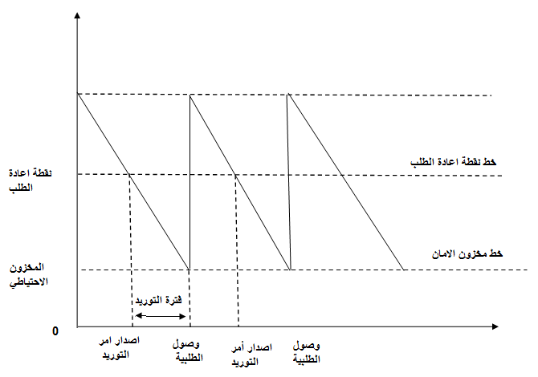

* **نقطة إعادة الطلب في حالة عدم التأكد:**

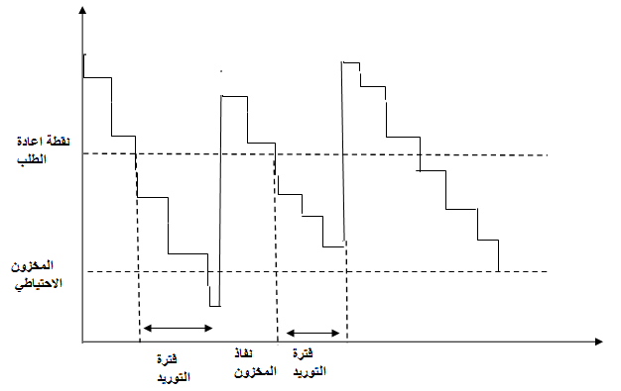

Inventory Management: Determining the optimal order quantity and reorder point are crucial for efficient inventory management. The economic order quantity (EOQ) formula can be used to calculate the ideal order quantity, considering factors such as demand rate, setup costs, and holding costs.

The EOQ formula is given by: EOQ = √((2DS) / H)

Where: D = Demand rate S = Setup or ordering cost per order H = Holding cost per unit per year

Once the EOQ is calculated, the reorder point can be determined by considering the lead time and demand rate. The reorder point is the inventory level at which a new order should be placed to replenish stock before it reaches a critical level. It can be calculated as: Reorder Point = Lead Time Demand

To ensure optimal inventory management, it is important to consider other factors such as service level and safety stock. The service level represents the desired level of customer satisfaction or the probability of meeting demand during the lead time. Safety stock is the additional inventory held to mitigate uncertainties in demand and lead time.

To calculate safety stock, factors such as demand variability, lead time variability, and desired service level need to be considered. Statistical methods like calculating standard deviation can be used to estimate these factors and determine the appropriate safety stock level.

Overall, effective inventory management involves finding the right balance between meeting customer demand, minimizing holding and setup costs, and maintaining a satisfactory service level. It requires continuous monitoring, analysis, and adjustment to optimize inventory levels and meet customer needs efficiently.

|  |  |  |  |  |  |  |  |  |  |
| --- | --- | --- | --- | --- | --- | --- | --- | --- | --- |
| مستوى الخدمة | 90 | 95 | 97.5 | 99 | 99.5 | 99.9 | 99.95 | 99.995 | 99.9995 |
| قيمة Z | 1.282 | 1.645 | 1.960 | 2.960 | 2.326 | 2.576 | 3.090 | 3.291 | 4.417 |

The Need for Safety Stock

The need for safety stock arises as a result of the following reasons:

1. Higher than average usage rate with a constant lead time.
2. Changing usage rate and constant usage rate.
3. Changing usage rate and lead time.
4. Case of changing usage rate and constant lead time: In this case, it is important that the usage rate is higher than the average usage rate. The project faces a shortage of the item. The magnitude of the shortage depends on the degree of increase in the usage rate above the high average usage rate. In this case, the equation is: S = U * T + Z * (σ)U* where: S is the safety stock level, U* is the average usage rate, T is the lead time, Z is determined by the desired service level, (σ)U* is the standard deviation of demand during the lead time.
5. Case of constant usage rate and changing lead time: The need to maintain safety stock leads to a possibility of delayed arrival of required quantities on time. The actual lead times are collected and averaged, and the statistical distribution is determined to specify the lead time distribution. An increased lead time leads to a decrease in safety stock at a constant rate due to the stability of usage rate. In this case, the equation is: S = U(T*) + Z(σ)t where: S is the safety stock level, U is the usage rate, T* is the average lead time, Z is determined by the desired service level, (σ)t is the standard deviation of the lead time.
6. Case of changing usage rate and lead time: In this case, the equation for safety stock is: S = U * T* + Z * sqrt(T * (σ)U + U * (σ)t)

Exercise Solutions:

Exercise 1:

1. We care about inventory to ensure uninterrupted supply, meet customer demand, and manage costs.
2. The main reasons for retaining inventory are to avoid stockouts, take advantage of economies of scale, and act as a buffer against uncertainties.
3. Risks and disadvantages of low inventory levels include stockouts, missed sales opportunities, and increased ordering costs. Risks of high inventory levels include obsolescence, holding costs, and capital tied up in inventory.
4. Different types of inventory include raw materials, work-in-progress, finished goods, and maintenance, repair, and operations (MRO) inventory. Costs associated with inventory include holding costs, ordering costs, setup costs, carrying costs, and stockout costs.
5. Inventory control refers to managing and monitoring inventory levels, ordering, and replenishment to maintain optimal stock levels and meet customer demand.
6. The ABC analysis is a method of classifying inventory items based on their value and importance. It categorizes items into three groups: A (high-value, high-priority), B (moderate-value, moderate-priority), and C (low-value, low-priority) items.
7. Economic order quantity (EOQ) refers to the optimal order quantity that minimizes total inventory costs by balancing ordering costs and carrying costs.
8. The basic assumptions of the economic order quantity model include constant demand, fixed ordering costs, instantaneous replenishment, no quantity discounts, and no stockouts.

Exercise 2:

* Economic order quantity (EOQ) can be calculated using the EOQ formula: EOQ = sqrt((2 * D * S) / H) where D is the annual demand, S is the ordering cost per order, and H is the holding cost per unit per year.
* The minimum total annual cost is calculated by multiplying the EOQ by the ordering cost per order and adding the holding cost per unit per year multiplied by the EOQ.
* The optimal number of orders per.