First year CPE

Alliouche Nadjiba

**The Writing Process**

Writing is a process that involves at least four distinct steps: prewriting, drafting, revising, and editing. It is known as a recursive process. While you are revising, you might have to return to the prewriting step to develop and expand your ideas.

**Step 1:Prewriting**

1. Prewriting is anything you do before you write a draft of your document. It includes thinking, taking notes, talking to others, brainstorming, outlining, and gathering information (e.g., interviewing people, researching in the library, assessing data).

2. Although prewriting is the first activity you engage in, generating ideas is an activity that occurs throughout the writing process.

**Step2: Drafting**

1. Drafting occurs when you put your ideas into sentences and paragraphs. Here you concentrate upon explaining and supporting your ideas fully. Here you also begin to connect your ideas. Regardless of how much thinking and planning you do, the process of putting your ideas in words changes them; often the very words you select evoke additional ideas or implications.

2. Don’t pay attention to such things as spelling at this stage.

3. This draft tends to be writer-centered: it is you telling yourself what you know and think about the topic.

**Step3: Revising**

1. Revision is the key to effective documents. Here you think more deeply about your readers’ needs and expectations. The document becomes reader-centered. How much support will each idea need to convince your readers? Which terms should be defined for these particular readers? Is your organization effective? Do readers need to know X before they can understand Y?

2. At this stage you also refine your prose, making each sentence as concise and accurate as possible. Make connections between ideas explicit and clear.

**Step4:Editing and Proofreading**

*Make it Correct*

1. Correct grammatical mistakes, spelling, capitalization, and punctuation.

2. Be sure all sentences are complete.

3. Change words that are not used correctly or are unclear.

4. Don’t edit your writing until the other steps in the writing process are complete.

# Freewriting

“The consequence [of writing] is that you must start by writing the wrong meanings in the wrong words; but keep writing until you get to the right meanings in the right words. Only in the end will you know what you are saying.” —Peter Elbow

“Don’t think; just write!” —Ray Bradbury

Freewriting, a writing strategy developed by Peter Elbow in 1973, is similar to brainstorming but is written in sentence and paragraph form without stopping. Thus, it . . .

1. increases the flow of ideas and reduces the chance that you’ll accidentally censor a good idea.
2. helps to increase fluency second-language learners—i.e., the ability to produce written language easily (as opposed to accuracy, which is of course important but which is better addressed later in the process).

As in brainstorming,

* 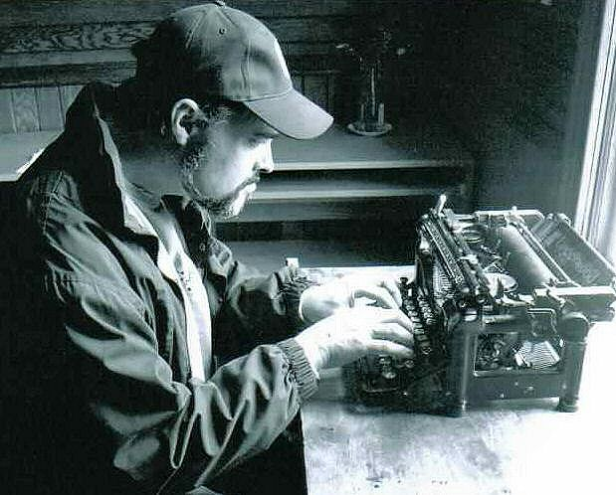DO write down every idea you can think of about your topic, no matter how "crazy"; you can judge later! (And no one else is going to see it)
* DON'T worry about correct grammar or spelling;

Unlike in brainstorming,

* DO write in sentence and paragraph form;
* DO KEEP YOUR HANDS MOVING. If you can’t think of anything,  just keep repeating your subject (e.g., “busy trap, busy trap”) or something like “I’m waiting for ideas to come and they will, I’m waiting for ideas to come and they will,” over and over until they do come. (They will!);
* DO feel free to use an occasional word from your native language if you can't think of the English word, but don't overdo this;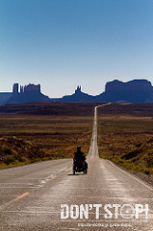
* DO keep going for 15 or 20 minutes or until you feel you have enough to start to build your paper or research on.
* NOTE: In Peter Elbow's original formulation of freewriting, designed to generate not only ideas but even a topic, the writer writes for a few minutes, chooses one idea or word from that freewriting and then freewrites about that new topic for several minutes, and then repeats that process again, successively refining their topic. This process can be a useful one if you are truly starting from scratch and are not even sure what you want to write your paper about.

Read a [sample freewrite](https://writingprocess.mit.edu/sample-freewrite).

- "Writer John" by Onomatomedia - Own work. Licensed under CC BY-SA 3.0 via Wikimedia Commons - [https://commons.wikimedia.org/wiki/File:Writer_John.JPG#/media/File:Writ...](https://commons.wikimedia.org/wiki/File:Writer_John.JPG#/media/File:Writer_John.JPG)

- "Don't Stop" ©2010, Hironori Nakagawa. All rights reserved.

* [Home](https://writingprocess.mit.edu/)
* [Background](https://writingprocess.mit.edu/background)
* [Step 1: Generate Ideas](https://writingprocess.mit.edu/process/step-1-generate-ideas)
  + [Brainstorming](https://writingprocess.mit.edu/process/step-1-generate-ideas/instructions/brainstorming)
  + [Freewriting](https://writingprocess.mit.edu/process/step-1-generate-ideas/instructions/freewriting)
    - [Sample Freewrite](https://writingprocess.mit.edu/sample-freewrite)
    - [Practice](https://writingprocess.mit.edu/process/step-1-generate-ideas/step-1-practice)
  + [Idea Map/Web](https://writingprocess.mit.edu/process/step-1-generate-ideas/instructions/idea-mapweb)
  + ["Moodling"](https://writingprocess.mit.edu/process/step-1-generate-ideas/instructions/moodling)
* [Step 2: Plan and organize](https://writingprocess.mit.edu/process/step-2-plan-and-organize)
* [Step 3: Draft](https://writingprocess.mit.edu/step-3-draft)
* [Step 4: Revise](https://writingprocess.mit.edu/process/step-4-revise)
* [Step 5: Edit](https://writingprocess.mit.edu/process/step-5-edit)
* [Final thoughts](https://writingprocess.mit.edu/final-thoughts)

[Login using Touchstone](https://writingprocess.mit.edu/Shibboleth.sso/Login?target=https%3A%2F%2Fwritingprocess.mit.edu%2F%3Fq%3Dshib_login%2Fnode%2F25)

## About

* [About the Instructor](https://writingprocess.mit.edu/about-instructor)
* [Contact](https://writingprocess.mit.edu/contact)

[https://writingprocess.mit.edu/sites/default/files/mit-redgrey-footer1.gif](http://web.mit.edu/)