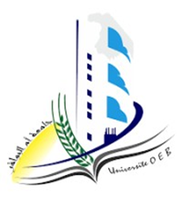الجمهورية الجزائرية الديمقراطية الشعبية

PEOPLE‘S DEMOCRATIC REPUBLIC OF ALGERIA

Ministry of Higher Education and Scientific Research

Larbi Ben M'Hidi University, Oum El Bouaghi-Algeria

Faculty of Economic, Commercial, and Management Sciences

Department of Finance and Accounting

English paper

**title**

**Submitted by: Field: Accounting/Finance/Audit**

Full name **Group:**

**Academic year:** 2024/2025

**References**