***Chapter I : presentation of the animal kingdom***

* 1. **Definitions:**

**Zoology** (Zoo = animal, logos = study)

Zoology is the science whose object is the knowledge of animals; considered in a general sense, this science deals with everything that concerns these beings, and embraces the study of their classification, anatomy, physiology and history. It is the science that studies the animal kingdom.

**Taxonomy:** Is the science of biological classification and the development of its laws, based on systematic knowledge. It includes classification, nomenclature and specimen identification.

**Systematics** is the arrangement of organisms into groups or taxa based on their similarity or evolutionary relatedness, in a coherent system

**Nomenclature** is the branch of taxonomy that deals with assigning names to taxonomic units according to strict rules (International Code)

**Identification** (or determination) is the practical application of taxonomy to ascertain the identity of a biological sample and recognize its affiliation with a previously described taxon.

**Individual:** It is a functional biological system that can be unicellular or composed of many cells, which can be organized into tissues and organs.

**Species:** is a group of individuals differing from others by a characteristic property called ‘specific difference,’ distinguishing multiple species within the same genus.

**Genus:** is a set composed of collections united by a common property. The elements of the genus are the species.

**1.2 Bases of Classification**

The animal kingdom comprises a multitude of living beings with varying appearances (morphology) and internal constitution (internal anatomy, histology, biochemistry)

In the 16th century, each of these forms was referred to by a long phrase describing its external appearance. The initial foundations of taxonomy were laid by Carl von Linné, a Swedish naturalist, who is also the initiator of binomial nomenclature.

The current classification of the animal kingdom is primarily based on research in embryology and paleontology.

**1.3 zoological nomenclature:**

**A/ zoological unit ( species):**

An species is recognized by 4 criteria:

_ Internal fertilization (intraspecific) and external sterility (interspecific)

_ Internal and external morphology

_ Physiology: biochemistry (odors, secretions,…) and biophysics (response to environmental conditions)

_ Ecology and distribution

**B/ Higher categories above the species:**

A group of species with common characteristics forms a higher category above the species called a genus.

The collection of genera forms a higher category called a family.

(The phylum is the level that corresponds to different stages of evolution, depending on the degree of complexity within a taxon, intermediate values may exist (subclass, subfamily, etc.).

**1.4. Binomial nomenclature:**

Indeed, the species is denominated using two Latin names: the genus and the species. These two names are typically followed by the name or initials of the author and the date of the nomination. This practice is a part of binomial nomenclature and helps provide a precise and unique identification for each species while also recognizing the scientist who described or named it.

Certainly, here’s an example of a taxonomic classification for the domestic dog:

Kingdom: Animalia

Phylum: Chordata

Class: Mammalia

Order: Carnivora

Family: Canidae

Genus: Canis

Species: Canis lupus familiaris

In this example, “Canis” is the genus, and “Canis lupus familiaris” represents the species of the domestic dog. This classification system helps scientists categorize and understand the relationships between different organisms.

**1.5. Biology and Phylogeny of the Animal Kingdom:**

The animal kingdom is divided into two subkingdoms :

**I _ Protozoa** (first or primitive) are unicellular animals whose usually fertilized eggs give birth to two similar individuals. The organelles within these cells perform all the vital functions of these primitive beings, including respiration, feeding, excretion, and reproduction.

**II_ Metazoans** (multiple or advanced) are multicellular animals whose development typically begins with a fertilized cell. During their embryonic development, this cell divides into a variable number of cells arranged in layers, each with different differentiations (ontogenesis = from the egg to the formation of organ rudiments) linked to various functions (contraction, locomotion, digestion, sensitivity, reproduction…). Each group of cells thus formed specializes to give rise to the formation of organs and systems (organogenesis = organ differentiation). The various phyla of metazoans can be grouped by considering the modalities and degree of complexity in their embryonic development.

**2.1 Diploblastic stage:**

Metazoans typically originate from a fertilized egg cell, and the segmentation process leads to the formation of a solid cell mass (morula), which then becomes hollow and is bounded by a single layer of blastomeres (blastula). The blastula transforms into a hollow germ layer bounded by a double wall (gastrula). The outer layer is called ectoderm (ectoblast), and the inner layer is called endoderm (endoblast). The internal cavity represents the primitive gut, which communicates with the outside through a single opening (blastopore) that serves the dual function of a mouth and anus.

Diploblastic metazoans are more primitive among current metazoans lack of symmetry, absence of defined organs, and the nervous system remains diffuse… examples include sponges and cnidarians

**2.2 Triploblastic stage:**

Ontogenesis is characterized by the appearance of a third layer (mesoderm or mesoblast) situated between the ectoderm and endoderm, replacing the mesoglea.It is possible to divide triploblastic organisms into two groups.

**a/ Acoelomate triploblasts:**

The mesoderm remains compact and never organizes into closed vesicles. This layer only plays a minor role by contributing to the formation of the parenchyma (diffuse tissue that fills the general cavity) and the development of some muscles and reproductive organs. Examples include flatworms and roundworms.

**b/ Coelomate triploblasts**:

mesodermal cells, on either side of the digestive tube, form paired, symmetrical cellular masses that organize into closed vesicles or coelomic cavities. This segmentation of the mesoderm is accompanied by the distribution of muscular masses, nervous structures, excretory, and genital formations. It is also accompanied by a condensation of anterior nervous elements.

**1.5 : A simplified phylogenetic classification:**



***Chapter II : General characteristics of the subkingdom Protozoa***

1. **General Characteristics :**

**1-Habitat** Protozoa are found in the aquatic environment. They live in freshwater or oceans. Some are free-living and some are parasitic in plants and animals. Mostly they are aerobic but some are anaerobic and present in the rumen or human intestine.

Some of the species are found in extreme environments like hot springs. Some of them form resting cyst to overcome dry environments.

**2-Size and Shape**The size and shape of Protozoa vary greatly, from microbial (1µm) to large enough and can be seen by the naked eye. The shell of unicellular foraminifera can have a diameter of 20 cm.

**3-Cellular Structure**They are unicellular having a eukaryotic cell. The metabolic functions are performed by some specialised internal structures.

**4-Nutrition** Protozoa are heterotrophic and have holozoic nutrition. They ingest their food by phagocytosis. Some of the protozoan groups have a specialised structure called **cytostome**for phagocytosis.

**5-Locomotion**Most of the protozoa species have flagella, cilia or pseudopodia. Sporozoa, which don’t have any locomotory structure, have subpellicular microtubules, which help in the slow movement.

**6-Reproduction** Mostly they reproduce by asexual means. They multiply by binary fission, longitudinal fission, transverse fission or budding.

In some of the species, sexual reproduction is present. The sexual reproduction is by conjugation, syngamy or by gametocytes formation.

1. **Protozoa classification and examples :**

Protozoa is a phylum having unicellular heterotrophs. It comes under Kingdom Protista.

Protozoa are divided into four major groups based on the structure and the part involved in the locomotion:

**1. Mastigophora or Flagellated protozoans:**

They are parasites or free-living.

* They have flagella for locomotion
* Their body is covered by a cuticle or pellicle
* Freshwater forms have a contractile vacuole
* Reproduction is by binary fission (longitudinal division)
* Examples: *Trypanosoma, Trichomonas, Giardia, Leishmania, etc.*

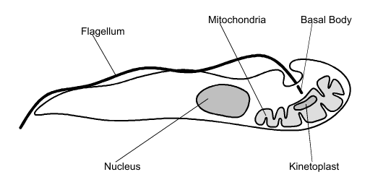

**2. Sarcodina or Amoeboids:**

They live in the freshwater, sea or moist soil.

* The movement is by pseudopodia. They capture their prey by pseudopodia
* There is no definite shape and pellicle is absent
* The contractile vacuole is present in the amoeboids living in freshwater
* Reproduction is by binary fission and cyst formation
* Examples: *Amoeba, Entamoeba, etc.*

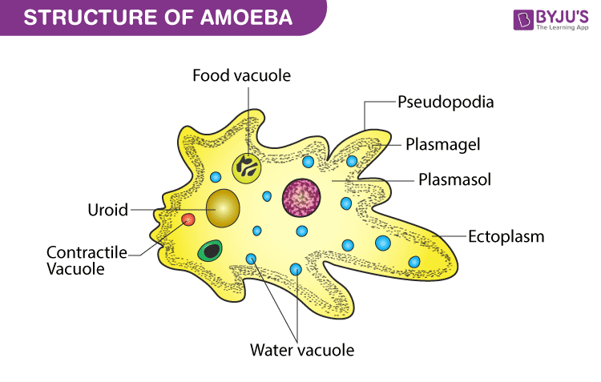

**3. Sporozoa or Sporozoans:**

They are endoparasitic.

* They don’t have any specialised organ for locomotion
* The pellicle is present, which has subpellicular microtubules, that help in movement
* Reproduction is by sporozoite formation
* Examples: *Plasmodium, Myxidium, Nosema, Globidium, etc.*

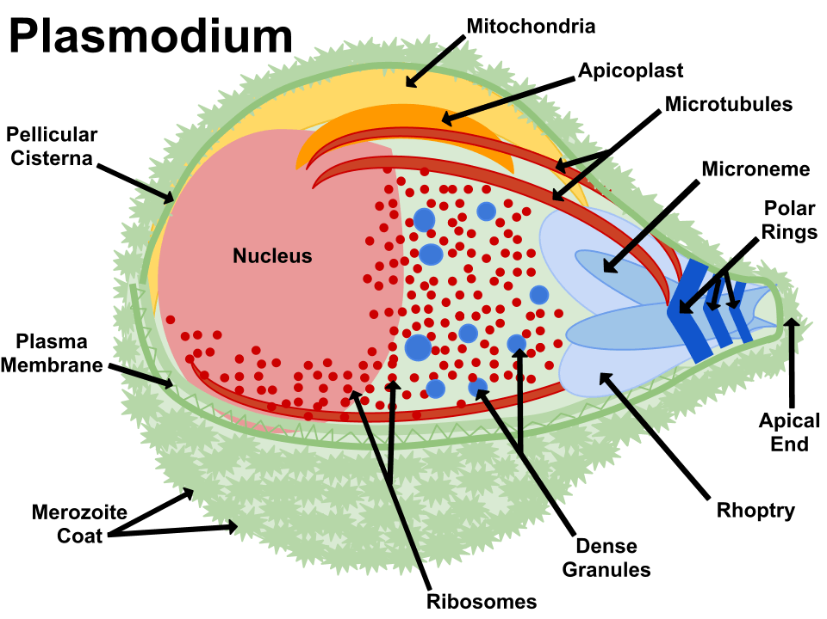

**4. Ciliophora or Ciliated protozoans:**

They are aquatic and move actively with the help of thousands of cilia.

* They have fixed shape due to covering of pellicle
* They may have tentacles, e.g. in the sub-class Suctoria
* Contractile vacuoles are present
* Some species have an organ for defence called **trichocysts**
* They move with the help of cilia and the movement of cilia also helps in taking food inside the gullet
* They reproduce by transverse division and also form cysts
* Examples: [*Paramecium*](https://byjus.com/neet/paramecium/)*, Vorticella, Balantidium, etc.*

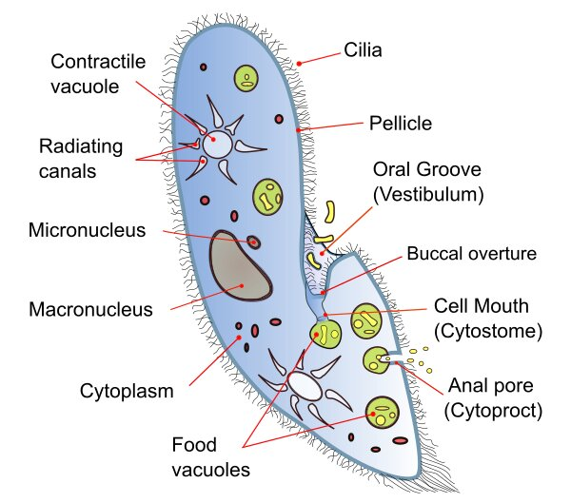

***Chapter III: General characteristics of the subkingdom Metazoans***

1. **Phylum Annelida :**

**General characteristics of the annelids :**

- The Annelids are ringed worms of the metazoans, triploblastic coelomates, characterised by their segmented "Annelid" body and bilateral symmetry.

- There are nearly 15,000 species in this phylum, ranging in size from less than 1 mm to 3 m.

- They are essentially aquatic. Some species live in damp soil.

- Their locomotion is ensured by parapods or bristles.

- They are predators or scavengers.

- The body wall is made up of circular external muscles and longitudinal internal muscles.

. - The digestive tract is complete.

- Annelids have a well-developed nervous system.

- Annelids are generally hermaphroditic. Reproduction is sexual. The reproductive system is well developed and includes several testicles and ovaries.

- The body comprises three regions (segmentation): the head (prosoma), which contains the sensory organs and the mouth, the trunk (soma) and the pygidium (telson).

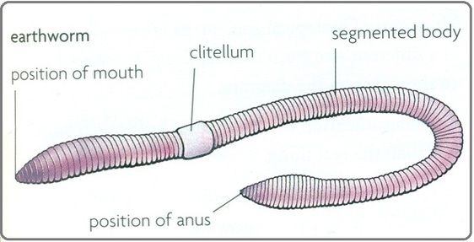

1. **Phylum of Molluscs :**

➢ **General characteristics of Molluscs :**

- Molluscs are aquatic and terrestrial animals, non-segmented, with bilateral symmetry.

- Their bodies are soft. It generally consists of a head, a visceral mass and a foot

➤ The head, which contains the mouth and sensory organs (eyes, tentacles)

➤ The foot, which is ventral, is a locomotor muscular mass

➤ The dorsal visceral mass, which contains most of the internal organs.

- The dorsal integument forms a fold: the mantle, the edge of which secretes the shell. At the rear, between the visceral mass and the mantle, is the mantle cavity where the anus, genital ducts and excretory organs open out. The gills (respiratory integumentary expansions) protrude into the mantle cavity.

- Presence of a calcareous shell secreted by the edges of the mantle.

- Enlargement of the buccal region reveals the "radula", a rough organ found in many molluscs. The radula resembles a belt of backward-curving teeth that protrude from the mouth and move back and forth, allowing the animal to scrape and retrieve its food.

- The nervous system typical of a mollusc comprises cerebrospinal ganglia (which may fuse to form a brain) linked to pedal ganglia and visceral ganglia by a double peri-oesophageal collar.

With an open circulatory system, circulation is incomplete. The heart consists of at least one ventricle and two atria. Short arteries branch off from the heart, but there are no veins or capillaries. The blood is colourless, or slightly coloured by dissolved haemoglobin or haemocyanin.

- The respiratory system is either gilled or lunged.

- Most species are gonochoric. However, some groups are hermaphroditic (gastropods in particular). Reproduction is exclusively sexual. Fertilisation is external and takes place in the water. The trochophore larva (first larval stage of a mollusc)

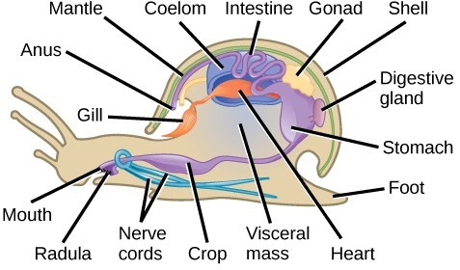

1. **Arthropod phylum**

**➢ General characteristics of arthropods:**

- Arthropods are bilaterally symmetrical invertebrates.

- Their bodies are segmented into two or three distinct parts.

- A rigid cuticle forms a thick, chitinous exoskeleton that protects the body.

- Articulated appendages on the segments (arthron= joint, podo= foot).

- The body cavity is the hemocoel.

- The digestive system consists of a differentiated digestive tract containing salivary glands, liver and pancreas. The digestive tract is divided into three parts: stomodeum (anterior intestine), mesentery (middle intestine) and proctodeum (posterior intestine).

- The respiratory system consists of specialised organs, gills (e.g. crustaceans), tracheae (e.g. myriapods, hexapods) or lungs and tracheae (e.g. spiders).

- The circulatory system is open with a dorsal tubular heart and the blood is colourless or bluish.

- The nervous system is well developed, with the ganglia in the head fused into a brain.

- The sexes are separate. Fertilisation is internal. Sexual dimorphism is present.

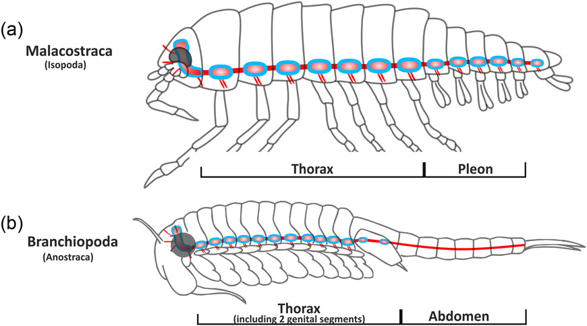

**Figure:** **Diagram of a primitive arthropod**

1. **Sponges**

Sponges are aquatic animals that can be freshwater or marine (98% marine). There are around 10,000 species. They are sessile organisms (living attached) that only develop on hard substrates (rocks, wrecks, etc.) and can be found at all depths and temperatures. Their only movements are local body contractions and the opening and closing of pores.

- They are the most primitive of animals in terms of structure: in the absence of tissues (atissular state), and therefore of specialised organs, all vital functions are carried out by more or less specialised cells. Consequently, sponges have no digestive tract, no real nervous system and no excretory system. Sponges are asymmetrical

- They are true filter feeders and respiratory organisms that can be likened to a biological filter pump.

- **Respiration and excretion** As sponges are only made up of two layers of cells, the supply of oxygen to the cells is ensured by simple diffusion through the cell walls. This also applies to cells that circulate freely within the mesenchyme. Sponges have no respiratory system. Similarly, waste products from the sponge's metabolism (CO2, NH4, etc.) are evacuated by diffusion. There is no excretory system.

**- Nutrition Sponges** are active filterers. Some sponges are capable of filtering up to 20,000 times their volume in a day, which can add up to considerable volumes. Water enters the sponge through the pores or ostioles and exits through the oscule. The pores are rarely visible, unless you look very closely, whereas the ostia are generally clearly visible. Water movement is ensured by choanocytes, thanks to the synchronised movement of their flagella.

**- Reproduction** Sponges can reproduce sexually or asexually. As with many animals that have both options, the reproductive strategy will depend essentially on the surrounding conditions.

Sexual reproduction Most sponges are hermaphroditic. However, cross-fertilisation remains the general rule.

Creation of the egg. The egg develops, either within the sponge or in seawater depending on the species, and eventually gives rise to a parenchymella ciliate larva. Sexual reproduction allows genes to be mixed. If the larval stage lasts long enough, it can also colonise larger areas than asexual reproduction.

Asexual reproduction Sponges have developed various sexual reproduction techniques: ✓

Budding; e.g. Aplysina aerophoba ✓

1. **Phylum of Echinoderms**

can be divided into five very different groups: Crinoids (or sea lilies), Asteroids, Ophiurids, Echinids and Holothurids (or sea cucumbers) (Fig. C)

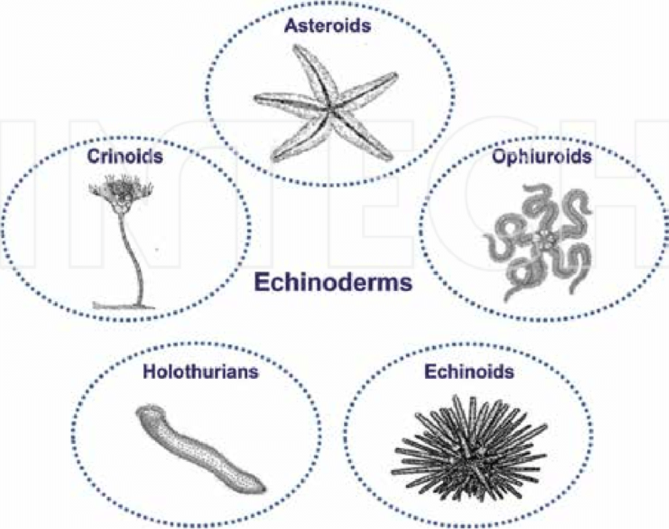

Figure C Present-day groups of echinoderms

**Anatomical characteristics of echinoderms**

**Locomotion** The ambulacral feet are the main locomotor structure. The coordinated movement of some of the ambulacral feet enables the starfish to move forward slowly.

Breathing and circulation echinoderms breathe through their skin. The epidermis, bearing ciliated dermal gills, allows for greater diffusion. The ambulacral feet also form a surface for respiratory exchanges. Sea cucumbers have respiratory trees (arborescent organs) that communicate with the outside via the cloaca. The internal tissues, however, are not in direct contact with seawater. The ambulacary system, with its ciliated inner surface, acts as a circulatory system, allowing oxygen, nutrients and waste products to pass from the epidermis to the internal tissues and vice versa.

Feeding and digestion Each echinoderm has its own diet.

Filter feeders: crinoids and holothurids, burrowers: flat sea urchins,

active predators: asteroids and certain sea urchins,

scavengers: ophiuroids and asteroids,

grazers on rocks: sea urchins.

1. **Cnidarians**

The general characteristics of cnidarians are diblastic metazoans, with a lifestyle that is either exclusively fixed (polyp, often with a calcareous skeleton), or free (jellyfish), or alternately fixed (polyp form) and free (jellyfish form, carrying the reproductive organs, allowing fertilisation and dissemination). The animal has tentacles bearing cells specialised in capturing prey, the cnidocytes. The only fossilisable forms are those with a calcareous skeleton, i.e. Anthozoa. There are, however, a few rare fossil traces of representatives of other groups.

**Reproduction of cnidaria**

Empirical and experimental data on cnidarian reproduction show it to be more variable than had been thought, and many patterns that had previously been deduced hold up poorly or not at all in light of additional data. The border between sexual and asexual reproduction appears to be faint. This may be due to analytical tools being insufficiently powerful to distinguish between the two, but it may be that a distinction between sexual and asexual reproduction is not very important biologically to cnidarians. Given the variety of modes by which it is now evident that asexual reproduction occurs, its ecological and evolutionary implications have probably been underestimated. Appropriate analytical frameworks and strategies must be developed for these morphologically simple animals, in which sexual reproduction may not be paramount, that during one lifetime may pass though two or more phases differing radically in morphology and ecology, that may hybridize, that are potentially extremely long-lived, and that may transmit through both sexual and asexual reproduction mutations arising in somatic tissue. In cnidarians, perhaps more than in any other phylum, reproductive attributes have been used to define taxa, but they do so at a variety of levels and not necessarily in the way they have conventionally been considered. At the species level, in Scleractinia, in which these features have been most studied, taxa defined on the basis of morphology, sexual reproduction, and molecular characters may not coincide; there are insufficient data to determine if this is true throughout the phylum. At the class level, transverse fission occurs in members of all three major taxa but is rare outside Scyphozoa, the group of which it is considered characteristic (pending more research, its absence in Cubozoa should be ascribed to poor knowledge). Understanding the role of transverse fission in the ecology and reproductive biology of hydrozoans and anthozoans could shed light on scyphozoan evolutionary history, and elucidating its morphogenesis in all groups is essential to determining if it is homologous across the classes. Only by comparing aspects of reproduction among cnidarians of various taxa will idiosyncratically adaptive strategies be distinguished from reproductive characters that reflect evolution and so are phylogenetically informative

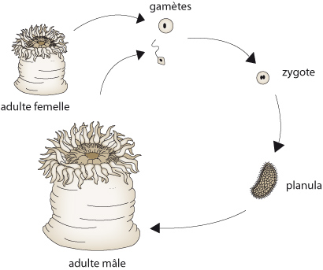

Life cycle of cnidaria

***Chapter IV: Vertebrates***

**Vertebrates**: This is a large group of living organisms characterized by the presence of a vertebral column which supports the body and protects the spinal cord. Vertebrates include fish, reptiles, birds and mammals, including humans.

vertebrates have a spine and an internal skeleton made of bones or bones

**The five classes of vertebrate animals:**

for each class, the animals which are part of it all have morphological characteristics in common :

* Birds

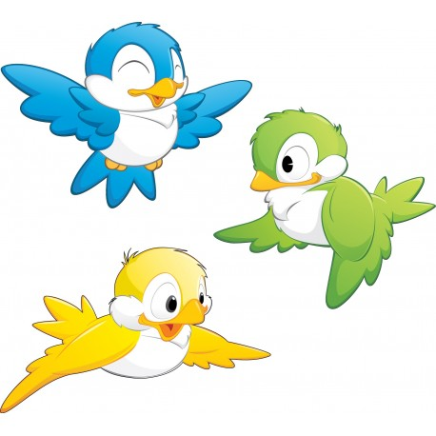

* Fish

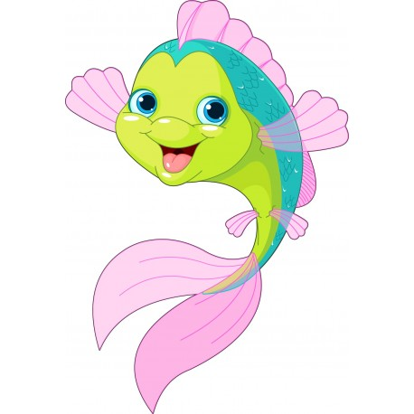

* Mammals

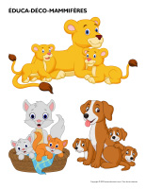

* Amphibians



* Reptiles

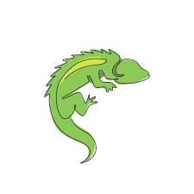

1. **Mammals**

* **have hair**
* **breathe using lungs**
* **have breasts**

1. **birds**

* **have feathers**
* **Have wings**
* **have a beak**
* **lay eggs**

1. **Fish**

* **have cold blood**
* **have a body covered in scales**
* **breath through gills**
* **have fins**

1. **Reptiles**

* **Animals that lay eggs with a soft shell**
* **A skin covered with scals**
* **Temperature variable**

**Nutrition :**

Nutrition of vertebrates varies depending on the type of organism seen:

-Fish feed on marine life, plants and algae.

-Reptiles feed on insects, mammals, other reptiles or plants.

- Birds feed on insects, other animals and plant foods.

- Mammals feed on meat and plants, including a variety of foods .

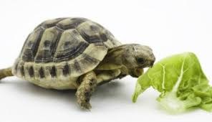

**Locomotion:**

Vertebrates have the ability to move thanks to a spine that helps support movement and muscular endurance. Some vertebrates move by different means, such as fish that swim using their fins, birds that fly using their wings, and reptiles and mammals that use all four limbs to walk, crawl or jump .

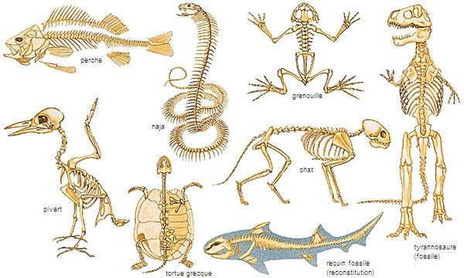

**Reproduction:**

Vertebrates reproduce sexually, with male and female mating to produce offspring. Some vertebrates can have internal embryos that grow and develop inside the female's body (as in mammals), while others give birth as eggs (as in birds and reptiles). Vertebrates can also be generated by asexual reproduction, as in the case of fish and reptiles .

