Chapter 2 : Algea

What is algae?
Algae are at the origin of the living world. Certain bacteria, the first forms of life on Earth, quickly acquired chlorophyll pigments and were thus able to initiate photosynthesis, and therefore the release of oxygen, allowing other forms of life to develop. From a common ancestor, blue, brown, red and green algae were formed. Only green algae will give rise to higher plants. Due to the disappearance of all their pigments, certain algae will give rise to organisms classified as fungi.

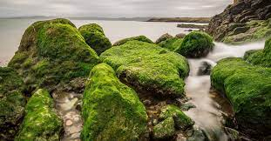

1 - General
- They constitute a very important part of biodiversity, and one of thebasics of food webs (nutrition types) in aquatic environments fresh, brackish and marine waters.
- They are also used in human food, by agriculture and the industry.
- These are Eukaryotes of very diverse shapes, capable of photosynthesis and both sexual and asexual reproduction.
- Algae are mainly aquatic, although some are found in the ground and on trees when humidity is high enough.
Generally, algae live in the rather cold waters of temperate zones.
1-1 Prokaryotes algae : Their genetic material is not found in a nucleus limited by an envelope but dispersed in the cytoplasm.
THE cyanophycea called blue-green algae or cyanobacteria Cyanophyceae are microscopic and prokaryotes. Their vegetative apparatus is a thallus
(Thallophytes) That of higher plants: corms, Cormophytes)
- They live in an aquatic or humid environment
- They are distinguished from bacteria by the presence of chlorophyll (photosynthesis).
-They are called cyanophyceae (cyan = blue and phyceae = algae) because they have a blue pigment: phycocyanin.
-Currently, they are called: Cyanobacteria

1-2Eukaryotes algae :
They have a real individualized nucleus surrounded by a double membrane.
Eukaryotic algae: Are the “true” algae divided into 3 large groups:

- Green algae or Chlorophytes
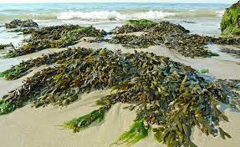

- Red algae or Rhodophytes
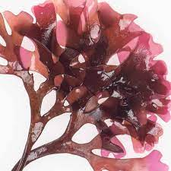
- Brown algae or Chromophytes
- 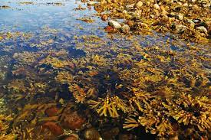

True algae are plants:
- Eukaryotic chlorophyllians
-Photosynthetics (autotrophs).
- Their habitats are varied and require the water.
1-3 Morphological diversity
- Color: Green, brown and red.
-Size: Microscopic or macroscopic (several meters, EX: Laminaria brown algae))
-Shape: Unicellular, filamentous, foliaceae, vesicles ……….

Chapter 3 : Embryophytes
3-1- Bryophytes
Bryophytes are non-vascularized leafy plants and constitute the most primitive group of terrestrial plants. Bryophytes comprise several classes, the three main being foams, liver and anthoceros. The main characteristics of their vegetative apparatus are presented according to their level of organization (from external appearance to cellular characteristics).
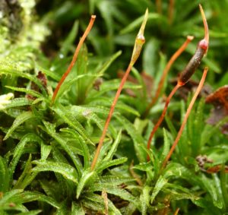
Photo 1: Atrichum undulatum (with its sporophytes), a foam of shaded places on fresh soil
3-2 Characteristics of Bryophytes
With the Bryophytes, a critical stage in evolution within the plant line – the conquest of terrestrial spaces – is reached. This involves, necessarily, the establishment of diversified mechanisms, already mentioned, to avoid dehydration of the organism. A reminder of the aquatic life of the plants’ ancestors – the green algae – persists nevertheless with the need for the male gamete to move in a liquid medium to reach the oosphere. Growing on emerging land, however, has some decisive benefits for autotrophic and phototrophical organisms, such as easier access to light

3-3 Classification of Bryophytes

The Bryophytes are divided into five classes:
- Class I, Hepaticopsida;
- Class II, Anthocerotopsida,
- Class III, Sphagnopsida
- and Class IV, Andreaeopsida.

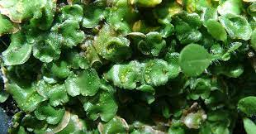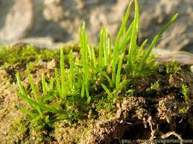

Hepaticopsida Anthocerotopsida,

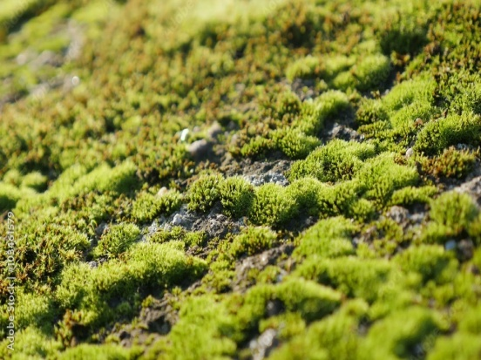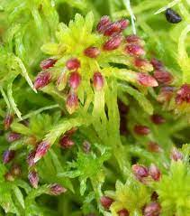

Andreaeopsida. Sphagnopsida

Hepatics are commonly referred to as all classes I and II, Sphaignes as class III, and Mousses as classes IV and V. The choice of these divisions and the order in which they are presented underline the independence of the Anthocerotopsida from other Hepatics, the importance of the distinctive characteristics of the Sphaignes in relation to the Mousses, the need to separate the small group of the Andreaeopsida of the enormous set of the Bryopsida.

Within each class, the morphological characteristics are not constant. Hence the Hepaticopsida have been subdivided into two orders: the Marchantiales, whose vegetative apparatus is a thalle and whose sporophytes are carried not by the thalle itself but by particular expansions of the thale; the Jungermanniales, the gametophyte of which appears either as a thale carrying lateral sporophyts (Jungermanniale anacrogynes), or as a leafy stalk at the end of which the sporophyte develops. (Jungermanniales acrogynes).
The Sphagnopsida currently comprise only one order, the Sphagnae, notable for the tissue of the gamethophyte and for the constitution of the sporophytes. The order of the Protosphagnales has only been found in the fossil state.
Anthocerotopsida and Andreaeopsida also have, each, a single order.
Bryopsida have a more complex structure than other classes, for example with regard to the morphology of the peristoma that closes the urn. They can be divided into about fifteen orders based on the wear of the gametophyte, the shape and arrangement of the leaves, the constitution of the capsule and the peristoma. These orders may contain a small number of families (e.g.: Fissidentales, 1 family; Polytrichales, 2 families) but, sometimes, a larger number (16 familles chez les Eubryales ; 21 familles chez les Isobryales).

Chapter 1 : General Ecology
Part one
The unit studied by ecology is the ecosystem. The term was proposed in 1935 by the English botanist Arthur Tansley.....The ecosystem is a relatively homogeneous and stable set (in the absence of disturbances) constituted by a community of living things (animals, plants, fungi, microbes) called biocenosis, in relation to a biotope (physicochemical factors determined by climate, topography, soil nature, humidity, etc.).
  - Definition of an ecosystem
The simplest definition of an ecosystem is as follows: it is a set of living beings who live within a specific environment or environment and interact with each other within that environment and with that environment.For example, a tropical forest is an ecosystem of living beings (trees, plants, insects, animals, micro-organisms) that are constantly interacting.
Ecosystem = biocenosis + biotope
An ecosystem evolves, in the absence of disturbance of natural or human origin, to a state of equilibrium called climax. However, most terrestrial or aquatic ecosystems are disrupted by human activities. We are talking about anthropogenic disturbance.
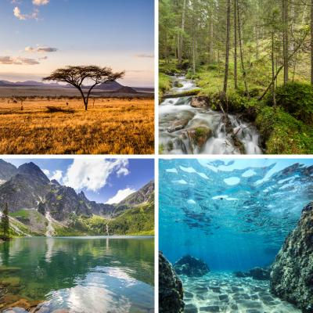
The biotope: the environment occupied by living beings The biotope is the place of life consisting of the external conditions: temperature, humidity, light, soil, relief... A biotope is the physical and chemical environment in which plants and animals live. This environment is the non-living, or abiotic, element of the ecosystem. It contains all the resources necessary for life. The biotope varies depending on ecosystems.
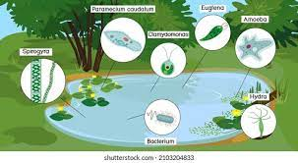
Biocenosis: The set of living beings in an environment....The second element in the ecosystem of a biocenosis are producers (chlorophyllic plants), consumers (herbivorous and carnivorous animals), decomposers (fungus, bacteria, and some animals).I mean all living beings, plants, animals and micro-organisms, who find in their environment conditions that enable them to live and reproduce.
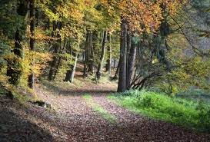

1-2 Trophy Chains
Trophy Chains (alimentaires) The place of a living being in a trophy chain represents its trophy level. There are three levels:
- the level of producers, or primary producers
the level of consumers (consommateur 1, consommateur 2, consommateur 3, etc.)
- the level of the decomposers.

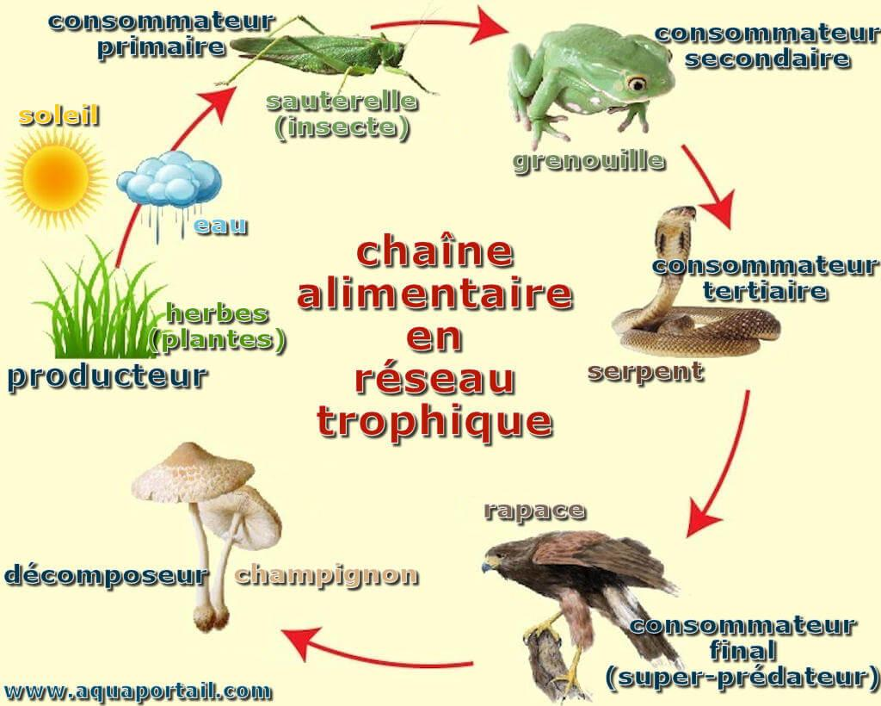
1-3 Different types of ecosystems
There are two main types of ecosystems: aquatic and terrestrial. Here are some examples of ecosystems:
I/ Aquatic ecosystems:
Aquatic ecosystems are all the ecosystem contained in a water mass. There are two types of aquatic ecosystems: freshwater and marine.
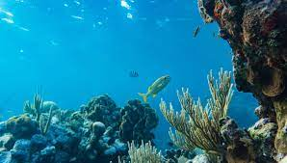
II/ Land ecosystems
Land-based ecosystems are eco-systems that exist only on Earth, such as deserts Prairies and forests.
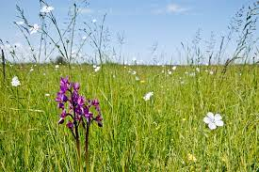

Part two : environmental factors
Classification of ecological factors:
They are of two types: biotic factors and abiotic factors
Abiotic factors: All the physical and chemical characteristics of the environment, they are divided into:
➢ Climate factors: (temperature, rainfall, light, wind...)
➢ Edaphic factors: (soil texture and structure, chemical composition of soil,...)
➢ Water factors: (water density, dissolved gas, salinity...)
1--Climate factors There are many elements of climate that play an ecological role. The main ones are temperature, humidity and rainfall, illumination and photoperiod (distribution, in the day, between the duration of the daytime and the dark phase). Others, such as wind and snow, are of less importance, but in some cases they may play a significant role.
- The Light
- temperature: Temperature plays a very important role in the development and maintenance of living organisms
- humidity (water): water is the essential constituent of living matter, living organisms are classified according to their need for water
- Wind is the result of the movement of the atmosphere between high and low pressures, The wind ensures pollination in so-called anemophilic flowering plants and the dissemination of seeds or non-carnal fruits
- Water in soil: Water is present in the soil
2-Biotic factors The relationships that exist between living organisms are either:
- Intra-specific (homotypic): they are exercised between individuals of the same species, within the same population.
- Interspecific: (Heterotypical) they are exercised between individuals of different species.
2-1-Competition)المنافسة)
a- intra-specific competition: is an interaction between two individuals of the same species, who seek and exploit the same resource that is present in the environment in limited quantity.
b-Inter-specific competition: The competition is important between two neighbouring species, two species that have the same needs cannot coexist, one will be eliminated after some time, this is the principle of competitive exclusion. Cohabiting species have mechanisms that allow them to reduce or avoid competition; they have developed ecological isolation.
2-2-Predation:
Definition: it can be defined as the consumption of all or part of an individual that is preyed by another individual who is the predator. We distinguish:
- The real predators: they kill their prey right after catching it
They kill their prey when we eat it.
- Parasites: they live in very close association with an individual prey called the host, often inside the tissues causing it problems. To get food, a predator must first search for its prey and then manipulate it (catch, prepare and eat).
2-3- Cooperative interactions (التعاون) There are positive interactions either for both species or for only one.
3- Interaction of the environment and living beings
3-1-The limiting factor: an ecological factor is called limiting when it limits the manifestation of a biological process (e.g. growth) conditioned by several other factors
Ex. Bore is rare in the soil, it is an essential element for plants when it is exhausted by the cultivated plants their growth stops even when the other elements are provided to these plants
3-2-The ecological optimum: Each organism presents to ecological factors the limits of tolerance within which its ecological optimal is situated. The abundance of the species is maximum in the vicinity of its ecological optimum.

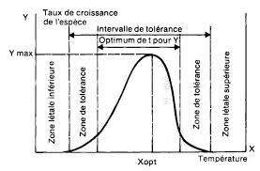
Species tolerance limits based on the intensity of the ecological factor
3-3- Ecological Valence: The ecological valence of a species is the ability of that species to populate different environments characterized by greater or lesser variations in ecological factors.

