New England Colonies

Religious Freedom
Unlike the Jamestown settlers, the next wave of colonists would arrive in search of religious freedom. England had been a Protestant country since 1534, when King Henry VIII broke away from the Roman Catholic Church and formed the Anglican Church. Not everyone in England was happy with the new church, however. Many people dissented—they disagreed with the beliefs or practices of the Anglicans. English Catholics, for example, still considered the pope the head of the church, and they were often persecuted, or treated harshly, for that reason.

At the same time, some Protestants wanted to change—or reform—the Anglican Church, while others wanted to break away from it altogether. The Protestants who wanted to reform the Angli- can Church were called Puritans. Those who wanted to leave and set up their own churches were known as Separatists.
The Separatists were persecuted in England, and some fled to the Netherlands. Though they found religious freedom there, the Separatists had difficulty finding work. They also worried that their children were losing their religious values and their English way of life.

Area claimed by New York and New Hampshire

NEW

The New England Colonies

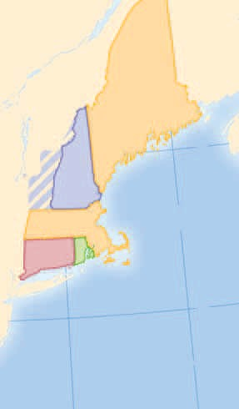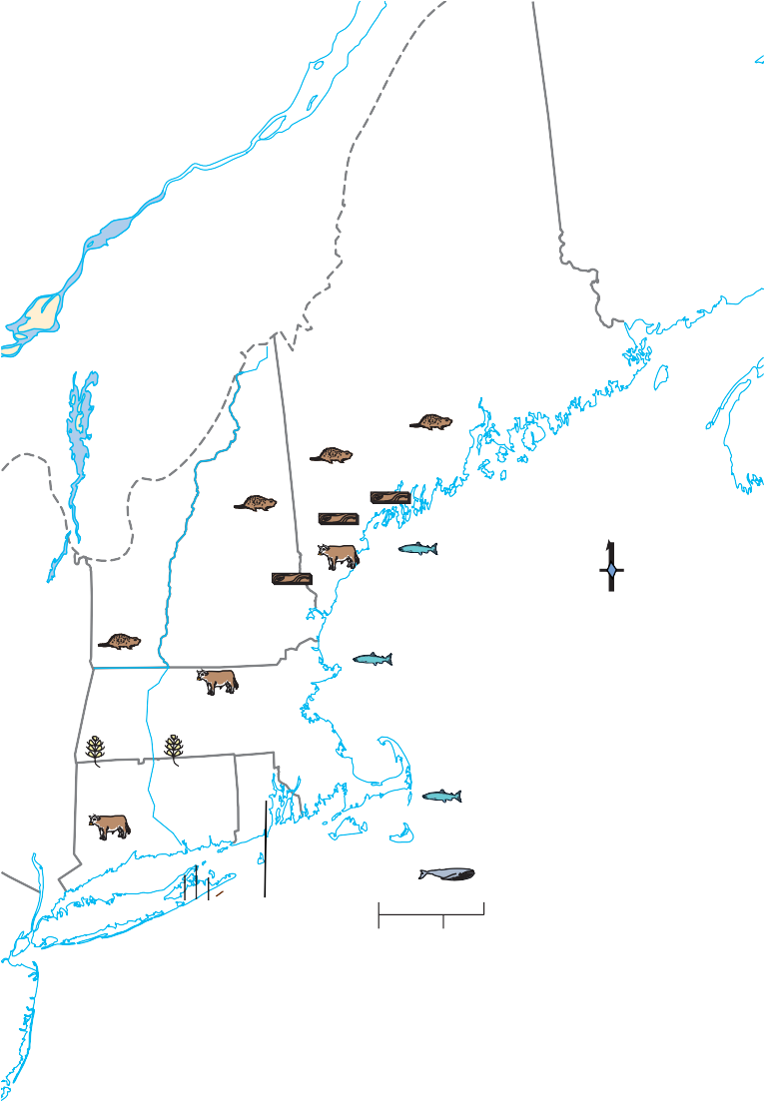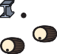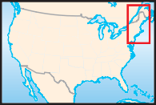MAINE
Grain Cattle
Lumber
Products
Fish Whales
Furs
Ships Iron
Rum
(part of Mass.)

The Pilgrims’ Journey
Some Separatists in the Netherlands made an arrangement with the Virginia Company. The Separatists could settle in Virginia and practice
HAMPSHIRE

MASSACHUSETTS

CONNECTICUT
Portsmouth

Salem Boston
Plymouth

Atlantic Ocean

their religion freely. In return they would give the company a share of any profits they made.
The Separatists considered themselves
Pilgrims because their journey had a religious

New
Haven
Newport

0
RHODE
ISLAND ₀

100 miles

100 kilometers

purpose. Only 35 of the 102 passengers who boarded the Mayflower in September 1620 were Pilgrims. The others were called “strangers.” They were common people—servants, crafts- people, and poor farmers—who hoped to find a better life in America. Because Pilgrim beliefs shaped life in the Plymouth colony, however, all the early settlers are usually called Pilgrims.

The Mayflower Compact
The Mayflower’s passengers planned to settle in the Virginia colony. The first land they sighted was Cape Cod, well north of their target. Because it was November and winter was fast approaching, the colonists decided to drop
Lambert Equal-Area projection

68°W

anchor in Cape Cod Bay. They went ashore on a cold, bleak day in December at a place called Plymouth. William Bradford, their leader and historian, reported that “all things stared upon them with a weather-beaten face.”
The Atlantic waters and thick forests proved valuable for
fishing and shipbuilding in New England.
- Region What were the four New England Colonies?
- Analyzing Information What did Connecticut produce?
Plymouth was outside the territory of the Vir- ginia Company and its laws. Before going ashore, the Pilgrims drew up a formal document called the Mayflower Compact. The compact pledged their loyalty to England and declared their inten- tion of forming “a civil body politic, for our better
ordering and preservation.” The signers also promised to obey the laws passed “for the general good of the colony.” The Mayflower Compact was a necessary step in the develop- ment of representative government in America.
; (See page 612 of the Appendix for the entire text of the Mayflower Compact.)

Help From the Native Americans
Their first winter in America, almost half the Pilgrims died of malnutrition, disease, and

The First Thanksgiving
In the autumn of 1621 the Pilgrims invited the Native Americans to celebrate the peace between them. After the struggle through the first winter, the Pilgrims also felt relieved to be raising food. During the feast the Pilgrims thanked God for the harvest and for their survival.

First Thanksgiving by Jennie A. Brownscombe

Who took part? About 50 men, women, and chil- dren colonists and 90 Wampanoag Native Americans took part in the three-day feast.
What did they do? Dancing, singing, and playing games were part of the celebration. The Wampanoag demonstrated their skills with the bow and arrow.

When was it held? Exactly when the festival took place is uncertain, but it is believed the celebration occurred sometime between September 21 and November 9.
What did they eat? They most likely ate wild fowl, duck, and turkey shot by the colonists and deer pro- vided by the Wampanoag.

cold. In the spring a few Native Americans approached the settlement. Two of them, Squanto and Samoset, befriended the colonists. Squanto was a Pawtuxet who had been kid- napped to Europe and had learned English.
Squanto and Samoset showed the Pilgrims how to grow corn, beans, and pumpkins and where to hunt and fish. Without their help the Pilgrims might not have survived. Squanto and Samoset also helped the Pilgrims make a treaty with the Wampanoag people who lived in the area. Massasoit, a Wampanoag leader, signed a treaty with the Pilgrims in March 1621, and the two groups lived in harmony.

New Settlements
In 1625 the English throne passed to Charles I. Charles objected to the Puritans’ calls for reform in the Anglican Church, and persecution of Puri- tans increased again. Some Puritans looked for a way to leave England.
In 1629 a group of Puritans formed the Massachusetts Bay Company and received a royal charter to establish a colony north of Plymouth. This was the Puritans’ chance to cre- ate a new society in America—a society based on the Bible.
The company chose a well-educated Puritan named John Winthrop to be the colony’s gover- nor. In 1630 Winthrop led about 900 men, women, and children to Massachusetts Bay. Most of them settled in a place they called Boston.

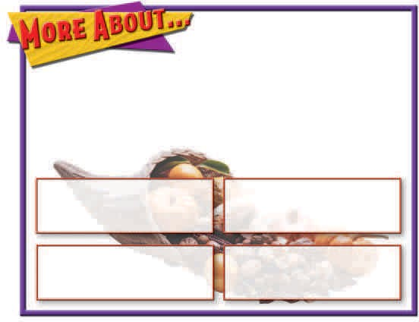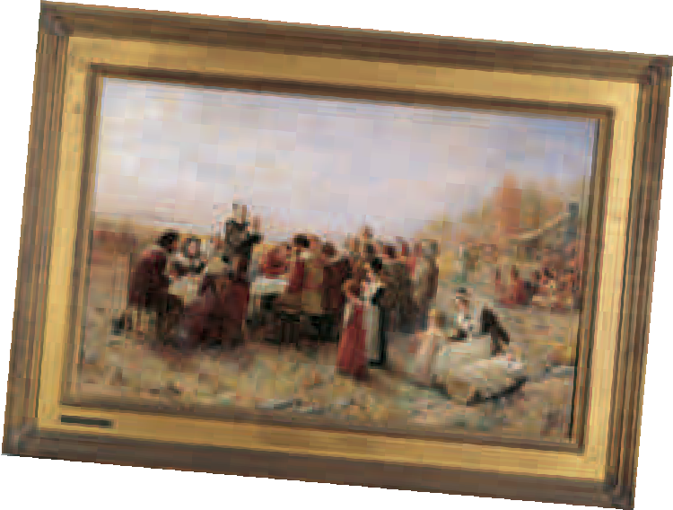

Citizenship
Growth and Government
During the 1630s, more than 15,000 Puritans journeyed to Massachusetts to escape religious persecution and economic hard times in Eng- land. This movement of people became known as the Great Migration.
At first, John Winthrop and his assistants made the colony’s laws. They were chosen by the General Court, which was made up of the colony’s stockholders. In 1634, settlers demanded a larger role in the government. The General Court became an elected assembly. Adult male church members were allowed to vote for the governor and for their town’s representatives to the General Court. In later years, they also had to own property to vote.
The Puritans came to America to put their religious beliefs into practice. The Puritans had little toleration—they criticized or persecuted people who held other religious views. This lack of toleration led to the creation of new colonies.

Connecticut and Rhode Island
The fertile Connecticut River valley, south of Massachusetts, was much better for farming
than was the stony soil around Boston. In the 1630s colonists began to settle in this area.
A minister named Thomas Hooker became dissatisfied with Massachusetts. He did not like the way that Winthrop and the other Puritan leaders ran the colony. In 1636 Hooker led his congregation through the wilderness to Con- necticut, where he founded the town of Hart- ford. Three years later Hartford and two other towns, Windsor and Wethersfield, agreed to form a colony. They adopted a plan of govern- ment called the Fundamental Orders of Con- necticut. This was the first written constitution in America, and it described the organization of representative government in detail.
Good land drew colonists to Connecticut, but Rhode Island was settled by colonists who were forced out of Massachusetts. The first of these was Roger Williams, a minister. Williams felt that peo- ple should not be persecuted for their religious practices. In his view the government should not force people to worship in a certain way. Williams also believed it was wrong for settlers to take land away from the Native Americans.
The ideas of Roger Williams caused Massa- chusetts leaders to banish him in 1635. He took refuge with the Narraganset people, who later

Anne Hutchinson came to Massachusetts with her husband in 1634.
She began questioning the religious authority of the colony’s ministers.
As Hutchinson gained followers, she was seen as a danger to the
colony’s stability. In 1637 the Massachusetts lead- ers put her on trial for speaking false ideas.
Hutchinson defended herself well, but she claimed God spoke to her directly. This disagreed with Puritan beliefs that
God spoke only through the Bible. Her accusers found her guilty and ordered her to leave the colony. With her family and some followers, Hutchinson moved to Rhode Island.

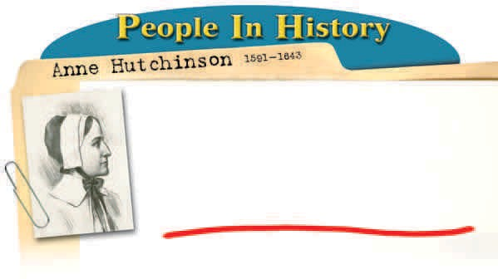

sold Williams land where he founded the town of Providence. Williams received a charter in 1644 for a colony east of Connecticut called Rhode Island and Providence Plantations. With its pol- icy of religious toleration, Rhode Island became a safe place for dissenters. It was the first place in America where people could worship freely.
Others followed Williams’s example, forming colonies where they could worship as they
pleased. In 1638 John Wheelwright led a group of dissidents from Massachusetts to the north. They founded the town of Exeter in New Hampshire. The same year, a group of Puritans settled Hamp- ton. The colony of New Hampshire became fully independent of Massachusetts in 1679.
Conflict With Native Americans

Native Americans helped the settlers adapt to the land. They also traded with the settlers, exchanging furs for goods such as iron pots, blankets, and guns. In Virginia the colonists had frequent encounters with the many tribes of the Powhatan confederacy. In New England the set- tlers met the Wampanoags, Narragansets, and other groups.
Conflicts arose, however. Usually settlers moved onto Native American lands without permission or payment. Throughout the colo- nial period, English settlers and Native Ameri- cans competed fiercely for control of the landIn 1636 war broke out between the settlers and the Pequot people. After two traders were killed in Pequot territory, Massachusetts sent troops to punish the Pequot. The Pequot then attacked a town in
Connecticut killing nine people. In May 1637, troops from Connecticut attacked the main Pequot fort with the help of the Narraganset people. They burned the fort, killing hundreds.
In 1675 New England went to war against the Wampanoag people and their allies. Metacomet, the Wampanoag chief, was known to settlers as King Philip. He wanted to stop the settlers from moving onto Native American lands. The war began after settlers executed three Wampanoags for murder. Metacomet’s forces attacked towns across the region, killing hundreds of people.
The settlers and their Native American allies fought back. King Philip’s War, as the conflict was called, ended in defeat for the Wampanoag and their allies. The war destroyed the power of the Native Americans in New England, leaving the colonists free to expand their settlements.

