HENRY VIII AND THE REFORMATION

A fool, a liar and a damnable rotten
worm. 'Martin Luther on Henry VIII
H

enry VIII was arguably the most brilliant, but certainly the most powerful and terrible of all English monarchs. Henry's court was
spectacular and he was the first monarch to be addressed as Majesty. He was also a great patron of the arts. But no king has been so ruthless with those who challenged him. Paranoid and cruel, he was both a hero and a monster.
Henry was a strikingly handsome and charming 17-year­ old when he became King of England in 1509. He was
particularly admired for his physical prowess - he was an expert horseman, wrestler, archer and dancer. He was also fluent in French, Spanish and Latin, and was an accomplished musician. The famous scholar Erasmus proclaimed that Henry was 'a universal genius'.
The young king seemed to have everything. He personally led three successful military campaigns in France on horseback. In 1521, the Pope granted him the title 'Defender of the Faith' after Henry had written an attack on Martin Luther (leader of the Protestant
Reformation, Europe's revolution against the Catholic 20 Church). But after nearly 20 years of marriage to Catherine of Aragon (the widow of his elder brother,
Arthur), Henry still lacked the one thing he wanted more than anything else - a son. He had become convinced that a series of failed pregnancies and stillbirths were the result of God's displeasure. The evidence was in the Bible: 'If a man shall take his brother's wife, it is an unclean thing ... they shall be childless.' All Henry needed was the Pope's
permission to divorce Catherine. He had a ready- 30
made replacement in Anne Boleyn, a self-assured beauty ten years his junior who was already pregnant with his child.
The Pope's refusal to grant Henry a divorce unleashed forces whose consequences are still felt today. In 1534, Henry formally broke with the Roman Catholic Church and granted himself a divorce from Catherine. He then proclaimed himself head of the Church of England. This was the English Reformation and it gave Henry sweeping
new powers which he was quick to use. He destroyed 40
600 monasteries and sold their land.

Anne Boleyn's marriage to such a man was to prove fatal for her. Her 'crime', like Catherine's before her, was her failure to produce a son. Henry wanted the marriage to end and so bent the truth for his own purposes. Thus, Anne's naturally flirtatious nature was used as definitive 'proof' of adultery. Men were tortured and absurd 'confessions' were produced. A court musician pleaded guilty to adultery. Anne's own
brother was charged with having sex with her.
On the morning of Anne's execution (19th May 1 536), she said: 'I hear the executioner is very good, and I have a little neck.' By that time, Henry was already on his way up the Thames to see Jane Seymour. The couple were engaged the very next day and married ten days after that. Jane was able to give Henry what he desperately wanted, a male heir. It was, however, a difficult birth and Jane died from a fever less than two weeks after giving birth. Her death brought Henry great sorrow. It was later
said that her name was on Henry's lips when he died in 1547, and he was buried next to her.
Henry was to marry three more times: to Anne of Cleves in 1540; to Catherine Howard, who was executed for adultery in 1542 along with her lover and three other members of the royal household; and finally, in 1543, to Catherine Parr, who survived him. Henry's ever-changing private life was matched by his increasingly extreme public policies. He behaved with great cruelty not only to those who he believed had
betrayed him but also to those who were closest to him. This included his brilliant ministers Thomas Cromwell and Cardinal Thomas Wolsey. The former was executed on 28th July 1 540; the latter died while facing charges of high treason. One historian has written: 'His most enduring conviction was that next to God, he knew best.'
The final years of Henry's reign, which Charles Dickens called 'a spot of blood and grease upon the history of

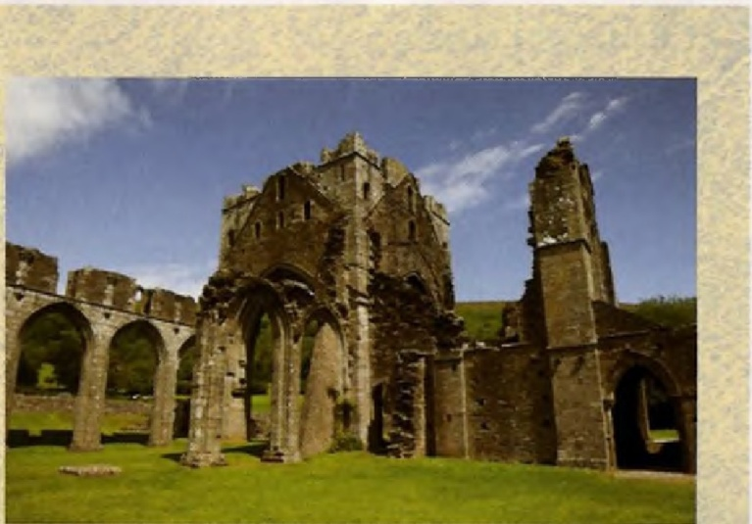
A ruined monastery

England', saw a descent into tyranny. Both Henry's appearance and conduct were transformed. Between the ages of 23 and 45 his waist measurement increased so gradually from 89 cm to 114 cm. By 1541, his waist measured 137 cm, his chest 145 cm. He became too
obese to walk, so a small cart was built to transport him around the royal palace at Hampton Court. His enormous size led to a variety of physical ailments. He had foul-smelling breath, his legs were covered in leaking boils and fungus, and he suffered from chronic haemorrhoids. Research suggests that his violent mood swings may have owed something to the complete
lack of vitamins in his diet. Henry would touch neither 90
vegetables nor fruit - he simply ate vast amounts of meat and drank immense quantities of alcohol.
In his 36-year reign, Henry squandered his many advantages. He came to the throne rich but left huge debts and a currency which had lost its value. As a result of his father's 'divorcements and such mischiefs', the sickly boy king Edward VI was given an impossible legacy. Henry's rule had been arbitrary, cruel and driven by anger. And as the Duke of Norfolk warned, 'The
consequence of royal anger is death.'

