Larbi Ben M’hidi University
English Department
Research Methodology/ 2nd Year
S. AROUF
Reference List
APA 7th Edition Referencing Style
Writing a Reference List
The reference list at the end of a paper provides the information necessary to identify and retrieve each work cited in the text. That is, the purpose of the reference list is to allow your sources to be found by your reader. It also gives credit to authors you have consulted for their ideas. All references cited in the text must appear in the reference list.
A reference list lists only the sources you refer to in your writing.
A bibliography is different from a reference list as it lists all the sources used during your research and background reading, not just the ones you refer to in your writing.
Format of a reference list
- What to include: All references cited in the text must appear in the reference list.
- Location: On a new page after the text and before any appendices.
- Heading: use References as the title at the top of the page (beginning with a capital letter, in bold, centered, and not in italics).
- Order: All references are listed alphabetically by author, or title if there is no author. If there are two entries with identical authors but different dates, order them chronologically, earliest first.
- Space: Double-space the whole reference list (between each reference AND within the reference).
- Hanging indent: 0.5 inch (1.27cm) from the left margin for the second and subsequent lines of each reference. This means that the first line of each entry is left aligned, while the second and subsequent lines are indented
- URL: use of hyperlinks is preferred. However, you may use plain text that is not underlined for URLs.
Notes:

- No specific font type or size required. Recommendations include Calibri size 11, Arial size 11, Lucida size 10, Times New Roman size 12, Georgia size 11 or Computer Modern size 10 (LaTeX).
- Each reference appears on a new line.
- References should not be numbered.
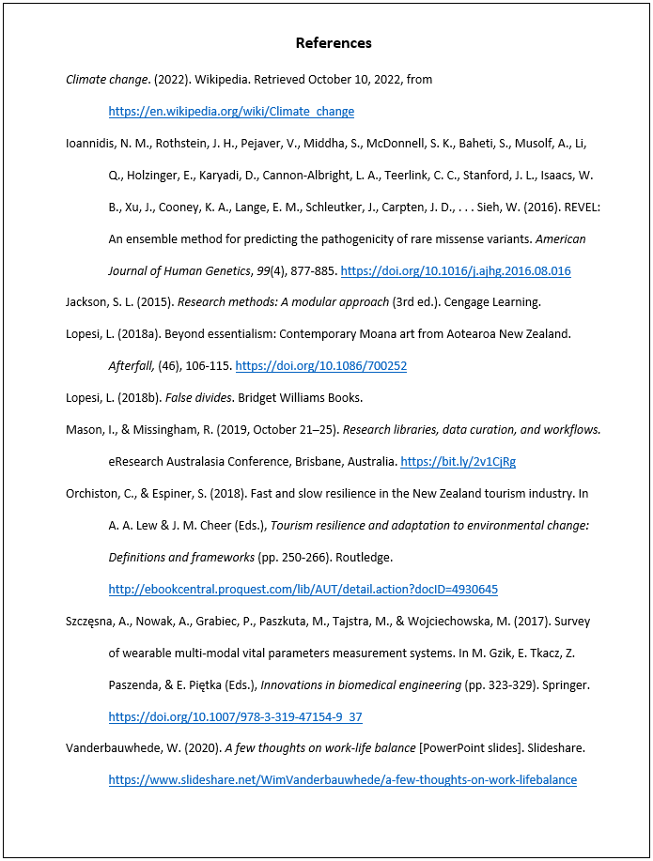
Four Elements of a Reference
A reference is the bibliographic information of a work cited. In APA, a reference generally has four elements: author, date, title, and source (Figure 1). Each element answers a question:
author: Who is responsible for this work?
date: When was this work published?
title: What is this work called?
source: Where can I retrieve this work?
The elements of a reference are illustrated in Table 1.
Table 1 Four Elements of a Reference
Who | When | What | Where
Author/s.  Editor/s.  Group author/s. | (Year/date). | Title of a book.  Title of a chapter of an edited book.  Title of a journal article. | Publisher of this book.  Title of the edited book.  Journal Name, volume(issue), pp–pp.

Figure 1 Example of Where to Find Reference Information for a Journal
Article
