Larbi Ben M’hidi University
English Department
Research Methodology/ 2nd Year
S. AROUF
Reference Examples
APA 7th Edition Referencing Style
Books
Basic Format:
Author, A. A. (Year of publication). Title of work: Capital letter also for subtitle. Publisher
Name. DOI or URL (if available)
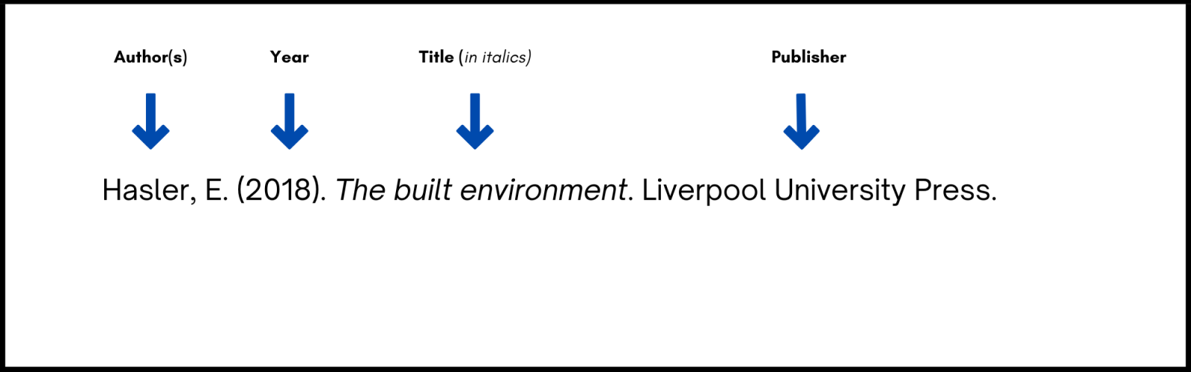
Note: If available, APA 7 requires a DOI for all works that have one — whether print or digital. If a print work does not have a DOI do not include it in the reference citation.
One author
Elements of  the reference | Author(s) of book – family name and initials. (Year). Title of book –  italicised. Publisher. DOI or Web address - if available
Reference list | Swartz, W. (2019). Descriptive psychology and the person concept:  Essential attributes of persons and behavior. Academic Press.  https://doi.org/10.1016/C2017-0-00372-5
Two authors
Elements of  the reference | Author(s) of book – family name and initials, use & for multiple authors.  (Year). Title of book - italicised. Publisher. DOI or Web address - if  available
Reference list | Whittingham, K., & Coyne, W. (2019). Acceptance and commitment  therapy: The clinician's guide for supporting parents​. Academic Press.  https://doi.org/10.1016/C2017-0-01265-X

Three to twenty authors
Elements of  the reference | Author(s) of book – family name and initials, with commas between authors,  and use & between the last two authors. (Year). Title of book –  italicised. Publisher. DOI or Web address - if available
Reference list | Sheldon, P., Rauschnabel, P. A., & Honeycutt, J. M. (2019). The dark side of  social media: Psychological, managerial, and societal perspectives.  Academic Press. https://doi.org/10.1016/C2017-0-04063-6
Twenty one or more authors
Elements of  the reference | Author(s) of book – family name and initials (for first 19 authors), . . . final  author name and initial(s). Title of book – italicised. Publisher. DOI or  Web address - if available
Reference list | Harris, K., Johnson, W., Matthews, L., Wilson, K., Lewis, S., Bailey, T., Kelly,  M., Norris, O., James, P., Harrison, I., Grant, Q., Vince, J., Patterson,  Y., Carson, H., Allison, T., Lang, R., Roberts, G., Gordon, N., Yates, J., . . .  Holland, F. (2019). Brisbane city history. University of Queensland.
No author
Elements of  the reference | Title of book - italicised. (Year). Publisher. DOI or Web address - if  available
Reference list | The CCH Macquarie dictionary of business. (1993). CCH Australia.
Author identified as anonymous
Elements of  the reference | Anonymous - only if author is specifically named as “Anonymous”. (Year).  Title of book - italicised. Publisher. DOI or Web address - if available
Reference list | Anonymous. (1996). Primary colors: A novel of politics. Random House.
Book or ebook by an organisation or institution (group author)
Elements of  the reference | The full name of the group author, use & for multiple group authors. (Year).  Title of book - italicised. Publisher. DOI or Web address - if available
Reference list | Queensland Health. (2002). Best practice guidelines for the management  of type 1 diabetes in children and adolescents.  If the author name is the same as the publisher, omit the publisher.
Edited book (book itself cited in text)
Last name of Editor of Book, First initial. Middle initial (Ed.). (year of publication). Title of
book. Publisher.
White, J. A. (Ed.). (2009). Plagiarism in the twenty-first century. Bluebird.
Hoffmann, C. R., & Wolfram Bublitz, W. (Eds.). (2017). Pragmatics of social
media. De Gruyter. https://doi.org/10.1515/9783110431070

Note: Edited book with a DOI, with multiple publishers
Schmid, H.-J. (Ed.). (2017). Entrenchment and the psychology of language learning: How we
reorganize and adapt linguistic knowledge. American Psychological Association; De Gruyter
Mouton. https://doi.org/10.1037/15969-000

Chapter in an edited book
Only reference a chapter if it has individual authors for each chapter in the book.
General format
Last name of author, First initial. Middle initial. (year of publication). Title of chapter. In
Initial of editor Last name of editor (Ed.), Title of book (edition number ed., pp. page
numbers).Publisher. DOI or Web address (if available)
Example
Rattan, A. (2019). How lay theories (or mindsets) shape the confrontation
of prejudice. In R. K. Mallett & M. J. Monteith (Eds.), Confronting
prejudice and discrimination: The science of changing minds and
behaviors (pp. 121-140). Academic Press. https://doi.org/10.1016/B978-
Book with different editions
Elements of  the reference | Author(s) of book – family name and initials, use & for multiple authors.  (Year). Title of book - italicised (Edition number ed.). Publisher. DOI or  Web address - if available
Reference list | Madigan, S. (2019). Narrative therapy (2nd ed.). American Psychological  Association. https://doi.org/10.1037/0000131-000
One volume of a multivolume work
Fiske, S. T., Gilbert, D. T., & Lindzey, G. (2010). Handbook of social psychology (5th ed., Vol.
1). John Wiley & Sons. https://doi.org/10.1002/9780470561119
Several volumes in a multivolume work
Lerner, R. M. (Ed.). (2015). Handbook of child psychology and developmental science (7th ed.,
Vols.1-4). John Wiley & Sons.
E-BOOKS
General format
Last name of author, First initial. Middle initial. (Year of publication). Title of book.
Publisher. URL.
Example
Shiller, A. L. (2011). APA Rules Made Easy. Henry Holt. http://www.ama.co/ap9734zHRP
Articles in a periodical
Journal article with DOI
General format

Last name of author, First initial. Middle initial. (year of publication). Title of article. Title of
Journal, volume number(issue number), page numbers. http://doi.org/xxxxxx
Example
Hammond, T. C. (2018). Citing information properly. College English,76(8), 276-281.
http://doi:.org/ 10.1275/0678-8743.76.2.276
Journal article with no DOI available
General format
Last name of author, First initial. Middle initial. (year of publication). Title of article. Title of
Journal, volume number(issue number), page numbers.
Example
Hammond, T. C. (2019). Citing information properly. College English,76(8), 276-281.
Note: If each issue of the journal starts with page 1, include the issue number in parentheses after the volume number, but do not italicize the issue number. [EXAMPLE: College English, 76(2)]
Newspaper article
General format
Last name of author, First initial. Middle initial. (year of publication, month day). Title of
article. Title of Newspaper, page numbers.
Example
Blum, R. S. (2007, December 3). Searching for credible sources. Canton Repository, C13.
Online newspaper article
General format
Last name of author, First initial. Middle initial. (year of publication, month day). Title of
article. Title of Newspaper. Retrieved from URL of newspaper
Example
Blum, R. S. (2007, February 22). Searching for credible sources. Canton Repository.
Retrieved from http://www.cantonrepository.com
WWW Sources
Webpage on a website with a retrieval date
General format
Last name of author, First initial. Middle initial. (year of publication, month day, if available).
Title of piece on website (article). Website Name. URL
Example
Latamer, A. C. (2009, May 3). Documentation made easy. http://www.oll.com
Webpage on a website with no date
General format
Last name of author, First initial. Middle initial. (n.d.). Title of piece on website
(article).Website Name. URL
Example
Smith, A. (n.d.). The new APA. College Writing Centers of America. http://www.CWCA.com
Webpage on a news website (like BBC, CNN, Reuters, not a newspaper)
General format
Last name of author, First initial. Middle initial. (year of publication, month day, if available).
Title of work.Website Name. URL
Example
Cummings, B. F. (2019, May 3). News on APA changes. CNN.
http://www.cnn.com/entry/newson-APA-changes_us_5b738021
Dissertations and Theses
Unpublished dissertation or thesis
General format
Author | Date | Title | Source
Author, A. A. | (2020). | Title of dissertation [Unpublished doctoral dissertation].  Title of thesis [Unpublished master’s thesis]. | Name of Institution Awarding the Degree.
Example
Harris, L. (2014). Instructional leadership perceptions and practices of elementary school
leaders [Unpublished doctoral dissertation]. University of Virginia.
Use the template shown next to construct references for published dissertations and theses.
 |  |  | Source
Author | Date | Title | Database or archive  name | URL
Author, A.  A. | (2020). | Title of dissertation [Doctoral dissertation, Name of Institution Awarding  the Degree].  Title of thesis [Master’s thesis, Name of Institution Awarding the Degree]. | Database Name.  Archive Name. | https://xxxxx
Dissertation or thesis from a database
Hollander, M. M. (2017). Resistance to authority: Methodological innovations and new lessons
from the Milgram experiment (Publication No. 10289373) [Doctoral dissertation,
University of Wisconsin–Madison]. ProQuest Dissertations and Theses Global.

Dissertation or thesis published online (not in a database)
Hutcheson, V. H. (2012). Dealing with dual differences: Social coping strategies of gifted and
lesbian, gay, bisexual, transgender, and queer adolescents [Master’s thesis, The College of
William & Mary]. William & Mary Digital Archive.
https://digitalarchive.wm.edu/bitstream/handle/10288/16594/HutchesonVirginia2012.pdf
Entry in a dictionary, with group author
American Psychological Association. (n.d.). APA dictionary of psychology. Retrieved June 14,
2019, from https://dictionary.apa.org/
Merriam-Webster. (n.d.). Merriam-Webster.com dictionary. Retrieved May 5, 2019, from
https://www.merriam-webster.com/

References
American Psychological Association (2020). Publication manual of the American psychological
association (7 th ed.).
University of Akron – Wayne College. (2020). APA handout for Wayne College students.

