Greeting/ Farewells
Greeting is an act of communication in which human beings intentionally make their presence known to each other, to show attention to, and to suggest a type of relationship,social status (formal or informal) between individuals or groups of people coming in contact with each other.

Formal greetings :When you greet someone formally, the greeting you use depends on what time of day it is. You say 'Good morning' until about noon. 'Good afternoon' is normal from about noon until about six o'clock, or until it is dark in the winter. After six o'clock, or after dark, you say
Good morning, Good evening 'Good afternoon. Afternoon etc..

You only say 'Goodnight' when you are leaving someone in the evening or going to bed. Don't use 'Goodnight' to greet someone.
'Good day' is old-fashioned and rather formal in British and American English, although the short form 'g'day' is more common in Australian English.
'Welcome' can be used to greet someone who has just arrived. It is quite formal in British English, but is normal in American English.
Welcome to Peking..Welcome back.

Informal Greetings :There are many more informal greetings in English than there are formal ones and this is because most situations call for a more laid back tone. We are now going to take a look at some informal greetings which you can use with English speaking friends, family or anyone else that you are familiar with.
- Hi or ‘hello‘ is probably one of the most commonly used greetings in the English language.
- Hiya – This is another take on the above mentioned ‘hi’ and is commonly used in the UK.
- Hey (there!)
- How’s it going?
- How you doing? .
- ‘Sup – More common in the USA, this greeting is a slang term meaning ‘what’s up?’ Many people will use the term ‘what’s up’ but often it is shortened to ‘sup.
- Yo – This is another one which is more common in the USA, and is simply another way to say ‘hey, what’s up?’
- How’s things/how’s life? – Rather than asking the more formal question ‘how are you?’ many people use this less formal term.
- Long time, no see – This greeting is usually used when bumping into a person who you have not seen for a long time.

Greetings are generally followed by introductions where you either introduce yourself or the person/s accompanying you. Choice of appropriate language is important in these situations.
EX
A : hello,how are you ?
B : im fine,pardon me.. what is your name
A : My name is Alex
.B : nice to meet you Alex,Im Sarah.
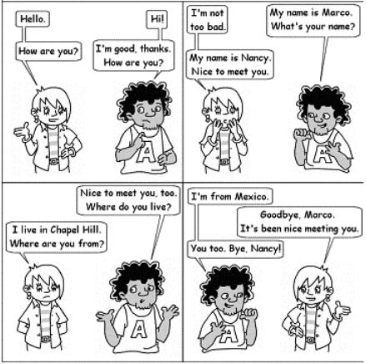

Asking questions ?
A WH question is a question in English that a request for information rather than to answer “yes” or “no”:
typically introduced by the word who, which, what, where, when, or how “

Yes / No questions
Yes / No Questions can be answered with a simple “Yes” or “No” You may ou may not complement your answer, the question has been answered anyway.
Some examples:
EX :Are they Russian? No, they are not.
EX :Can you help me? Yes, I can.

Yes/No Questions – Structure

To be + subject + complement
Is she nice? Yes, she is.
Are the cats hungry? No, they are not.
Was the house clean? Yes, it was.
Were they at home? No, they were not.
Am I late? No, you are not

WH Questions are open questions, they need a proper specific answer. It is not possible to answer them using Yes or No.
- What is your name? My name is John.
- Where are you from? I am from London.
- How old are you? I am 32.





