3. Hydraulic structures
A hydraulic structure is a structure submerged or partially submerged in any body of water, which disrupts the natural flow of water. They can be used to divert, disrupt or completely stop the flow. An example of a hydraulic structure would be a dam, which slows the normal flow rate of river in order to power turbines. A hydraulic structure can be built in rivers, a sea, or any body of water where there is a need for a change in the natural flow of water.

Classification of hydraulic structures on the basis of material
- Earth fill
- Rock fill
- Concrete
- Stone masonry
- Timber
- Steel coffer

Classification of hydraulic structures on the basis of function
- Flow control structures
They are used to regulate the flow and pass excess flow. They might be gates, spillways, valves, or outlets.
- Flow measurement structures
They are used to measure discharge. They are weirs, orifices, flumes etc.
- Division structures
They are used to divert the main course of water flow. They are coffer dams, weirs, canal headwork’s, intake works.
- Conveyance structures
They are used to guide the flow from one place to another. They are open channels, pressure conduit, pipes, canals and sewers.
- Collection structures
They are used to collect water for disposal. They are Drain inlets, infiltration galleries, wells.
- Energy dissipation structures
They are used to prevent erosion and structural damage. They are stilling basins, surge dams, check dams.
- River training and water stabilizing structures
They are used to maintain river channel and water transportation. Levees, cutoffs, locks, piers, culverts
- Sediment and quality control structures
They are used to control or remove sediments and other pollutants. They are racks, screens, traps, sedimentation tanks, filters, sluiceways.
- Hydraulic machines
They are used to convert energy from one form to another. They are turbines, pumps, ramps,
- Storage structures:
They are used for the purpose of storage of water. These may be dams or tanks, etc….
- Shore protection structures
They are used to protect banks. Dikes, groins, jetties, revetments

Earthfill dams
An earth dam is made of earth (or soil) built up by compacting successive layers of earth, using the most impervious materials to form a core and placing more permeable substances on the upstream and downstream sides. A facing of crushed stone prevents erosion by wind or rain, and an ample spillway, usually of concrete, protects against catastrophic washout should the water overtop the dam. Earth dam resists the forces exerted upon it mainly due to shear strength of the soil. Although the weight of the structure also helps in resisting the forces, the structural behavior of an earth dam is entirely different from that of a gravity dam. The earth dams are usually built in wide valleys having flat slopes at flanks (abutments).The foundation requirements are less stringent than those of gravity dams, and hence they can be built at the sites where the foundations are less strong. They can be built on all types of foundations. However, the height of the dam will depend upon the strength of the foundation material. The reason for such wide spread use of earth fill dams are
- The foundation requirements are not as rigorous as other dams
- Local available soil is the main construction material
- High skill not required
- No special plants are required. Most earth-moving machines can be used
Rockfill Dams
A rockfill dam is built of rock fragments and boulders of large size. An impervious membrane is placed on the rockfill on the upstream side to reduce the seepage through the dam. The membrane is usually made of cement concrete or asphaltic concrete. In early rockfill dams, steel and timber membrane were also used, but now they are obsolete. A dry rubble cushion is placed between the rockfill and the membrane for the distribution of water load and for providing a support to the membrane. Sometimes, the rockfill dams have an impervious earth core in the middle to check the seepage instead of an impervious upstream membrane. The earth core is placed against a dumped rockfill. It is necessary to provide adequate filters between the earth core and the rockfill on the upstream and downstream sides of the core so that the soil particles are not carried by water and piping does not occur. The side slopes of rockfill are usually kept equal to the angle of repose of rock, which is usually taken as 1.4:1 (or 1.3:1). Rockfill dams require foundation stronger than those for earth dams.
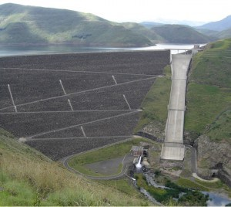

Arch Dams
An arch dam is curved in plan, with its convexity towards the upstream side. They transfer the water pressure and other forces mainly to the abutments by arch action. An arch dam is quite suitable for narrow canyons with strong flanks which are capable of resisting the thrust produced by the arch action. The section of an arch dam is approximately triangular like a gravity dam but the section is comparatively thinner. The arch dam may have a single curvature or double curvature in the vertical plane. Generally, the arch dams of double curvature are more economical and are used in practice.
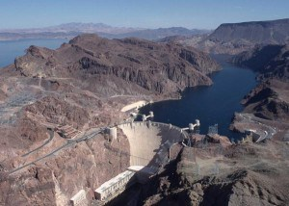
Buttress Dams
Buttress dams are of three types: (I) Deck type, (ii) Multiple-arch type, and (iii) Massive-head type. A deck type buttress dam consists of a sloping deck supported by buttresses. Buttresses are triangular concrete walls which transmit the water pressure from the deck slab to the foundation. Buttresses are compression members. Buttresses are typically spaced across the dam site every 6 to 30 meter, depending upon the size and design of the dam. Buttress dams are sometimes called hollow dams because the buttresses do not form a solid wall stretching across a river valley. The deck is usually a reinforced concrete slab supported between the buttresses, which are usually equally spaced.
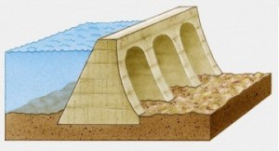
Steel Dams
Dams: A steel dam consists of a steel framework, with a steel skin plate on its upstream face. Steel dams are generally of two types: (I) Direct-strutted, and (ii) Cantilever type. In direct strutted steel dams, the water pressure is transmitted directly to the foundation through inclined struts. In a cantilever type steel dam, there is a bent supporting the upper part of the deck, which is formed into a cantilever truss. This arrangement introduces a tensile force in the deck girder which can be taken care of by anchoring it into the foundation at the upstream toe. Hovey suggested that tension at the upstream toe may be reduced by flattening the slopes of the lower struts in the bent. However, it would require heavier sections for struts.
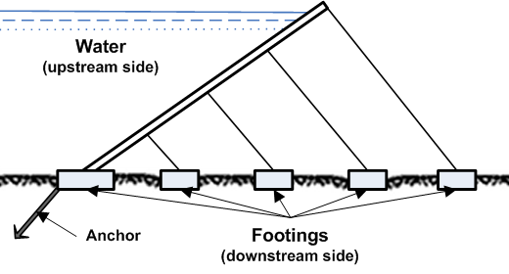

Timber Dams
Main load-carrying structural elements of timber dam are made of wood, primarily coniferous varieties such as pine and fir. Timber dams are made for small heads (2-4 m or, rarely, 4-8 m) and usually have sluices; according to the design of the apron they are divided into pile, crib, pile-crib, and buttressed dams. The openings of timber dams are restricted by abutments; where the sluice is very long it is divided into several openings by intermediate supports: piers, buttresses, and posts. The openings are covered by wooden shields, usually several in a row one above the other. Simple hoists—permanent or mobile winches—are used to raise and lower the shields.
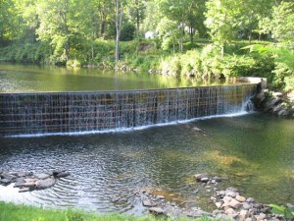
Rubber Dam
A symbol of sophistication and simple and efficient design, this most recent type of dam uses huge cylindrical shells made of special synthetic rubber and inflated by either compressed air or pressurized water. Rubber dams offer ease of construction, operation and decommissioning in tight schedules. These can be deflated when pressure is released and hence, even the crest level can be controlled to some extent. Surplus waters would simply overflow the inflated shell. They need extreme care in design and erection and are limited to small projects
