Southern Colonies

By 1660, while tobacco prices fell, large plantations continued to prosper because they were better able to maintain high profits than were small farms. Along with the growth of plantations, there was an increasing need for work- ers in the newly settled Southern Colonies.
Establishing colonies in North America involved a great deal of work. The set- tlers had to clear the land, construct homes and churches, plant crops, and tend the fields. As the colonies expanded, the demand for capable workers grew.

Not all people came to work in the colonies of their own free will. English criminals and Scottish and Irish prisoners of war were also shipped to the colonies. They could earn their release by working for a period of time—often seven years. Some colonists complained that their settlements were dumping grounds for “His Majesty’s seven- year passengers.” African rulers took prisoners during wars and raids. They enslaved the cap- tives and sold them to European slave traders who took them to the colonies. Many people came to the colonies as indentured servants. To pay for their passage to America, they agreed to work without pay for a certain period of time.

Establishing Maryland
Maryland arose from the dream of Sir George Calvert, Lord Baltimore, a Catholic. Calvert wanted to establish a safe place for his fellow Catholics, who were being persecuted in England. He also hoped that a colony would
their workers. Baltimore, founded in 1729, was Maryland’s port. Before long Baltimore became the colony’s largest settlement.

Aristocrats and Farmers
Lord Baltimore gave large estates to his rela- tives and other English aristocrats. By doing so he created a wealthy and powerful class of landowners in Maryland.
The colony needed people to work in the plan- tation fields. To bring settlers to the colony, Lord Baltimore promised land—100 acres to each

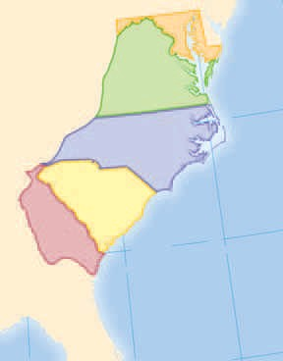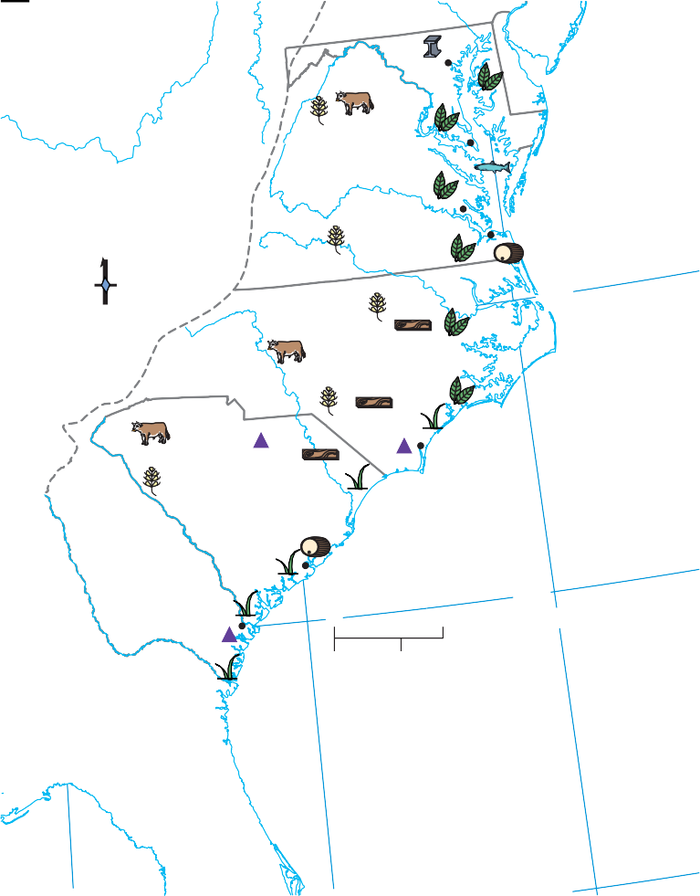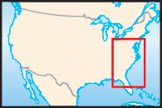The Southern Colonies
Rice Indigo
Cattle
Products
Grain Tobacco
Fish
Lumber Iron
Rum
Baltimore

VIRGINIA St. Marys

bring him a fortune.
Calvert’s dream came true in 1632 when King Charles I gave him a proprietary colony north of Virginia. Calvert died before receiving the grant. His son Cecilius Calvert inherited the colony. It was named Maryland either after the English queen, Henrietta Maria, or after the Virgin Mary.
Williamsburg

NORTH CAROLINA
Norfolk

The younger Calvert—the new Lord Balti- more—never lived in Maryland. Instead, he sent two of his brothers to run the colony. They reached America in 1634 with two ships and more than 200 settlers. Entering the Chesa- peake Bay, they sailed up the Potomac River
through fertile countryside. A priest in the
SOUTH CAROLINA

GEORGIA
Savannah
Wilmington

Atlantic Ocean
Charles Town
0 100 miles

0 100 kilometers

76°W

party described the Potomac as “the sweetest and greatest river I have ever seen.” The colonists chose a site for their settlement, which they called St. Marys.
Knowing that tobacco had saved the Virginia colony, the Maryland colonists turned first to tobacco farming. To keep the colony from becoming too dependent on one crop, however, a Maryland law declared that “every person planting tobacco shall plant and tend two acres of corn.” In addition to corn, most Maryland tobacco farmers produced wheat, fruit, vegeta- bles, and livestock to feed their families and
Lambert Equal-Area projection

The climate in the Southern Colonies allowed colonists to grow rice and tobacco.
- Region What were the five Southern Colonies?
- Analyzing Information What rivers acted as colonial borders in the Southern Colonies?

Born in England, Mar- garet Brent moved to Maryland in 1638. She quickly accumulated sev- eral thousand acres of land and became one of the largest landowners. According to colonial records, she was also the first woman to own land in her own name.
Brave and forceful, Brent helped to put down
a rebellion from neighbor- ing Virginia, and she took charge of paying Mary- land’s troops. Refusing to follow the restricted life of most colonial women, she later served as attor- ney for Lord Baltimore, Maryland’s proprietor.
In January 1648 Brent came into conflict with the colonial government when she appeared before
the assembly. She demanded two votes, one for herself as a landowner and one as Lord Baltimore’s legal representative. After the government denied her claim, she moved to a large plantation in Vir- ginia. There, America’s first woman lawyer lived the rest of her life.

male settler, another 100 for his wife, 100 for each servant, and 50 for each of his children. As the number of plantations increased and additional workers were needed, the colony imported indentured servants and enslaved Africans.

The Mason-Dixon Line
For years the Calvert family and the Penn family argued over the boundary between Maryland and Pennsylvania. In the 1760s they hired two British astronomers, Charles Mason and Jeremiah Dixon, to map the line dividing the colonies. It took the two scientists many years to lay out the boundary stones. Each stone had the crest of the Penn family on one side and the crest of the Calverts on the other.
Another conflict was even harder to resolve. The Calverts had welcomed Protestants as well as Catholics in Maryland. Protestant settlers outnumbered Catholics from the start.

Act of Toleration
To protect the Catholics from any attempt to make Maryland a Protestant colony, Baltimore passed a law called the Act of Toleration in 1649. The act granted Protestants and Catholics the right to worship freely but tensions contin-
ued between Protestants and Catholics. In 1692, with the support of the English government, the Protestant-controlled assembly made the Angli- can Church the official church in Maryland, and imposed the same restrictions on Catholics that existed in England.

Virginia Expands
While other colonies were being founded, Vir- ginia continued to grow. Wealthy tobacco planters held the best land near the coast, so new settlers pushed inland. As the settlers moved west, they found the lands inhabited by Native Americans. In the 1640s, to avoid conflicts, Virginia’s governor William Berkeley worked out an arrangement with the Native Americans. In exchange for a large piece of land, he agreed to keep settlers from pushing farther into their lands.

Bacon’s Rebellion
Nathaniel Bacon, a wealthy young planter, was a leader in the western part of Virginia. He and other westerners opposed the colonial

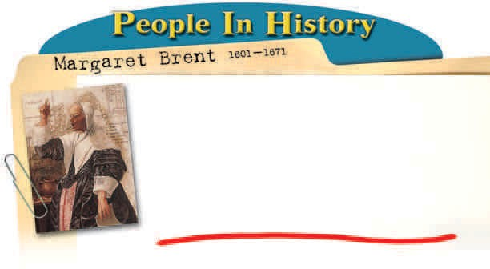

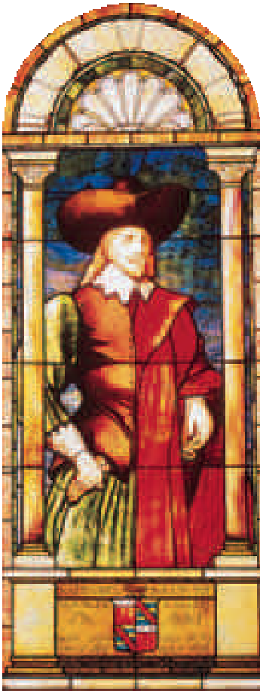government because it was domi- nated by easterners. Many of the westerners resented Governor Berkeley’s pledge to stay out of Native American territory. Some of them settled in the forbidden lands and then blamed the gov- ernment in Jamestown for not protecting them from Native American raids.
Nathaniel Bacon
In 1676 Bacon led the angry westerners in attacks on Native American villages. Governor Berkeley declared Bacon “the greatest rebel that ever was in Virginia.” Bacon’s army marched to Jamestown, set fire to the capi- tal, and drove Berkeley into exile. Only Bacon’s sudden illness and death kept him from taking charge of Virginia. England then recalled Berkeley and sent troops to restore order.
Bacon’s Rebellion had shown that the settlers were not willing
to be restricted to the coast. The colonial gov- ernment created a militia force to control the Native Americans and opened up more land to settlement.

Settling the Carolinas
In 1663 King Charles II created a large propri- etary colony south of Virginia. The colony was called Carolina, which means “Charles’s land” in Latin. The king gave the colony to a group of eight prominent members of his court who had helped him regain his throne.
The Carolina proprietors carved out large estates for themselves and hoped to make money by selling and renting land. The propri- etors provided money to bring colonists over from England. Settlers began arriving in Car- olina in 1670. By 1680 they had founded a city, which they called Charles Town after the
king. The name later became
Charleston.
John Locke, an English politi- cal philosopher, wrote a constitu- tion for the Carolina colony. This constitution, or plan of govern- ment, covered such subjects as land distribution and social ranking. Locke was concerned with principles and rights. He argued that
“every man has a property in his own person. This nobody has any
right to but himself. The labour of his body, and the work of his hands, we
may say, are properly his. ”
Carolina, however, did not develop according to plan. The people of northern and southern Carolina soon went their sepa- rate ways, creating two colonies.

$ Economics
Northern and Southern Carolina
The northern part of Carolina was settled mostly by farmers from Virginia’s backcountry. They grew tobacco and sold forest products such as timber and tar. Because the northern Carolina coast did not have a good harbor, the farmers relied on Virginia’s ports and merchants to conduct their trade.
The southern part of the Carolinas was more prosperous, thanks to fertile farmland and a good harbor at Charles Town. Settlements spread, and the trade in deerskin, lumber, and beef flourished. In the 1680s planters discovered that rice grew well in the wet coastal lowlands. Rice soon became the colony’s leading crop.
In the 1740s a young Englishwoman named Eliza Lucas developed another important Car- olina crop—indigo. Indigo, a blue flowering plant, was used to dye textiles. After experi- menting with seeds from the West Indies, Lucas succeeded in growing and processing indigo, the “blue gold” of Carolina.

Slave Labor in the Carolinas
Most of the settlers in southern Carolina came from another English colony—the island of Bar- bados in the West Indies. In Barbados the colonists used enslaved Africans to produce sugar. The colonists brought these workers with them.
Many enslaved Africans who arrived in the Carolinas worked in the rice fields. Some of them knew a great deal about rice cultivation because they had come from the rice-growing areas of West Africa. Growing rice required much labor, so the demand for slaves increased. By 1708 more than half the people living in southern Carolina were enslaved Africans.
By the early 1700s, Carolina’s settlers were angry at the proprietors. They wanted a greater role in the colony’s government. In 1719 the set- tlers in southern Carolina seized control from its proprietors. In 1729 Carolina became two royal colonies—North and South Carolina.
Explaining Who was John Locke?
What did he do for Carolina?
History
A rice plantation included the owner’s large house surrounded by the small dwellings of enslaved Africans. Why did rice cultivation increase the demand for enslaved labor?

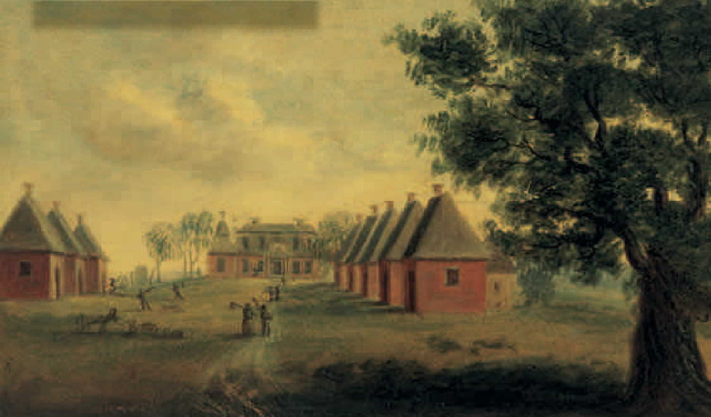
Georgia
Georgia, the last of the British colonies in America to be established, was founded in 1733. A group led by General James Oglethorpe received a charter to create a colony where Eng- lish debtors and poor people could make a fresh start. In Great Britain, debtors—those who are unable to repay their debts—were generally thrown into prison.
The British government had another reason for creating Georgia. This colony could protect the other British colonies from Spanish attack. Great Britain and Spain had been at war in the early 1700s, and new conflicts over territory in North America were always breaking out. Located between Spanish Florida and South Car- olina, Georgia could serve as a military barrier.

Oglethorpe’s Town
Oglethorpe led the first group of “sober, industrial, and moral persons” to Georgia in 1733. They built a town called Savannah, as well as forts to defend themselves from the Spanish. Oglethorpe wanted the people of Georgia to be hardworking, independent, and Protestant. He kept the size of farms small and banned slav-
ery, Catholics, and rum.

Founding the Thirteen Colonies
1st Permanent
Colony | Settlement | Reasons Founded | Founders or Leaders
New England Colonies
Massachusetts Plymouth | 1620 | Religious freedom | John Carver, William Bradford,
Mass. Bay Colony | 1630 | Religious freedom | John Winthrop
New Hampshire | c. 1620 | Profit from trade and fishing | Ferdinando Gorges, John Mason
Rhode Island | 1636 | Religious freedom | Roger Williams
Connecticut | 1635 | Profit from fur trade, farming; religious and political freedom | Thomas Hooker
Middle Colonies
New York | 1624 | Expand trade | Dutch settlers
Delaware | 1638 | Expand trade | Swedish settlers
New Jersey | 1638 | Profit from selling land | John Berkeley, George Carteret
Pennsylvania | 1682 | Profit from selling land; religious freedom | William Penn
Southern Colonies
Virginia | 1607 | Expand trade | John Smith
Maryland | 1634 | To sell land; religious freedom | Cecil Calvert
North Carolina | c. 1660s | Profit from trade and selling land | Group of eight aristocrats
South Carolina | 1670 | Profit from trade and selling land | Group of eight aristocrats
Georgia | 1733 | Religious freedom; protection against Spanish Florida; safe home for debtors | James Oglethorpe

Although Georgia had been planned as a debtors’ colony, it actually received few debtors. Hundreds of poor people came from Great Britain. Religious refugees from Germany and Switzerland and a small group of Jews also set- tled there. Georgia soon had a higher percentage of non-British settlers than any other British colony in the Americas.

The Colony Changes
Many settlers complained about the limits on the size of landholdings and the law banning slave labor. They also objected to the many rules Oglethorpe made regulating their lives. The colonists referred to Oglethorpe as “our perpet- ual dictator.”

Oglethorpe grew frustrated by the colonists’ demands and the colony’s slow growth. He agreed to let people have larger landholdings and lifted the bans against slavery and rum. In 1751 he gave up altogether and turned the colony back over to the king.
The thirteen colonies were founded over a span of 125 years.
Sequencing What colony was the first to be settled? Which was the last?
The thirteen colonies were founded over a span of 125 years.
Sequencing What colony was the first to be settled? Which was the last?
By that time British settlers had been in what is now the eastern United States for almost a century and a half. They had lined the Atlantic coast with colonies.

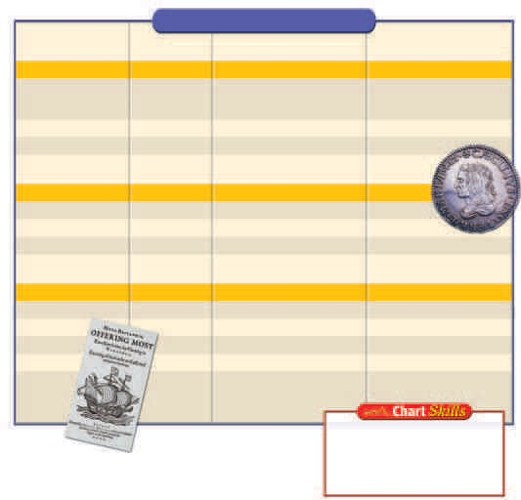

New France
The British were not the only Europeans who were colonizing North America, however. Else- where on the continent, the Spanish and the French had built settlements of their own.
The French had founded Quebec in 1608. At first they had little interest in large-scale settle- ment in North America. They were mainly con- cerned with fishing and trapping animals for their fur. French trappers and missionaries went far into the interior of North America. French fur companies built forts and trading posts to pro- tect their profitable trade.
In 1663 New France became a royal colony. King Louis XIV limited the privileges of the fur companies. He appointed a royal governor who strongly supported new explorations.

Down the Mississippi River
In the 1670s two Frenchmen—a fur trader, Louis Joliet, and a priest, Jacques Marquette— explored the Mississippi River by canoe. Joliet and Marquette hoped to find gold, silver, or other precious metals. They were also looking for a water passage to the Pacific Ocean. The two explorers reached as far south as the junc- tion of the Arkansas and Mississippi Rivers. When they realized that the Mississippi flowed south into the Gulf of Mexico rather than west into the Pacific, they turned around and headed back upriver.
A few years later, René-Robert Cavelier, Sieur de La Salle, followed the Mississippi River all the way to the Gulf of Mexico. La Salle claimed the region around the river for France. He called this territory Louisiana in honor of King Louis XIV. In 1718 the French governor founded the port of New Orleans near the mouth of the Mississippi River. Later French explorers, traders, and mis- sionaries traveled west to the Rocky Mountains and southwest to the Rio Grande.

Growth of New France
French settlement in North America advanced very slowly. Settlement in New France consisted of a system of estates along the St. Lawrence River. The estate holders received land in exchange for bringing settlers
to the colony. Known as tenant farmers, the settlers paid their lord an annual rent and worked for him for a fixed number of days each year.
The French had better relations with the Native Americans than did other Europeans. French trappers and missionaries traveled deep into Indian lands. They lived among the Native American peoples, learned their languages, and respected their ways.
Although the missionaries had come to convert Native Americans to Catholicism, they did not try to change the Indians’ customs. Most important, the French colony grew so slowly that Native Americans were not pushed off their lands.

New Spain
In the early 1600s, England, France, and the Netherlands began their colonization of North America. The Spanish, however, still controlled most of Mexico, the Caribbean, and Central and South America. They also expanded into the western and southern parts of what would one day be the United States.
Spain was determined to keep the other Euro- pean powers from threatening its empire in America. To protect their claims, the Spanish sent soldiers, missionaries, and settlers north into present-day New Mexico.
In late 1609 or early 1610, Spanish missionar- ies, soldiers, and settlers founded Santa Fe. Another group of missionaries and settlers went to what is now Arizona in the late 1600s. When France began exploring and laying claim to lands around the Mississippi River, the Spanish moved into what is now Texas. Spain wanted to control the area between the French territory and their own colony in Mexico. In the early 1700s, Spain established San Antonio and seven other military posts in Texas.

Missions in California
Spanish priests built a string of missions along the Pacific coast. Missions are religious settlements established to convert people to a

particular faith. The missions enabled the Span- ish to lay claim to California.
The Spanish did more than convert Native Americans to Christianity. Spanish missionaries and soldiers also brought them to the mis- sions—often by force—to serve as laborers in fields and workshops.
In 1769 Junípero Serra, a Franciscan monk, founded a mission at San Diego. Over the next 15 years, Father Serra set up eight more mis- sions in California along a route called El Camino Real (The Royal Highway)—missions that would grow into such cities as Los Angeles and Monterey.
The distance from one mission to the next was usually a day’s walk, and Serra traveled on foot to visit each one and advise the missionar- ies. Serra also championed the rights of the Native Americans. He worked to prevent Span- ish army commanders in the region from mis- treating them.

European Conflicts in North America
The rivalries between European nations car- ried over into the Americas. Britain and France fought several wars in the 1700s. When the two countries were at war in Europe, fighting often broke out between British colonists in America and French colonists in New France.
France and Great Britain were the principal rivals of the colonial period. Both nations were expanding their settlements in North America. In the late 1700s and early 1800s, wars in Europe between the British and the French would shape events across the Atlantic even more decisively.

