Water pollution COURS N°06
- Definition
Water pollution occurs when harmful bodies degrading water quality and rendering it toxic to humans and the environment.
When the substances contaminate water, they alter the nature of the water in such a manner that negatively affects its legitimate uses
Water bodies:
A/ Surface water: rivers, lakes, oceans, seas, streams, wetlands …
b/ Groundwater is water that exists underground: The risk of groundwater pollution depends on local conditions such as the type of soil, the amount of moisture in the area, and the depth of the groundwater

- Types of pollutants:
Water bodies can be polluted by a wide variety of substances, including:
- Pathogenic microorganisms,
- Putrescible organic waste,
- Fertilizers and plant nutrients,
- Toxic chemicals,
- Sediments, heat, petroleum (oil), and radioactive substances.
- Sources of water pollution
Water pollutants come from:
Point sources or
Dispersed sources (nonpoint sources)
A / Point source
- Is a pipe or channel used for discharge from an industrial facility or a city sewerage system.
- Point sources of water pollution are easier to control because the contaminated water can be collected and conveyed to one single point where it can be treated.
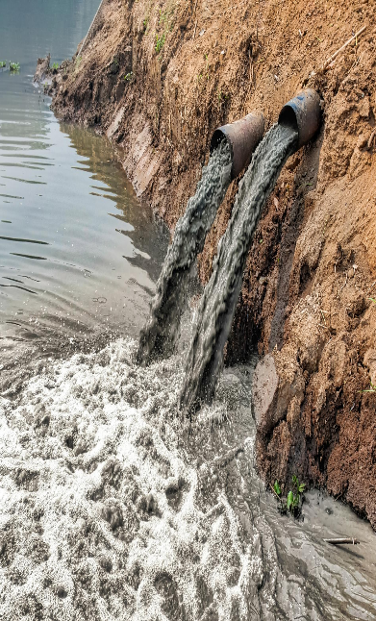

b/Dispersed (or nonpoint) source
- Dispersed points from which a variety of pollutants enter the water body, such as the runoff from an agricultural area
- Pollution from dispersed sources is difficult to control and continue to cause a large fraction of water pollution problems.

- Sources of water pollution
Domestic sewage
- Domestic sewage is the primary source of
pathogens (disease-causing microorganisms) and putrescible organic substances.
- Pathogens are excreted in feces and they potentially present a direct threat to public health.
- Putrescible organics present a threat to water quality. As organics are decomposed by bacteria and other microorganisms, the dissolved oxygen content of the water is depleted. This endangers the living conditions of aquatic organisms.

- Domestic sewage is a major source of plant nutrients, mainly nitrates and phosphates.
- Excess nitrates and phosphates in water promote the growth of algae.
- When the algae die, oxygen dissolved in the water declines because microorganisms use oxygen to digest algae during the process of decomposition.
- Anaerobic organisms: bacteria (organisms that do not require oxygen to live) metabolize the organic wastes, releasing gases such as methane and hydrogen sulfide, which are harmful to the aerobic forms of life.

- Solid waste
- The improper disposal of solid waste is a major source of water pollution.
- Solid waste pollution is damaging the health of aquatic ecosystems and can harm wildlife directly.
- Many solid wastes, such as plastics and electronic waste, break down and leach harmful chemicals into the water, making them a source of toxic or hazardous waste.

- Toxic waste
Waste is considered toxic if it is poisonous, radioactive, explosive, carcinogenic (causing cancer), mutagenic (causing damage to chromosomes), teratogenic (causing birth defects),
Sources of toxic chemicals include improperly disposed wastewater from industrial plants and chemical process facilities (lead, mercury, chromium) as well as surface runoff containing pesticides used on agricultural areas.

- Sediment
- Sediment resulting from soil erosion or construction activity can be carried into water bodies by surface runoff.
- Suspended sediment interferes with the penetration of sunlight and upsets the ecological balance of a body of water.
- Also, it can disrupt the reproductive cycles of fish and other forms of life.

Thermal pollution
- Heat is considered to be a water pollutant because it decreases the capacity of water to hold dissolved oxygen in solution
- Fish cannot survive in water with very low levels of dissolved oxygen.
- A major source of heat is the practice of discharging cooling water from power plants into rivers; the discharged water may be as much as 15 °C (27 °F) warmer than the naturally occurring water.
- The rise in water temperatures because of global warming can also be considered a form of thermal pollution.

- Petroleum (oil) pollution
- Petroleum (oil) pollution occurs when oil from roads and parking lots is carried in surface runoff into water bodies.
- Accidental oil spills are also a source of oil pollution. Oil slicks eventually move toward shore, harming aquatic life and damaging recreation areas.

