IMPACTS AND SOLUTIONS TO WATER POLLUTION
1/ IMPACTS OF WATER POLLUTION

- Drinking Water Issues
Water pollution in multiple ways is causing a severe pure water shortage.
- Water pollution has a significant effect on human health
Water pollution is increasing the prevalence of various diseases such as cholera, typhoid, diarrhea, and even cancer. And is causing the death of millions of people, especially in developing countries.

- Agricultural issues
People in various parts of the world depend on food that is growing in highly polluted water and soil leading to severe health issues.

- Threat to the Aquatic ecosystems
Due to water pollution, aquatic lives are in danger. We are already noticing the extinction of many species of aquatic plants and animals.

- Effects on the Economy
Increased Water Treatment Costs

2/ SOLUTIONS TO WATER POLLUTION
- Education and awareness raising
Making people aware of the problem is the first step to solving it. Greater public awareness can make a positive difference.

- Laws
Environmental laws can prevent people to pollute, but to be effective they must operate across national and international borders. This is why we have international laws governing the oceans, and seas.
Creation and enforcement of water quality regulation This involves creation of public policies that protect water resources.
- Economics
- Most environmental experts agree that the best way to tackle pollution is through the polluter pays principle.
- This means that whoever causes pollution should have to pay to clean it up.
- Switch to renewable energy
Investing in sustainable energy technologies that are non-polluting our energy demand can be satisfied without endangering our water resources.
- Better practices for wastewater management.
- Sustainable agriculture
Agricultural policies should encourage the use of ecological and organic farming methods that use few to no toxic chemicals and protect water bodies from pollution.

- Smart and sustainable water management in cities
All new developments should be “green” to help prevent stormwater runoff in urban areas and capture rainwater through the use of trees, bioswales, and natural areas, and the use of structures such as permeable pavements, green roofs and rain gardens.
Natural areas should be conserved to help capture stormwater, especially near lakes, rivers, and streams.

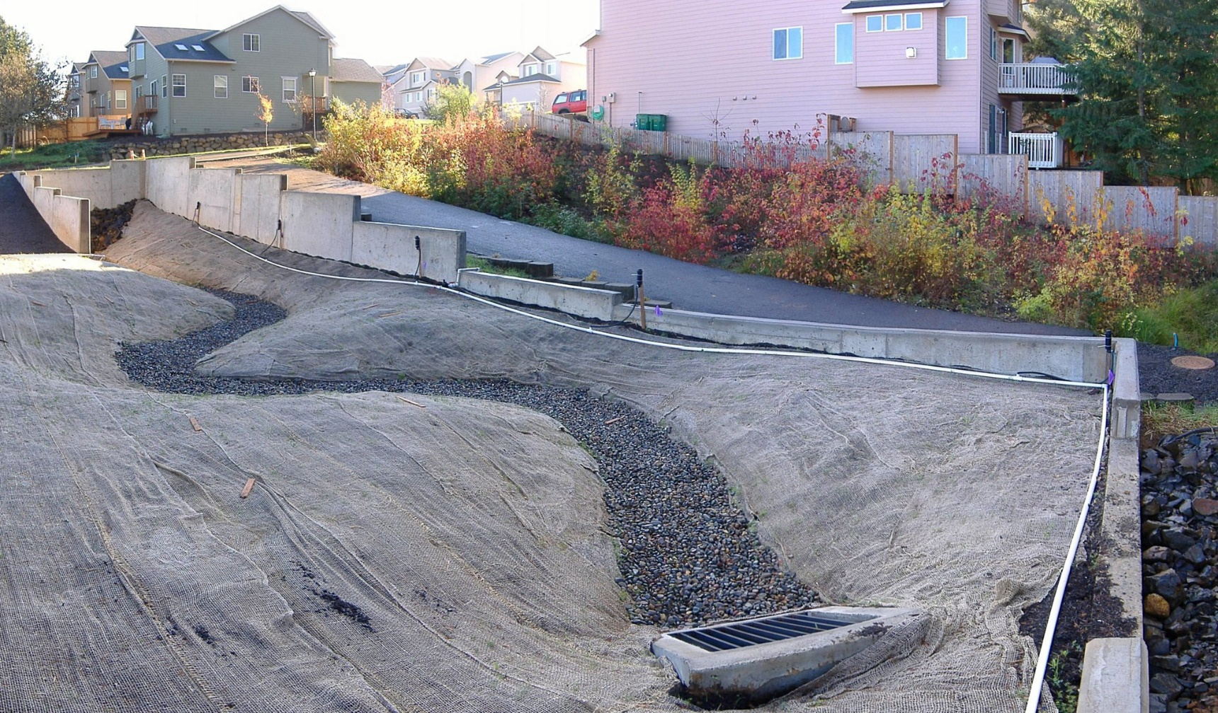
Bioswales are channels designed to concentrate and convey stormwater runoff while removing debris and pollution. Bioswales can also be beneficial in recharging groundwater

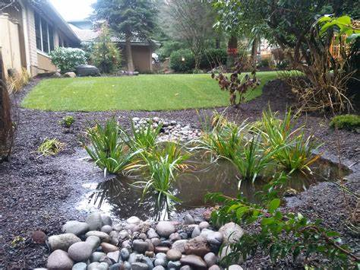
called bioretention facilities, are one of a variety of practices designed to increase rain runoff reabsorption by the soil

