Understanding the Different Types of Businesses :

It's essential to understand the different types of businesses, their structures, and how they operate in the market. we'll explain the different types of businesses and provide relevant examples to help you understand how they work.

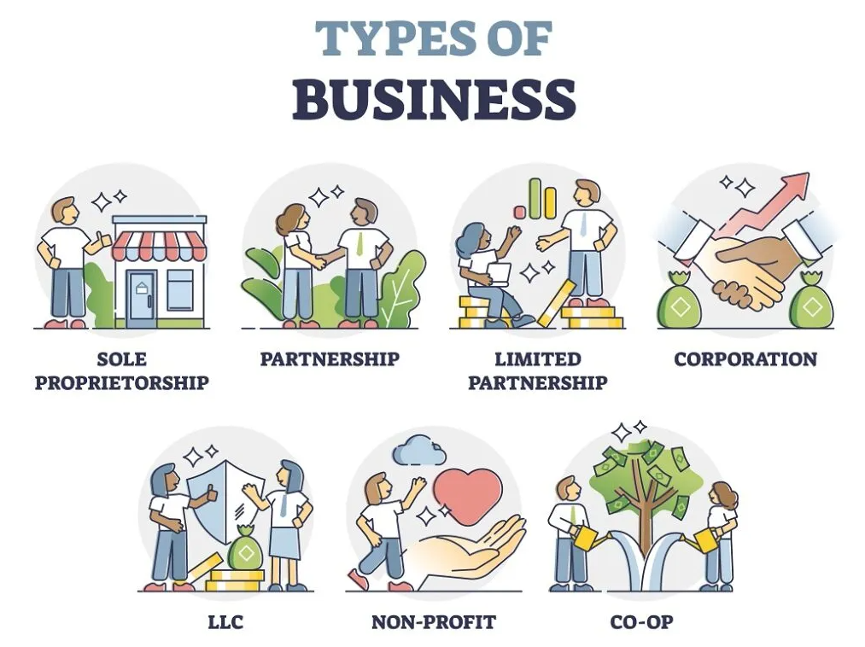

Sole Proprietorship
A sole proprietorship is a business owned and operated by one person. It's the simplest and most common form of business entity, and it doesn't require any formal legal structure. The owner is solely responsible for the debts and liabilities of the business.
For instance, a freelance writer who works from home and manages all aspects of their writing business is an example of a sole proprietorship.

Advantages:
- Easy and inexpensive to set up and run
- The owner has complete control over the business
- The profits are taxed at the owner's personal tax rate, which may be lower than corporate tax rates
- The owner can deduct business losses on their personal tax return

Disadvantages:
- The owner is personally liable for the business's debts and obligations, which can put their personal assets at risk
- It can be challenging to raise capital, as investors may be hesitant to invest in a business with a single owner
- The business's life is tied to the owner's life, and it may be challenging to transfer ownership or sell the business

Partnership
A partnership is a business structure that involves two or more individuals who share ownership of the company. Partnerships can be general or limited, and the partners share profits and losses based on their contribution to the business.
A real-world example of a partnership is the law firm of Skadden, Arps, Slate, Meagher & Flom LLP, where the partners share ownership of the company and the profits based on their contribution.

Advantages:
- Easy and inexpensive to set up and run
- The partners can pool their resources and expertise to run the business
- The profits are taxed at the partners' personal tax rate, which may be lower than corporate tax rates
- The partners can deduct business losses on their personal tax return

Disadvantages:
- The partners are personally liable for the business's debts and obligations, which can put their personal assets at risk
- Disputes between partners can arise, which can lead to conflict and even legal action
- The business's life is tied to the partners' lives, and it may be challenging to transfer ownership or sell the business.
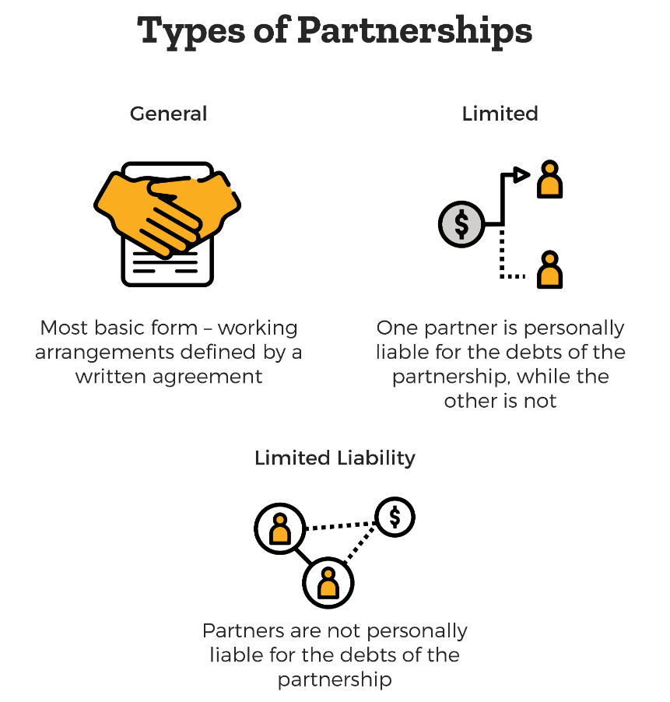

Limited Liability Company (LLC)
A Limited Liability Company (LLC) is a type of business structure that combines the flexibility of a partnership with the limited liability of a corporation. It offers the owners protection from personal liability for the company's debts and obligations. LLCs can be taxed as a pass-through entity, similar to a partnership, or as a corporation.
For example, B Lab Company, which certifies socially responsible businesses, is an LLC, as it combines the flexibility of a partnership with the limited liability of a corporation.

Advantages:
- Offers limited liability protection for its owners, which protects their personal assets from business debts and obligations
- Flexible management structure
- The profits can be taxed as a pass-through entity, which means they are taxed at the owner's personal tax rate
- Easier to raise capital than sole proprietorships or partnerships

Disadvantages:
- More expensive to set up than sole proprietorships or partnerships
- The owners may have to pay self-employment taxes on their share of the profits
- The regulations and tax laws governing LLCs can be complex and require expert advice.

Corporation
A corporation is a legal entity that is separate from its owners. It's owned by shareholders, who elect a board of directors to manage the company's affairs. The corporation can issue stock and raise capital, and its owners are generally protected from personal liability for the company's debts and obligations.
One of the best examples of a corporation is Amazon, which is publicly traded, and the shareholders own the company.

Advantages:
- Offers limited liability protection for its owners, which protects their personal assets from business debts and obligations
- Can raise capital by issuing stock
- The business can have a perpetual life, which means it can continue even if the owners change
- The owners can deduct the corporation's expenses on their personal tax return

Disadvantages:
- More expensive to set up and maintain than other business structures
- Subject to more regulatory requirements than other business structures
- Double taxation: the corporation pays taxes on its profits, and the owners pay taxes on their share of the profits.

Nonprofit Organization
A nonprofit organization is a business that operates for the benefit of the public rather than for profit. It's exempt from federal income taxes and may receive donations from individuals or corporations.
A real-world example of a nonprofit organization is the Bill & Melinda Gates Foundation, which aims to improve healthcare and reduce poverty worldwide.

Advantages:
- Exempt from federal income taxes and may receive donations from individuals or corporations
- Can operate for the benefit of the public rather than for profit
- Can receive grants and other forms of funding from the government or private organizations

Disadvantages:
- Cannot distribute profits to owners or shareholders
- Must adhere to strict regulations and reporting requirements to maintain tax-exempt status
- May have limited access to capital compared to for-profit businesses

Cooperatives
Cooperatives are businesses that are owned and operated by their members, who share in the profits and decision-making. They can be structured as corporations, LLCs, or partnerships.
For example, the Amalgamated Sugar Company is a cooperative, and the farmers who supply the sugar beets own the company.

Advantages:
- Owned and operated by members who share in the profits and decision-making
- Offers a democratic business structure where each member has an equal say in the business's operations
- Can provide economic and social benefits to its members and the community

Disadvantages:
- More complex to set up and run than other business structures
- May require a higher level of cooperation and coordination among members
- May have limited access to capital compared to other business structures

Conclusion
Understanding the different types of businesses is essential for finance professionals as it can help them better advise their clients on the best business structure to achieve their goals. Sole proprietorships and partnerships are suitable for small businesses, while LLCs and corporations are ideal for larger businesses that want to protect their owners' personal assets. Nonprofits and cooperatives serve the public good and offer a unique business structure that can benefit society.

