University of Oum El Bouaghi

Faculty of Exact Sciences, Natural and Life Sciences
Department of Mathematics and Computer Science
3rd year Bachelor ISSE Academic year: 2024/2025

Tutorial 1: Series of exercises on HTML
Exercise 1: Give the HTML code of the following display

Monday Times
- Medecine
- Food
- Marketing

Medecine Section

Medecine Article 1
texte
texte
texte

Medecine Article 2
texte
texte
texte

Food Section

Food Article 1
texte
texte
texte

Food Article 2
texte
texte
texte

marketing Section

marketing Article 1
texte
texte
texte

marketing Article 2
texte
texte
texte
© 2024 Monday Times. All rights reserved.

Exercise 2: Give the display of the following HTML code
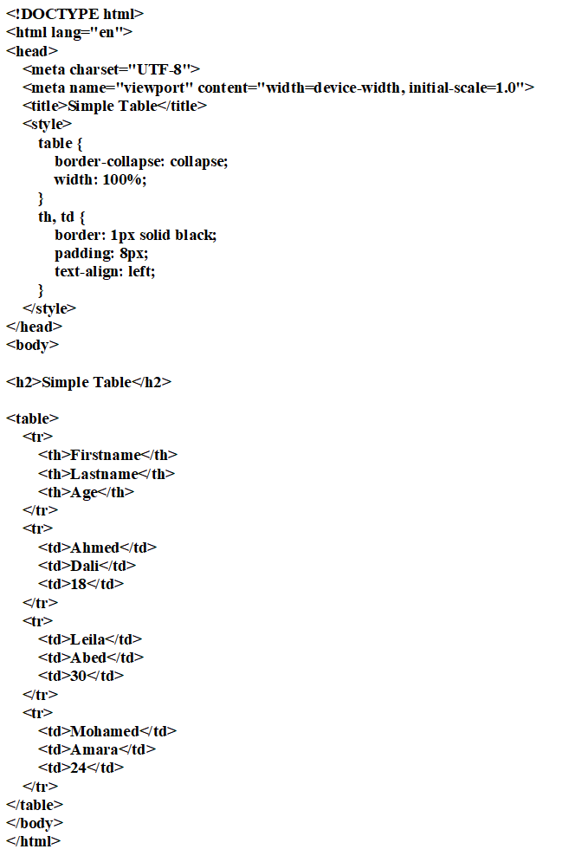

Exercise 3: Give the display of the following HTML code
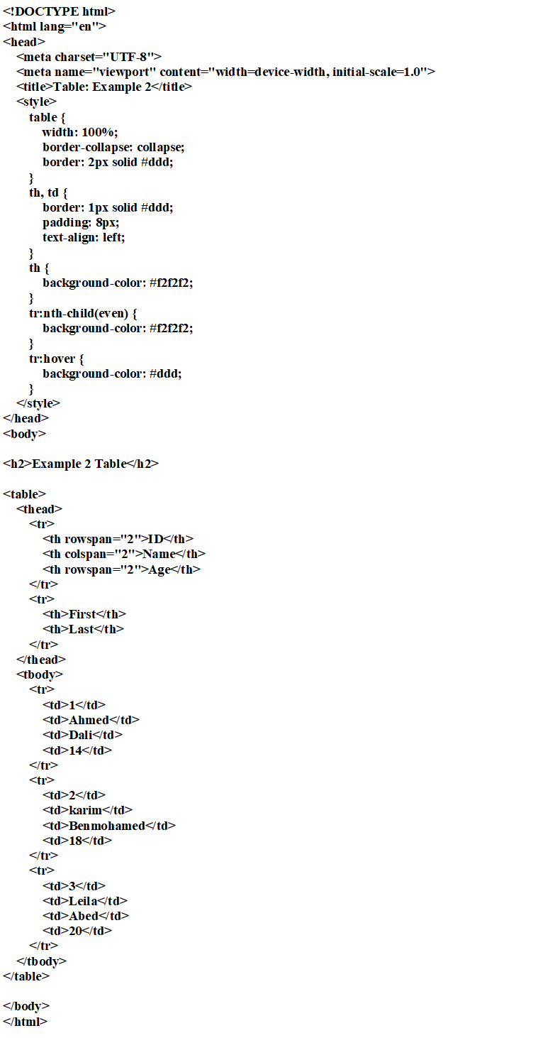
Exercise 4: Draw the tree corresponding to the following HTML code:
