EU countries members

The EU countries are: Austria, Belgium, Bulgaria, Croatia, Republic of Cyprus, Czech Republic, Denmark, Estonia, Finland, France, Germany, Greece, Hungary, Ireland, Italy, Latvia, Lithuania, Luxembourg, Malta, Netherlands, Poland, Portugal, Romania, Slovakia, Slovenia, Spain and Sweden.

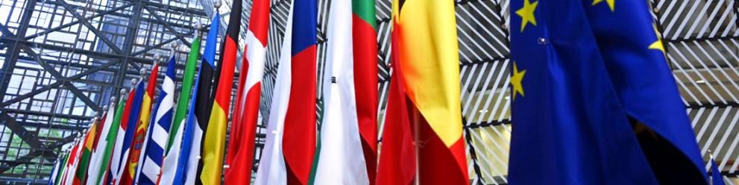

The EU is a unique economic and political partnership between 27 European countries that together cover much of the continent.
It was created in the aftermath of the Second World War. The first steps were to foster economic cooperation: the idea being that countries who trade with one another become economically interdependent and so more likely to avoid conflict.
In 1951, six countries founded the European Coal and Steel Community, and later, in 1957, the European Economic Community and the European Atomic Energy Community:
- Belgium
- Germany
- France
- Italy
- Luxembourg
- the Netherlands
A further 22 countries have since joined the EU, including a historic expansion in 2004 marking the re-unification of Europe after decades of division.
As of 1st of February 2020 the United Kingdom is no longer part of the European Union.

Timeline
- 01-07-2013
Croatia joins the EU
After Slovenia, Croatia is the second country from ex-Yugoslavia to join the EU. The European perspective remains open to the entire Western Balkans region.
- 01-01-2007
Romania and Bulgaria join
Two more countries from eastern Europe, Bulgaria and Romania, join the EU, bringing the number of member states to 27 countries.
- 01-05-2004
Largest enlargement so far
Ten new countries join the EU: Czech Republic, Estonia, Cyprus, Latvia, Lithuania, Hungary, Malta, Poland, Slovakia and Slovenia. This was the largest single enlargement in terms of people, and number of countries.

- 01-01-1958
Founding fathers
The organisation founded in 1957 which is now known as the European Union, originally had six members: Belgium, France, Germany, Italy, Luxembourg and the Netherlands.

