Middle Colonies

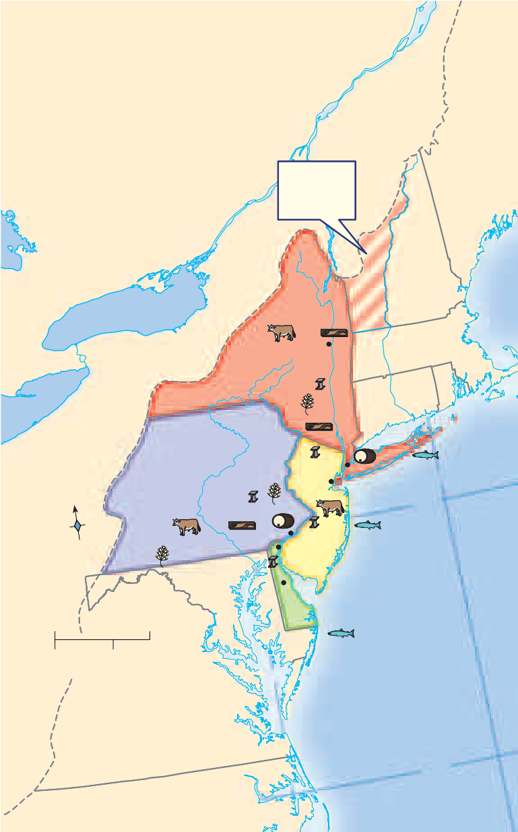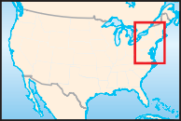England and the Colonies
Products
Grain Fish
Cattle Lumber
Rum
Iron
In England the Puritans who controlled Parliament were engaged in a strug- gle for power against King Charles I. In 1642 a civil war began. Led by Oliver Cromwell, a Puritan, the Parliamentary forces defeated the king. Charles I was beheaded in 1649 after a parliamentary court declared him guilty of treason.
A new government was established with Cromwell as Protector. During these years of unrest, many Puritans left New England and returned to England to fight with Parliament’s forces. After the war ended, English men and women loyal to the king went to royal colonies like Virginia.
After Cromwell died in 1658, Parliament brought back the monarchy, but placed new lim- its on the ruler’s powers. Charles II, son of Charles I, became king in 1660. His reign is called the Restoration because the monarchy had been restored.
In 1660 England had two clusters of colonies in what is now the United States—Massachu- setts, New Hampshire, Connecticut, and Rhode Island in the north and Maryland and Virginia in the south. Between the two groups of English colonies were lands that the Dutch controlled.
In 1621 a group of Dutch merchants had formed the Dutch West India Company to trade in the Americas. Their posts along the Hudson

The Middle Colonies
Area claimed by New York and New Hampshire

Albany
NEW YORK

New York City

River grew into the colony of New Netherland. The main settlement of the colony was New Amsterdam, located on Manhattan Island. In 1626 the company bought Manhattan from the

Manhates people for small quantities of beads

and other goods. Blessed with a good seaport, the city of New Amsterdam soon became a cen- ter of shipping to and from the Americas.
To increase the number of permanent settlers in its colony, the Dutch West India Company sent over families from the Netherlands, Germany, Sweden, and Finland. The company gave a large estate to anyone who brought at least 50 settlers to work the land. The wealthy landowners who acquired these riverfront estates were called patroons. The patroons ruled like kings. They had their own courts and laws. Settlers owed the patroon labor and a share of their crops.

76°W
36°N

England Takes Over
New Netherland boasted an excellent harbor and thriving river trade. The English wanted to acquire the valuable Dutch colony that lay between England’s New England and Southern Colonies. In 1664 the English sent a fleet to attack New Amsterdam.
At the time Peter Stuyvesant was governor of the colony. His strict rule and heavy taxes turned many of the people in New Netherland against him. When the English ships sailed into New Amsterdam’s harbor, the governor was unprepared for a battle and surrendered the colony to the English forces.

King Charles II gave the colony to his brother, the Duke of York, who renamed it New York. New York was a proprietary colony, a colony in which the owner, or proprietor, owned all the land and controlled the government. It differed from the New England Colonies, where voters elected the governor and an assembly.
Most of New York’s settlers lived in the Hud- son River valley. The Duke of York promised the diverse colonists freedom of religion and allowed them to keep their property. As a result,

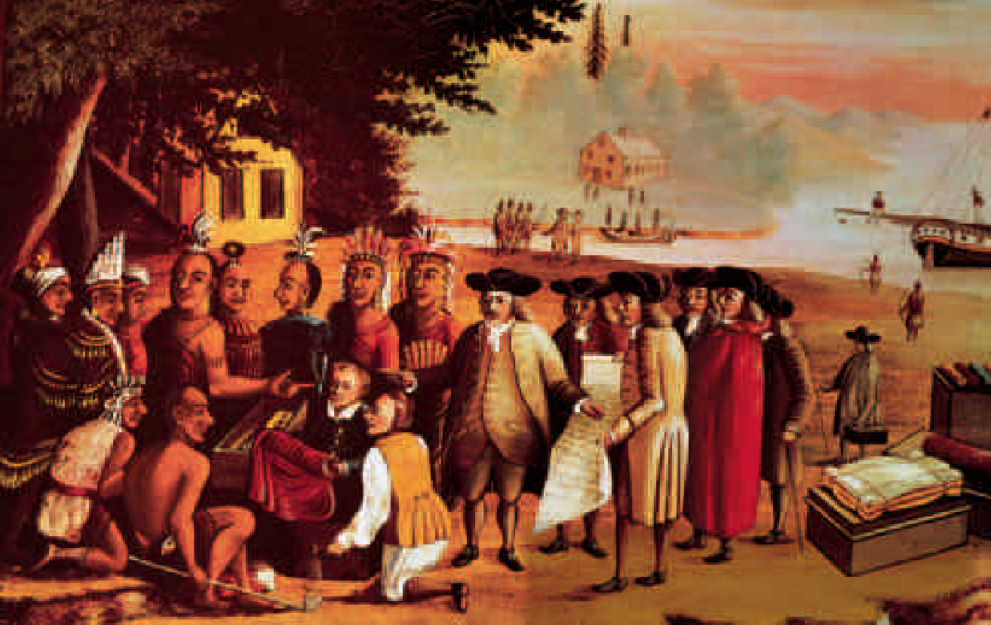
History Through Art
Penn’s Treaty with the Indians In 1682 William Penn made his first treaty with the Delaware people. Why did Penn see Pennsylvania as a “holy experiment”?

most of the Dutch colonists decided to remain in New York. In 1664 New York had about 8,000 inhabitants. Most were Dutch, but Germans, Swedes, Native Americans, and Puritans from New England lived there as well. The popula- tion also included at least 300 enslaved Africans. New Amsterdam, which was later called New York City, was one of the fastest-growing loca- tions in the colony.
By 1683 the colony’s population had swelled to about 12,000 people. A governor and council appointed by the Duke of York directed the colony’s affairs. The colonists demanded a rep- resentative government like the governments of the other English colonies. The duke resisted the idea, but the people of New York would not give up. Finally, in 1691, the English govern- ment allowed New York to elect a legislature.

New Jersey
The Duke of York gave the southern part of his colony, between the Hudson and Delaware Rivers, to Lord John Berkeley and Sir George Carteret. The proprietors named their colony New Jersey after the island of Jersey in the Eng- lish Channel, where Carteret was born.
To attract settlers, the proprietors offered large tracts of land and generous terms. They also promised freedom of religion, trial by jury, and a representative assembly. The assembly would make local laws and set tax rates.
Like New York, New Jersey was a place of ethnic and religious diversity. Because New Jer- sey had no natural harbors, however, it did not develop a major port or city like New York.
The proprietors of New Jersey did not make the profits they had expected. Berkeley sold his share, West Jersey, in 1674. Carteret’s share, East Jersey, was sold in 1682.
By 1702 New Jersey had passed back into the hands of the king, becoming a royal colony. The colonists still continued to make local laws.

Pennsylvania
In 1680 William Penn, a wealthy English gen- tleman, presented a plan to King Charles. Penn’s father had once lent the king a great deal of money. Penn had inherited the king’s promise to

repay the loan. Instead of money, however, Penn asked for land in America. Pleased to get rid of his debt so easily, the king gave Penn a tract of land stretching inland from the Delaware River. The new colony, named Pennsylvania, was nearly as large as England.
William Penn belonged to a Protestant group of dissenters called the Society of Friends, or Quakers. The Quakers believed that every indi- vidual had an “inner light” that could guide him or her to salvation. Each person could experience religious truth directly, which meant that church services and officials were unnecessary. Every- one was equal in God’s sight. Though firm in their beliefs, the Quakers were tolerant of the views of others.
Many people in England found the Quakers’ ideas a threat to established traditions. Quakers would not bow or take off their hats to lords and ladies because of their belief that everyone was equal. In addition they were pacifists, people who refuse to use force or to fight in wars. Quakers were fined, jailed, and even executed for their beliefs.
William Penn saw Pennsylvania as a “holy experiment,” a chance to put the Quaker ideals of toleration and equality into practice. In 1682 he sailed to America to supervise the building of Philadelphia, the “city of brotherly love.” Penn believed that
“any government is free to the people under it . . . where the laws rule, and the people are a party to those laws.”
Penn had designed the city himself, making him America’s first town planner. Penn also wrote Pennsylvania’s first constitution.
Penn believed that the land belonged to the Native Americans and that settlers should pay for it. In 1682 he negotiated the first of several treaties with local Native Americans.
To encourage European settlers to come to Pennsylvania, Penn advertised the colony throughout Europe with pamphlets in several languages. By 1683 more than 3,000 English, Welsh, Irish, Dutch, and German settlers had arrived. In 1701, in the Charter of Liberties, Penn granted the colonists the right to elect represen- tatives to the legislative assembly.
The southernmost part of Pennsylvania was called the Three Lower Counties. Settled by Swedes in 1638, the area had been taken over by the Dutch and the English before becoming part of Pennsylvania. The Charter of Privileges allowed the lower counties to form their own legislature, which they did in 1704. Thereafter the counties functioned as a separate colony known as Delaware, supervised by Pennsylvania’s governor.

