Activity (Source, Janet Holmes, 2013)
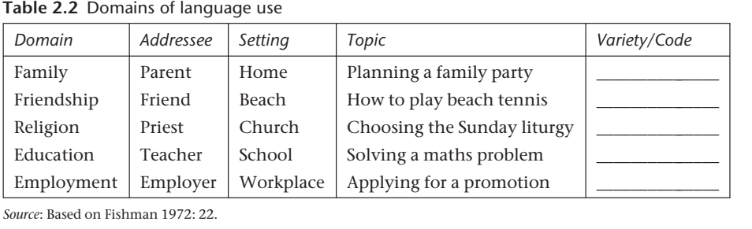
What is Domain?
………………………………………………………………………………………………………………………………………………………………………………………………………………………………………………………………………………………………………………………………………………………………………………………………………………………………………………………………

