Water supply systems

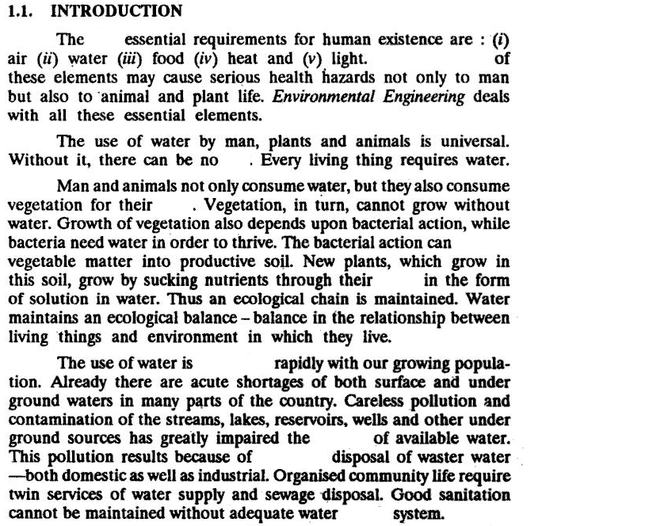

1. Fill in the blanks by the following words:
Increasing, five, food, quality, contamination, improper, supply, life, convert, roots.

2. Translate the following words from the above text into French language:
Requirements; health hazards; consume water; need water; grow; sucking; careless pollution

