Université Larbi Ben M’hidi-Oum El Bouaghi
Faculté des Sciences et des Sciences Appliquées
Département d’Hydraulique
Module: Anglais technique

Master I (HU) Contrôle N°1 2/2/2020 : 1^{30min}

Read carefully the figure below then answer the questions:

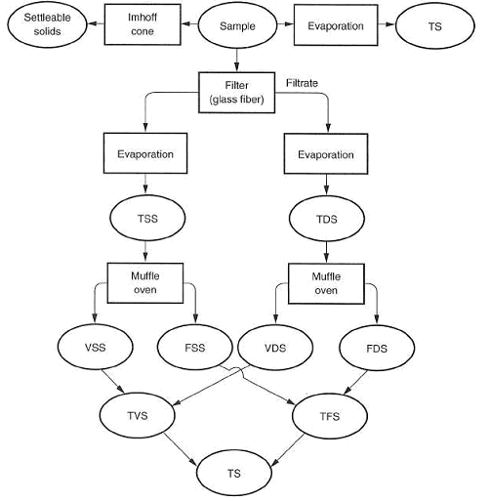

- Complete the legend and translate into French language: TS, TSS, TDS, VSS, FSS, VDS, FDS, TVS, TFS. (9pts)
- Translate into French language: settleable solids, sample, glass fiber, oven, dry, wastewater, sludge, stormwater, water reuse, ideal flow, water treatment. (11pts)

