Larbi Ben M’hidi University
Department of English
DL/1st Year Students (Licence)
S. AROUF
Modal Verbs
Modals and Modality
- Definition: Modal verbs are a specific category of auxiliary verbs found in Germanic languages, such as English.
- Function: They are placed before other verbs to express "modality".
- Modality: This refers to how a speaker uses grammar to express subjective attitudes and opinions, such as certainty, ability, permission, and possibility.
- Examples of modal verbs: These include verbs like must, can, could, may, might, shall, should, will, would, and ought to.
Key Characteristics of Modals
Modal verbs differ from regular verbs in four primary ways:
- Infinitives without "to": Modals are followed by the base form of a verb (e.g., Can I use... vs. I want to use...).
- No Third-Person "-s": They do not change form for he/she/it (e.g., Joe can speak... vs. Joe knows...).
- No "Do": Questions and negatives are formed without the auxiliary "do" (e.g., Can you help me?).
- No Infinitives or Participles: Modals lack forms like to can or musted; instead, other phrases like be able to or have to are used.
Must : Must expresses certainty or necessity in affirmative sentences.
- Must: Certainty
You can use must in affirmative sentences to say that you believe something is certain.
- This must be the right address!
- I’m sure Sally gave me her phone number. I must have it somewhere.
- Must: Necessity and Strong Recommendation
You can use must in affirmative sentences to give your own opinion (for example, to say what you think is necessary, or to recommend someone to do something).
- I haven’t spoken to Sue for ages. I must phone her. (= I say this is necessary)
- Students must pass an entrance examination to study at this school. (= this is necessary)
- You must take some medicine for that cough. (= strong recommendation)
- Questions :Generally speaking, we use must in questions when we mean ‘Is this really necessary?’
- Must we tell the police when we change addresses?
Must and Can’t
The negative of must (to talk about certainty) is can’t. You can use can’t to say that you believe something is certainly not possible (= certainly impossible).
- What you are saying can’t be true. (= it is certainly not true.) Not ‘It mustn’t be true.’
- You’ve just had lunch. You can’t be hungry already. (= it is impossible that you are hungry.)
For the past (past certainty) we use must have (done), ie., must have + pp with positive/affirmative sentences and can’t have (done) with negative sentences.
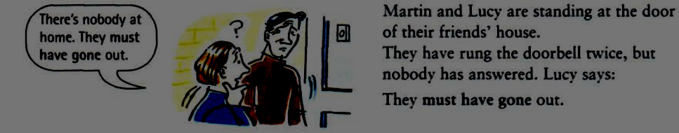
If we say that something must have happened, we mean that we feel sure/certain that it (has) happened.
- I didn’t hear the phone. I must have been asleep. (= I am sure I was asleep/ have been asleep.)
If we say that something can’t have happened, we mean that we feel sure/certain that it has not happened or did not happen.
- Sue hasn’t contacted me. She can’t have got my message. (= I am certain that she didn’t get my message.)
Must Mustn’t Needn’t
The negatives of must (to talk about necessity) are mustn’t and needn’t.
- You mustn’t do something = it is necessary that you do not do it, so don’t do it.
- You must keep it a secret. You mustn’t tell anybody else.
- You needn’t do something = you don’t need to do it. So, ‘This isn’t necessary’ but you can if you like.
- You can come with me if you like, but you needn’t come if you don’t want to. (= it is not necessary for you to come)
- We’ve got plenty of time. We needn’t hurry. (= it is not necessary to hurry)
Have to and Must
Have to is not a modal verb, but its use is similar to the use of must.
- I have to do something = it is necessary to do it, I am obliged to do it.
- You can’t turn right here. You have to turn left.
- Last week Tina broke her arm and had to go to hospital.
- We use do/does/did in questions and negative sentences (for the present and past simple)
- What do I have to do to get a new driving licence? (not What have I to do?)
- Karen doesn’t have to work Saturdays. (not Karen hasn’t to)
- Why did you have to leave early?
- We can use have to like must to express what we think is necessary, or to recommend someone to do something.
- It’s later than I thought. I must go. or I have to go.
- Pat and Jan are so nice; we must see them again Or we have to see them again.
- We use have to (not must) to say what someone is obliged to do. The speaker is not giving his/her own opinion; he is just talking about facts.
- I have to work from 8.30 to 5.30 every day. (a fact, not an opinion)
- Jane has to travel a lot for her work.
Mustn’t and don’t have to are completely different, but don’t have to and needn’t are completely similar.
You mustn’t do something = it is necessary that you do not do it (so don’t do it):  - You must keep it a secret. You mustn’t tell anyone. (= don’t tell anyone) | You don’t have to do something = you don’t need to do it = this isn’t necessary (but you can if you want):  - You don’t have to tell him, but you can if you want to.
Can/Could
Can: It has three main functions:
- Possibility and Ability
We use can to say that something is possible or allowed, or that somebody has the ability to do something.
- She can drive a car.
- I cannot hear you. (I can't hear you.)
- Can you hear me?
Note: Normally, we use can for the present. But it is possible to use can when we make present decisions about future ability.
A. Can you help me with my homework? (present)
B. Sorry. I'm busy today. But I can help you tomorrow. (future)
- You can say that somebody is able to do something, but can is more usual:
- We are able to see the lake from our bedroom window.
- Requests and Orders: Asking someone to do something (can you …?). This usage is generally informal, such as with friends or family.
- Can you make a cup of coffee, please?
- Can you be quiet?
- Permission: Asking or giving the "OK" to do something in an informal setting.
- Can I smoke in this room?
Using "Could"
Could is often the past tense version of can, but it also serves to make language more formal.
- Past Ability/Possibility: Used to describe general abilities or freedoms someone had in the past.
- I could swim when I was 5 years old.
- When we arrived home, we could not open the door. (...couldn't open the door.)
- Could you understand what he was saying?
- Formal Requests: Could is more polite than can, making it suitable for strangers, teachers, or bosses.
- Could you tell me where the bank is, please?
- Could I possibly borrow your paper...? (Very polite) .
- Could is frequently used with verbs of perception like see, hear, and understand.
- We had a lovely room... We could see the lake.
- As soon as I walked into the room, I could smell gas.
Could and Was/Were able to
We use could (positive) and couldn't (negative) for general ability in the past. But if you want to say that somebody did something in a specific situation, use was/were able to or managed to (not could) in positive sentences and couldn't in negative sentences.
 | Past
 | General | Specific Situation
+ | My grandmother could speak Spanish. | A man fell into the river yesterday. The police were able to save him.
+ | Mike was an excellent tennis player when he was younger. He could beat anybody. (= he had the general ability to beat anybody. ) | Mike and Pete played tennis yesterday. Peter played very well, but Mike was able to /managed to beat him. (= he managed to beat him in this particular game)
- | My grandmother couldn't speak Spanish. | Peter played well, but he couldn’t beat Mike.
- | My grandfather couldn’t swim. | A man fell into the river yesterday. The police couldn't save him.

May/ Might
- Present Possibility
Study this example situation:
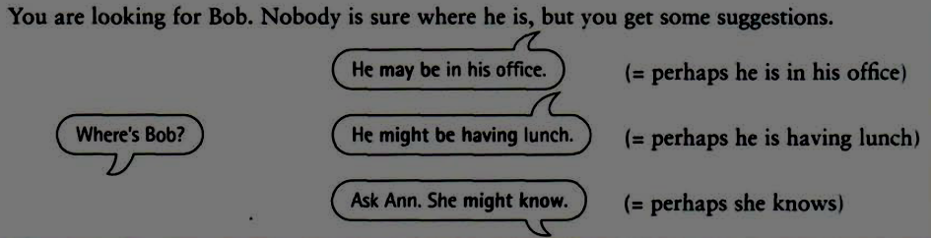
We use may or might to say that something is a possibility.
- It may be true. or It might be true. (= perhaps it is true)
The negative forms are may not and might not (or mightn’t)
- It may not be true. (= perhaps it isn’t true)
- She might not work here any more. (= perhaps she doesn’t work here.)
Future Possibility
We use may and might to talk about possible actions or happenings in the future.
- I haven’t decided yet where to go for my holidays. I may go to Ireland. (= perhaps I will go there)
- Take an umbrella with you. It might rain later. (= perhaps it will rain.)
The negative forms are may not and might not (mightn’t):
- Liz may not go out tonight. She isn’t feeling well. (= perhaps she will not go out)
- There might not be enough time to discuss everything at the meeting. (= perhaps there will not be enough time.)
Compare will and may/might.
- I’ll be late this evening. (for sure)
- I may/might be late this evening. (possible)
Note: we use only might (not may) when the situation is not real.
- If I were in Tom’s position, I might look for another job.(The situation here is not real because I am not in Tom’s position (so I’m not going to look for another job).
May have done/ Might have done
If we say that something may have/might have happened, we mean that perhaps it (has) happened.
- A: I wonder why Kate didn’t answer the phone.
B: She may have been asleep. (= perhaps she was asleep)
- A: I can’t find my bag anywhere.
B: You might have left it in the shop. (= perhaps you left it in the shop)
May (Permission)
May is used for permission in settings that are very formal or academic.
- Asking for Permission: Often used in schools or polite inquiries.
- May I have your name, please sir?
- Giving/Refusing Permission: Used to state what is or is not okay to do.
- You may open your books now.
- You may not leave until the bell rings.
Should
Should is used to express that something is the "right" or "good" thing to do.
- Advice and Opinions :It is used to give advice or share a viewpoint.
- You look tired. You should go to bed.
Shouldn't: Indicates that an action is not a good idea.
- You shouldn’t believe everything you read.
Should vs. Must
Should is weaker than must or have to.
Should implies it would be a "good thing" to do, whereas must implies "no alternative" or necessity.
- You should apologise. (= it would be a good thing to do)
- You must apologise. / You have to apologise. (= you have no alternative)
Past Regrets (Should have done)
- Should have done: You did not do something, but it would have been the right choice.
- You missed a great party last night. You should have come. Why didn’t you? (= you didn’t come,but it would have been good to come)
- Shouldn't have done: You did something, but it was the wrong thing to do.
- I shouldn’t have eaten so much.
Practice :
Task1 : Choose all the correct modal verbs for each gap below. In some sentences there are TWO possible correct answers.
1 I think there ______ a mistake in your tax return. You should check it. Choose TWO correct options
A. can't be
B. might be
C. may be
2 If Suzan said that, it ______ true. She never lies.
A.might be
B. must be
C.can be
3 Sorry, but I'm not Connor. You ______ me for someone else.
A. might be confusing
B. must confuse
C. must be confusing
4 I'm not sure I trust Peter. He ______ the person we think he is.
A. might not be
B. can't be
C. must not be
5 You have been walking for ten hours. You ______ exhausted.
A. can be
B. can't be
C. must be
6 He ______ his son, they look completely different.
A. might be
B. can't be
C. must not be
7 There's a bit of traffic, so I ______ arrive in time. Choose TWO correct options
A. might not
B. must not
C. may not
8 He ______ be very proud of you right now. You disappointed him.
A. must not
B. can't
C. might
9 I wouldn't swim in this river if I were you. It ______ dangerous. Choose TWO correct options
A. might be
B. may be
C. can be
Task2 : Choose the correct option to complete the sentences below. .
1 Nobody knows exactly why he died. But we think it should have/ might have/ can have been an accident.
2 I could have/might have/ should have revised more for the exam. I was lazy, and now I'll fail!
3 Sarah looked very happy. She should have/must have/ can’t have passed her driving test.
4 I didn't know you were going to Phil's party yesterday. You should have/ can’t have/ must have told me!
5 I can't believe Jim hasn't arrived yet. He can have/must have/should have taken the wrong train.
6 I can't believe Jim hasn't arrived yet. He mustn’t have/ can’t have/shouldn’t have taken the right train.
7 You couldn’t have/ may not have/ mustn’t have been ill yesterday. Jessie saw you at the bowling alley.
8 I don't know where they went but they can have/could have/must have gone to Paris or Marseille.
9 You can’t have/should have/must have paid more attention. Now we are lost.
10The window was broken, so the thieves must have/may have/should have got in through that window.
Task3: Choose the correct option to complete the sentences below.
1 You mustn’t /don’t have to/haven’t to go to the ceremony if you don't feel like it. It'll be very boring
anyway.
2 We took too much risk. We mustn’t made/ needn’t have made/shouldn’t make that decision.
3 He shouldn’t have spent/shouldn’t spend/had better not spend so much money on the trip last summer.
4 We couldn't find a hotel so we had to sleep/must have slept/should have slept in the car. It was so
uncomfortable!
5 You ought not/mustn’t/don’t have to forget to take your medicine.
6 We didn’t have toget up/needn’t get up/needn’t have got up early because it was a holiday, so we slept till
late.

Bibliography :
Hewings, M. (1999). Advanced grammar in use: A self-study reference and practice book for advanced
learners of English. Cambridge: Cambridge University Press.
References
Murphy, R.(2004). English grammar in use :A self-study reference and practice book for intermediate students of English (3rd ed.). Cambridge,UK : Cambridge University Press.

