Nature of Listening
The "Nature of Listening" is characterized not as a passive reception of sound, but as a complex, active, and interpretive cognitive activity. The sources situate this definition within a theoretical evolution—moving from mechanical models to social ones—and detail the specific cognitive processes and pedagogical implications involved.

1. The Definition: Active and Interpretive
Applied linguistics reject the traditional view of listening as a passive process where information is simply "poured" into a receiver. Instead, the nature of listening is defined as:
- A Bundle of Processes: It is not a single operation but a combination of recognizing sounds, perceiving intonation, and interpreting relevance.
When we listen, our brain doesn't wait for the speaker to finish; it processes these three layers at the same time:
- Recognition of Sounds: The listener decodes the acoustic stream into phonemes and words, such as discriminating between similar sounds or identifying fast-speech forms like /g∂mmt/ for "government".
- Perception of Intonation: The listener tracks prosody—including stress, pitch, and rhythm—to identify where the speaker is focusing information or what their "mood" might be.
- Interpretation of Relevance: The listener uses top-down processing to link what is being said to the current topic and their own prior knowledge (schemata).
- Active and Interpretive: Good listeners are as active as speakers. Crucially, listening is an "interpretive process" rather than an exact decoding of a message. This implies that comprehension is inherently variable; because interpretation relies on context and non-linguistic variables, different listeners may derive different meanings from the same input.
Distinctive Features The nature of listening is fundamentally different from reading due to several unique constraints:
- Real-Time Processing: Listeners generally have only one chance to process input and must do so in real time.
  - Example: Unlike a reader who can control their pace, a listener must process linguistic and non-linguistic input at the speed of the speaker. In most cases, there is no opportunity to "rewind" or ask for a rephrase.
- Ephemerality: It is an "ephemeral, one-shot" event.
  - Listening is described as a "one-shot" nature. The acoustic signal is ephemeral; it exists for a moment and then vanishes, requiring immediate mental registration.
- Prosody and Assimilation: Listening involves rich prosody (rhythm, stress, intonation) and the characteristics of natural fast speech (such as assimilation, where "government" becomes /g∂mmt/), which are absent in written language.
  - Spoken language contains a "rich prosody"—including stress, intonation, rhythm, and loudness—that provides essential cues for meaning and information focus. These elements are entirely absent from written language.

2. Theoretical Perspectives: The Evolution of the Listener
There are four models that trace how the understanding of the nature of listening has evolved:
- The Communication Theory Model (CT): This model, rooted in the mathematical work of Shannon and Weaver (1949) who Viewed communication as transmission and reception. Human participation was peripheral, and the focus was on signal intelligibility rather than human perception.
- Linear Process: Communication is viewed strictly as a sequence of transmission, signal, and reception.
- Peripheral Human Role: Because it was developed to solve engineering problems, human participation was considered peripheral to the process.
- Focus on Intelligibility: Researchers were primarily concerned with the "intelligibility" of the signal—essentially evaluating the equipment's ability to carry sound—rather than the "perception" or mental processing of the listener.
- Noise: The model introduced the concept of "noise" as any interference that disrupts the signal between the sender and the receiver.
- Information Processing Model: We can frame it as the transition from a "mechanical" view of listening to a "cognitive" one, where the human mind is compared to a complex computer system. The listener is considered as a "limited processor" managing input, processing, and output. Modern interpretations of this model acknowledge that to cope with real-time demands, listeners use "parallel distributed processing," handling multiple sources of information simultaneously.
  - The "Limited Processor": Humans are viewed as processors with finite cognitive capacity; when tasks become complex, we must shift attention from one aspect of the task to another.
  - Sequential Stages: Early versions suggested stages of understanding, such as Anderson’s (1985) "Perception, Parsing, and Utilization" or Brown’s (1995) "Identify, Search, File, and Use".
  - Parallel Distributed Processing: Modern views recognize that sequential "stages" are too slow for real-time speech. Instead, listeners process multiple sources of information simultaneously to keep up.
  - Integrating Clues: Successful listening requires the simultaneous integration of "bottom-up" clues (linguistic data) and "top-down" clues (background knowledge and context).

- Social/Contextual Model: Shifts the nature of listening from an individual cognitive act to a social one. Here, listeners are "creators of meaning," and understanding is achieved in the "interactional space" between participants. Context is primary, and computing metaphors like "input" and "output" are viewed as misleading because they obscure the active participation of the listener.
- Active Creators of Meaning: Listeners are seen as participants in and creators of meaning, rather than passive recorders of information.
- The Interactional Space: Meanings are not achieved just inside individual heads; they are achieved in the "interactional space" between participants.
- Primary Role of Context: Context is assigned a primary role in language use, moving beyond the idea of language as just a set of linguistic codes.
- Rejection of Computing Metaphors: Proponents argue against metaphors like "input" and "output," claiming they are misleading and belittle the active participation of the listener.
- Mutual Cognitive Environment: Even in constrained settings, conversational partners work together to negotiate meanings and establish a "mutual cognitive environment".
- Situated Action Model: Suggests that the nature of listening is evolutionary, driven by the need to "do things" rather than merely archive information.
  - Listening to "Do" Rather than "Store": Evolutionary psychologists argue that humans spend much of their time trying to understand in order to perform specific actions—termed "situated action"—rather than simply archiving information in memory.
  - Evolutionary Pressures: The foundational properties of human language reflect ancient pressures to control the actions of others in activities such as hunting, gathering, and simple industry.
  - Practical Orientation: While it does not rule out an archival function for memory, the model emphasizes that daily interactions are usually oriented toward future action (e.g., following a recipe, treating an illness, or finding food).
  - Contrast with Formal Education: Supporters of this model suggest that formal education and science occurred too recently in human history to have fundamentally changed these evolutionary listening pressures.
Model | Central Metaphor | Goal of Listening | Listener's Role
Communication Theory | The Telephone | Intelligibility | Peripheral Receiver
Information Processing | The Computer | Processing Data | Limited Processor
Social/Contextual | The Conversation | Creating Meaning | Active Co-Creator
Situated Action | The Tool / Survival | Taking Action | Evolutionary Actor

3. The Process: Orchestrating Bottom-Up and Top-Down

The cognitive nature of listening involves the integration of two distinct processing directions:
- Bottom-Up Processing: This is the linear process of piecing together linguistic input (sounds, words) in sequence. The sources argue this is "indispensable" because listeners must discriminate sounds to facilitate further processing.
- Top-Down Processing: This is holistic, moving from whole to part. It involves the listener acting as an "active model-builder," using prior knowledge (schemata) to predict and infer meaning. Schemata can be "content" (topic knowledge) or "rhetorical" (knowledge of discourse structure).
The Necessity of Integration Competent listening requires the "orchestration" of both processes. Research highlights the risks of relying too heavily on one; for example, unskilled listeners might use a "lexical" strategy where they grasp a word and invent a context that contradicts the acoustic evidence (bottom-up), whereas skilled listeners use context to support, not overrule, acoustic data.
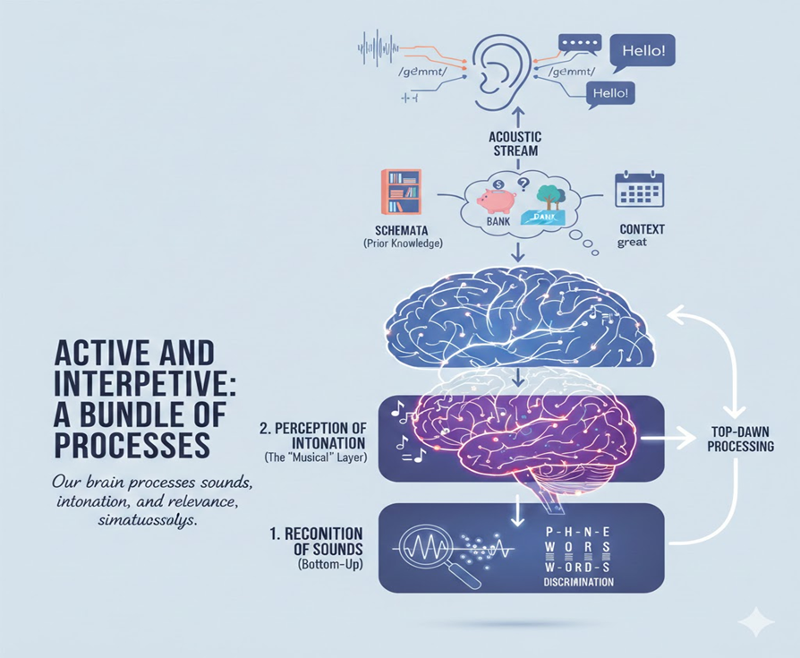

4. Modes of Listening: Transactional vs. Interactional
The nature of listening shifts depending on its function:
- One-way (Transactional): The goal is the transfer of information (e.g., lectures, news). This is often "listening in order to learn" and involves formal language and high cognitive density.
- Two-way (Interactional): The goal is maintaining social relations. This is better termed "listening-and-speaking" because it involves the pressure of immediate response and turn-taking.
  - Listener Roles: In this mode, the nature of the listener's engagement varies by their rights to speak. One may be a Participant (full speaking rights), Addressee (limited rights), Auditor (expected not to respond), or Overhearer (no rights).

5. Pedagogical Context
Understanding the nature of listening informs how it is taught and assessed:
- Enabling vs. Enacting Skills: Pedagogy distinguishes between Enabling skills (perception and interpretation, such as deducing meaning or inferring links) and Enacting skills (making appropriate responses, such as taking notes or asking for clarification).
- Strategy Instruction: Because the process is largely internal, teachers should encourage "strategy instruction". This involves teaching learners to use metacognitive strategies (planning, monitoring), cognitive strategies (predicting, inferencing), and social/affective strategies (cooperation, anxiety reduction).
- Investigation Methods: Because we cannot observe the nature of listening directly, researchers use Observation, Introspection (think-aloud protocols), and Retrospection to understand how listeners derive meaning.
Models of Listening
Based on the provided sources, the "Models of Listening" represent a theoretical evolution from viewing listening as a passive mechanical act to understanding it as a complex, active, and social cognitive process. These models directly inform the "Process" (how we listen) and "Pedagogy" (how we teach listening).
The sources detail four specific models that reflect the changing concerns and technologies of the last half-century.

1. The Communication Theory Model
Originating from Shannon and Weaver’s (1949) mathematical theory for telecommunications, this model introduced terms like "transmission," "signal," "reception," and "noise".
- Theory: It viewed communication as a linear engineering problem where the focus was on the intelligibility of the signal rather than human perception.
- Critique: Human participation was viewed as "peripheral," and the listener was essentially a passive receiver,. While researchers warned against applying this strictly to human comprehension, it provided the baseline vocabulary for understanding message transfer.

2. The Information Processing Model
Influenced by computing, this model conceptualizes the human listener as a "limited processor" managing "input," "processing," and "output",.
- Process: Because human attention is finite, listeners must devote attention selectively. While early versions implied sequential stages (Perception ____Parsing ____Utilization), modern interpretations recognize that listeners use parallel distributed processing. This involves simultaneously integrating:
  - Bottom-up processing: Linear decoding of linguistic clues (acoustic signal, phonemes),.
  - Top-down processing: Activating "schemata" (background knowledge and context) to predict and interpret meaning,.
- Pedagogy: This model has heavily influenced teaching. Rost’s (1990) taxonomy of listening skills—divided into Perception, Interpretation, and Response—parallels the Information Processing model's "Input, Processing, and Output" structure. This helps teachers distinguish between enabling skills (perceiving and interpreting) and enacting skills (responding).

3. The Social/Contextual Model
This model critiques the Information Processing view for treating the listener as a solitary computer. It posits that comprehension is a cognitive process uniting the individual with the social.
- Theory: Meaning is not just "inside the head" but is achieved in the "interactional space" between participants. Listeners are "creators of meaning" who negotiate with speakers to reach a "mutual cognitive environment",.
- Critique of Metaphor: Proponents like van Lier argue against computing metaphors (Input/Output) because they obscure the active, interactive nature of listening,.
- Pedagogy: This model supports the teaching of Two-Way Listening (interactional), where the listener must cope with time pressure and the social obligation to respond appropriately,. It emphasizes the shifting roles of the listener (Participant, Addressee, Auditor, Overhearer),.

4. The Situated Action Model
Grounded in evolutionary psychology, this speculative model suggests that language and listening evolved to control action (e.g., hunting, gathering) rather than to archive information,.
- Theory: Listening is "situated action"—we listen in order to "do things".
- Process: Daily interactions are oriented toward future action (e.g., finding out where to shop or how to treat an illness) rather than static data storage.

Synthesis: Implications for Pedagogy and Research
hese models are complementary rather than mutually exclusive; different listening tasks require different combinations of these models,.
- From Theory to Strategy: Understanding that listening is an active, interpretive process (supported by the IP and SC models) has led to Strategy-Based Instruction. Teachers are encouraged to help learners "orchestrate" meta-cognitive, cognitive, and social strategies to compensate for gaps in linguistic knowledge.
- Researching the Process: Because the processes described in these models are internal and unobserved, research and pedagogy rely on Introspection (think-aloud protocols), Retrospection (post-listening recall), and Observation to understand how learners derive meaning,.
Types of Listening
Based on the provided sources, the types of listening are categorized into two primary modes: One-way listening and Two-way listening. These modes are distinguished by the role of the listener, the purpose of the communication, and the specific cognitive and social demands placed upon the learner.
1. One-way Listening (Transactional) This mode is traditionally linked to the "transactional" function of language, where the primary purpose is the transfer of information.
- Contexts: Common examples include academic settings (lectures, school lessons) and media consumption (watching films, listening to the radio).
- Characteristics: This type of listening is often described as "listening in order to learn". The discourse typically features a density of cognitive content, formal language similar to writing, and a tendency toward decontextualization.
- Pedagogical Context: Historically, language teaching has focused almost exclusively on this mode, utilizing monologues for practice. In this context, the listener is often required to "do something" with the information, such as taking notes, rather than responding verbally.
2. Two-way Listening (Interactional) This mode corresponds to the "interactional" function of language, where the focus is on maintaining social relations.
- Nature of the Process: Also termed "listening-and-speaking," this mode involves dialogue or discussion. It is "reciprocal," meaning the listener acts as both a receiver and a sender of meaning.
- Cognitive and Social Demands: The sources highlight that two-way listening involves specific "costs and benefits".
  - Costs: The listener faces time pressure to process speech and respond immediately and appropriately, carrying the risk of misinterpretation.
  - Benefits: The listener has the opportunity to resolve problems and clear up doubts immediately through negotiation.
- Pedagogical Context: Despite being the most common form of listening in daily life, two-way listening has traditionally been under-represented in research and teaching materials.
Listener Roles in Discourse Within the context of two-way listening, the sources utilize Bell’s (1984) framework to define the specific rights and expectations of the listener. These roles illustrate that "listening" is not a uniform activity but relies on social norms:
- Participant: Someone being spoken to with equal speaking rights.
- Addressee: Someone spoken to but with limited rights to speak.
- Auditor: Someone spoken to but not expected to respond.
- Overhearer: Someone not spoken to and with no right to speak. The sources note that these roles are norms rather than fixed rules; for example, modern mobile phone usage in public spaces is blurring the line between an "overhearer" and a "participant",.
Pedagogical Integration Understanding these types of listening is crucial for developing "enacting skills." While one-way listening focuses on enabling skills (perception and interpretation), two-way listening requires enacting skills, which involve making appropriate responses based on what was heard. Teachers are encouraged to move beyond solely transactional tasks to include interactive settings where learners must contribute relevantly to the discourse.
Processing Levels
The "Processing Levels" of listening are defined by the interaction between bottom-up and top-down cognitive operations. In the context of theory, process, and pedagogy, successful listening is not a linear stage-by-stage event, but a "parallel distributed processing" phenomenon where listeners integrate information from both levels simultaneously.
1. Bottom-Up Processing (Linguistic/Acoustic) Bottom-up processing involves piecing together the parts of what is being heard in a linear fashion, sequence by sequence.
- Process: It focuses on the acoustic level—discriminating between sounds, recognizing word boundaries, and identifying grammatical forms.
- Theory: While older theories viewed this as a passive "tape recorder" function, current theory posits that bottom-up processing is indispensable.
- Research Insight: Studies indicate that bottom-up skills may be the deciding factor in listening proficiency. Tsui and Fullilove (1998) found that skilled listeners were better at bottom-up processing, which allowed them to verify incoming data without relying solely on guessing; conversely, less skilled listeners had to rely on context because their linguistic decoding failed. Wu (1998) similarly concluded that linguistic processing is basic to success, and failure here forces listeners to let background knowledge dominate their interpretation, often incorrectly.
2. Top-Down Processing (Schematic/Holistic) Top-down processing is described as holistic, moving from the "whole to the part," and focusing on the interpretation of meaning rather than the recognition of sounds.
- Process: The listener acts as an "active model-builder," formulating hypotheses about the speaker's meaning and modifying them as new information arrives.
- Theory (Schemata): This level relies heavily on "schemata"—prior knowledge stored in memory. The source distinguishes between:
  - Content Schemata: Knowledge regarding specific topics (e.g., earthquakes).
  - Rhetorical Schemata: Knowledge of discourse genres and organization (e.g., how a lecture or sermon is structured).
- Strategies: This level enables strategies like predicting (guessing the rest of a message) and inferencing (listening between the lines to understand implicit meaning).
3. Integration and Orchestration The source emphasizes that competent listening requires the integration of both levels.
- Risks of Imbalance: A study by Field (2004) illustrated the dangers of failing to integrate these levels. When presented with contradictory acoustic and contextual information, some learners utilized a "lexical" strategy (guessing a known word that fit the context but ignored the sound) while others used a "phonological" strategy (writing down the sound even if it made no sense).
- Faulty Strategy: Field noted that a strategy is flawed if it "potentially overrules contextual information and modifies perceptual," or vice versa.
4. Pedagogical Implications The understanding of processing levels directly informs how listening is taught and diagnosed.
- Skills vs. Strategies: The source suggests a balance between "skills training" (improving bottom-up linguistic competence, such as processing fast speech and intonation) and "strategy instruction" (improving top-down abilities like predicting and monitoring).
- Diagnostic Approach: Teachers are encouraged to use models like Rost’s (1990) to distinguish between "enabling skills" (perception and interpretation) and "enacting skills" (response). This helps educators pinpoint whether a student's failure is due to a lack of acoustic recognition (bottom-up) or a failure to interpret context (top-down).
- Caveats: While strategy instruction is valuable, the source warns it should not be regarded as the answer to "everything"; a successful listener must still possess the linguistic proficiency to monitor incoming acoustic signals.

