Tectonique I
Partie 2 : Distensive Continental structures
Chapitre 1 : Sedimentary basins
Definition
Sedimentary basins were defined as structural lows or cups in which sediments accumulate and have accumulated in the past. This geometric idea of a hollow in the earth’s crust, as we have said, is essential as it defines (fig. 1).
- A receptacle or containerوعاء which is the basin substrataum, generally called basement.
- The container fill, or content, which is the accumulation of deposits or sedimentary cover resting on the basement.
We can distinguish a functional basin (where sediment are still accumulating) and a residual basin which in no more receiving sediments it is already filled).
Some basins display several kilometers thick sediments, how do they form?
Here come the notion of subsidence and sedimentary input.
Subsidence is the gradual settling of a basin floor with time under the load of the accumulating sediments. The basin floor is not stationary, and the available volume for accumulating deposits varies accordingly.
If sediment input exceeds subsidence the basin fills up and dies and then it is called a filled basin. If the basin continues to receive sediments upon subsidence the basin is functional.
This basin idea can be visualized by examining the earth’s entire surface. Basins differ in size, geometry, depth, environment and sedimentation medium, climatic position and volume of sediments fig. 2).
We can distinguish basins in the form of vast lacustrine depression on the continents like Aral Sea, Lake Baikal, Lake Tchad and East Afrcain Lakes. On the other hand, under the seas, we can find a set basins that are different in depth, geometries, salinity, currents…etc. for instance, the Black Sea basin is different from the Baltic or the North Sea basins, the red sea or the Caribbean.
The diversity of all of those basins requires explanations and classification.

Figure 1. Basin Diagram: Cup like depression fills with sediments
The topographique hollow is a trap for sediments that gradually deposit in the course of time. Once the cup is filled, the basin is no longer functional A but residual B. C represents gradual filling.

2- Basin classification
Sedimentary basins are created by deformation of Earth's lithosphere in diverse geological settings, usually because of plate tectonic activity. Mechanisms of crustal deformation that lead to subsidence and sedimentary basin formation include the thinning of underlying crust; depression of the crust by sedimentary, tectonic or volcanic loading; or changes in the thickness or density of underlying or adjacent lithosphere. Subsidence is amplified by further sediments deposition and loading (isostasy).
Sedimentary basins can subdivided into three main categories:
1. Basins whose evolution is mainly controlled by lithospheric thinning (stretching basins). These are the rift basins, whatever the mode of stretching of the lithosphere (rifts, pull-apart basins and strike-slip corridor basins.
2. Basins whose evolution is mainly controlled by the cooling of the lithosphere, whether continental (intracontinental basins), oceanic (abyssal plains), or the continent-ocean transition (divergent margins).
3. Basins whose evolution is mainly controlled by the flexion of the lithosphere (flexural basins), whether oceanic (subduction) or continental (foreland basins).
Although no one basin classification scheme has been widely adopted, several common types of sedimentary basins are widely accepted and well understood as distinct types.
1- Rift basin : where subsidence is rapid and brittle, in a context of divergent plate boundaries..
2. Pull-apart basin : Pull-apart basins are created along major strike-slip faults where a bend in the fault geometry or the splitting of the fault into two or more faults creates tensional forces that cause crustal thinning or stretching due to extension, creating a regional depression.
3. Post orogenic basins, of the “Basin and Range” type, where subsidence reflects the thinning of a mountain range and its return to normal crustal thickness.
4. Cratonic basins, where subsidence is slow and progressive.
5. Fore-range basins, linked to lithospheric flexure.
The sedimentary basins of continental margins, active and passive, will be discussed in the chapter devoted to these margins.
1- Rift Basin (les fossés d’effondrement, graben)
These are narrow and elongated structures, limited by conjugate normal faults, with opposite thrust directions (antithetic faults) (fig. opposite). Due to these fractures, the collapse trenches almost always show alkaline volcanism.
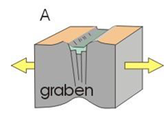
Figure 3. Diagrams showing the shape of a graben structure (collapse ditch) (A and B)
These structures are also called grabens. They can be divided into secondary grabens by compartments that remain protruding or horsts.
Half-grabens and half-horsts are limited by faults with the same direction of rejection (so-called synthetic faults), which causes the compartment to tilt (tilted blocks).
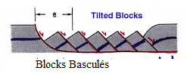
When the graben becomes of continental scale, that is to say, 100 to several hundred or thousands of kilometres long and several tens of kilometres wide, changes in the crust and upper mantle occur vertically. In this case, we are talking about rifts. The Rhine rift is a typical example (fig. 4 and 5). This structure, 300 km long and 35 to 40 km wide, is located with Bresse, Limagne and others, on a distension axis that, in the Tertiary, crossed Europe, from Germany to the lower Rhone valley (fig. 4).

Figure 4. Schéma montrant le fossé d’effondrement de Rhenan.

Figure 5. Coupe transversale dans le fossé d’effondrement de Rhenan.
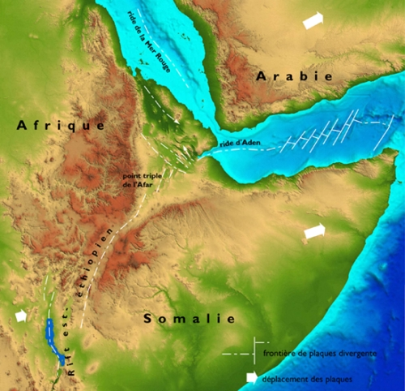
Le rift éthiopien et la dépression afar, dans le contexte de la tectonique des plaques.

1.1 mechanism of rift formation

The upwelling of the asthenosphere causes a wide bulge of the Earth’s surface commonly several hundred kilometers wide. The overlying mantle lithosphere and crust respond to this process and both are thinned as a result.
As the process of distension continuous, the mantle lithosphere and lower crust deform plastically and the upper crust undergo brittle deformation by fracturing and faulting.
The upper crust breaks along a system of conjugate normal faults defining an elongated and narrow trench composed of horst and grabens, while at depth the ductile crust thins.
The thinning is compensated on the surface by a subsidence, which allows the rapid deposition of a thick sedimentary series. At depth, it causes the rise of the mantle and its partial fusion.
The rise of the mantle and especially the magmatic intrusions in the basement of the basin are responsible for the significant heat flow, in particular when hydrothermal circulations use the fault fields bordering the trench.
The thinning of the crust in the axis of the trench considerably lightens the lithosphere. In response, the edges rise by bending, producing the shoulders of the rift (Vosges and Black Forest).
Exemple
The Great Lakes Trench of East Africa (fig. next )
It runs from the Zambezi in the S to the Red Sea in the N, i.e. 6,000 km, with an average width of 40 to 60 km, but it is divided into two branches, E and W, connected to each a lineament (intracontinental transform fault?) that appears clearly on spatial images, the Assoua lineament. The W branch also shows a bayonet-shaped trace due to the Tanganyika-Malawi strike-slip corridor, a right-hand transtension corridor, parallel to the Assoua lineament. All these lineaments are modeled on ancient Precambrian fractures. The eastern branch ends curiously in the S: it is not abruptly interrupted by the Assoua lineament but spreads out in a "crow's foot" of radiating, seismically active faults (Fig. 3.11), reflecting that the extension is not totally rejected to the W by the strike-slip lineament in question.
The trench opened in the Miocene and its filling remained continental or lacustrine.
The deposits can reach up to 8,000 m in thickness (Fig. 3.12) and the discontinuities observed there are of climatic or tectonic origin (tilting and replay of blocks).
Volcanism
The East African Rift shows the usual volcanism of this type of structure, especially at the eastern branch, which may indicate that, the distension there is greater as would be expected because of its links with the Afar.
Fig. 3.12 Structure du rift est-africain au niveau du lac Tanganyika (inspiré de Sander et Rosendahl, 1989).
En pointillé, le remplissage mio-pliocène.
Carte structurale simplifiée du rift Est-Africain.
Ce rift est formé de deux branches qui se relaient de part et d’autres du linéament d’Assaoua. Dans cette zone de relais, le lac Victoria, peu profond et à faible taux de sédimentation, sépare les deux branches et contraste avec les lacs qui jalonnent
celles-ci. Son origine est liée aux soulèvements bordiers des deux branches du rift, à l’E comme à l’W, qui déterminent une cuvette intermédiaire (d’après J. Chorowicz, 1983). MNT (GTOPO).

2-

2 1- PULL-APART BASINS (les bassins sur décrochement)
They are four-sided rhombohedral basins sometimes develop along major transform fault or a major slip fracture. These are extension basins prompted by a general longitudinal slip movement. The Jordan trough (fig. 6) is a classic example of pull-apart basins.
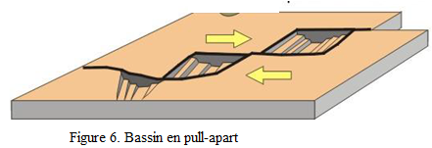

The initial fracture often being in a broken line. The sliding on each of the border faults stretches the crust following a diamond-shaped block which thins and collapses. It will be noted that the distensive regime is only local, the general deformation being strike-slip. The most classic example is that of the Dead Sea along the Jordan strike-slip fault (fig. opposite).

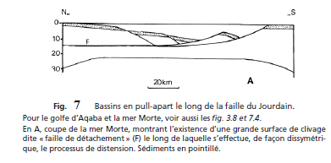

2.2 STRIKE-SLIP BASINS (Bassins de décrochants)
Wider than the previous ones, they form by distension between sliding faults and reflect a sort of flexible "joint" within a continental mass so that they can also record the periods of compression undergone by the mass in question in response to the play of the large lithospheric plates (fig. 8).
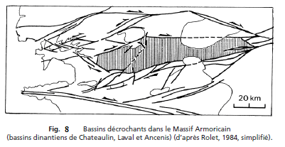

2 3 .Complex strike-slip basins (Bassins sur décrochement complexes)
They always show a sedimentary basin settling on a distensive strike-slip structure but this time being able to overflow it largely. The whole represents, as we have said, a sort of flexible joint within a craton, a joint which also records, in the form of local folding, the temporary compression of the latter. Distension and compression can therefore follow one another or alternate.
3- LATE-OROGENIC DISTENSION BASINS, "BASIN AND RANGE" TYPE
(Bassins de distension tardi-orogénique)
They are areas with broad zones of tectonic deformation characterized by numerous, parallel graben and horst blocks or metamorphic domes (see below).
The Basin and Range Province comprises two kinds of extensional faults, low-angle normal detachment faults with associated metamorphic core complexes (described below) that are responsible for most of the horizontal extension (over 200 % in some places), and high-angle normal faults that create the numerous parallel basins (grabens) and ranges (horsts). The Basin and Range Province (USA) is extended in an east-west direction across 600 km.
These are reliefs, of variable length, sometimes corresponding to classic horsts and grabens but most often they are half-horsts and half-grabens, that is to say, ultimately, tilted blocks. The difference in level between them reaches 5,000 to 6,000 m. These blocks are delimited by typical normal faults, of the listric type (concave upwards). The extension that they translate has been estimated at a value between 10 and 35% of the original width, locally 100%.
Topographic relief map and simplified geologic map of a portion of the Basin and Range
Province in North

3 1- Distension mechanism
The process can be as follows:
– Dans un premier stade (fig. 11), un plan de cisaillement se formerait plus ou moins horizontalement au sein de la croûte. Viennent s’y raccorder les failles normales listriques (f) séparant les premiers blocs basculés par distension.
– Ultérieurement, et sous l’effet de la distension persistante, des failles listriques plus plates et plus proches de la surface (« failles de détachement » F1) apparaissent et compliquent le découpage des blocs basculés (stade 2).

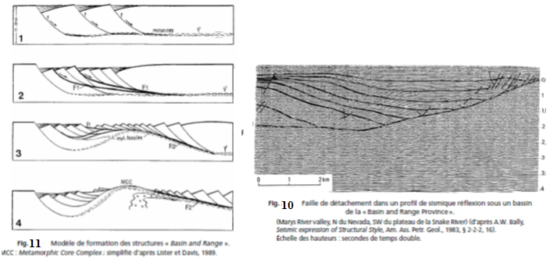

– Au stade 3, la distension finit par provoquer un amincissement de la croûte suffisant pour déclencher la remontée d’un manteau supérieur, donc de la croûte inférieure amincie.
- C’est-à-dire qu’à partir d’un certain stade (stade 4) une nouvelle faille de détachement (F2) se met à fonctionner en séparant ces blocs superficiels du socle sous-jacent.

4-LES BASSINS PROPREMENT DITS (bassins cratoniques)
Ce sont des dépressions ovales ou arrondies où les sédiments prolongent en continuité ceux des plates-formes voisines, beaucoup plus minces et lacunaires. Le maximum d’épaississement reste au voisinage du même axe pendant toute l’évolution. Le rapport profondeur/diamètre est de l’ordre de 1/100 à 1/50. Exemple : Les bassins de la plate-forme Saharien de l’Algérie (bassin d’Ain Salah, Hassi Berkine, Bechar, Tindouf), Taoudeni et Paris.
Autres exemples de bassin cratonique :
Bassins paléozoïques de la plate-forme russe, du Michigan, de l’Illinois, de l’Oklahoma, en Amérique du N, de Tindouf et du Karroo en Afrique, ou ceux, mésozoïques à tertiaires du Tchad (fig. 3.22), du Fezzan, du Sud-Lybien en Afrique, d’Arabie, de Chine.. etc.
5- Les Bassins complexes
Des complications de structure interviennent parfois, notamment :
1. Quand la superficie du bassin est très grande et que son histoire est longue car il se divise alors en bassins secondaires dans lesquels l’onde de subsidence maximum se déplace, d’où des bassins basculés et emboîtés les uns dans les autres. C’est le cas du bassin du Sahara (fig. 8).
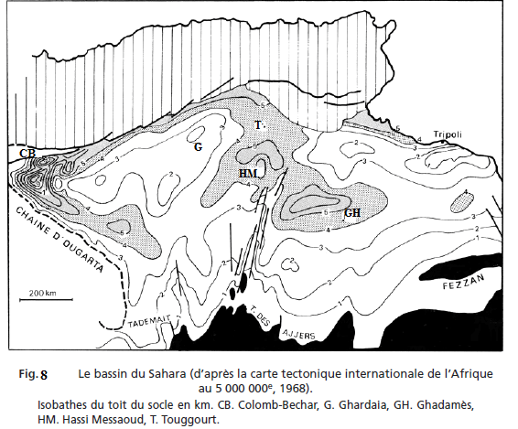

6- LES BASSINS D’AVANT-CHAÎNE
On appelle ainsi des bassins situés au front des chaînes de montagnes et qui en reçoivent les produits d’érosion ou molasses, d’où le nom aussi utilisé de bassins molassiques. Ils s’installent au front d’une chaîne en cours de plissement, parallèlement à sa direction et ses structures tectoniques sur une lithosphère qui fléchit sous la charge que représente la chaîne, d’où le nom de bassins « flexuraux » qu’on leur donne parfois. Les exemples abondent : le bassin molassique suisse au front des Alpes, le bassin carpatique au front des Carpates, le bassin padan au front de l’Apennin. L’Adriatique peut être considérée comme un bassin de ce type, encore actuel, au front des chaînes dinariques.
Exemples :
6 1 Le bassin molassique péri-alpin (fig. 3.37 à 3.41)
Né dans le Bas-Dauphiné, au pied des chaînes subalpines, il se développe largement en Suisse. De Lausanne à Zurich, son extension correspond exactement au front des grandes nappes des Alpes suisses (nappes préalpines et helvétiques). Au-delà du lac de Constance, il passe au bassin bavarois puis au bassin de Vienne, au front desAlpes orientales faites des nappes austro-alpines.
Le bassin est dissymétrique en ce sens que les plus grandes épaisseurs de sédiments sont au voisinage de la chaîne. Par ailleurs, il y a contemporanéité des crises de subsidence avec les périodes de mise en place des nappes.

